Registration Wizard

NOTE: This document is formatted for use as an online Help file. Therefore, some of the formatting might not have translated properly to this printed document.

Table of Contents
regwiz 1
Registration Wizard 1
Enable the Registrar in Remote Backup Server 1
Initialize the Client Database with Customize Client Installer 2
Client Registration Configuration Utility 3
Configuring the Introduction Panel 3
Configuring the User Information Panel 5
Configure User Name and Password Assignment Method 7
Connection Setup Panel 8
Configuring Backup / Schedule Options 9
Online Registration Text 12
FINISH Text 13
Files used in the Registration Wizard 14
Rbackup.reg 15
Index 21

regwiz

Registration Wizard



The Registration Wizard allows your clients to register on your RBS Server and add an account automatically.

The Registration Wizard is configured using the Client Wizard Configuration utility on the RBS Manager's Tools Menu.

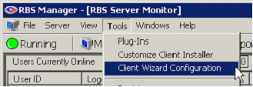

You can display this help file any time by pressing the Help button anywhere in the Client Wizard Configuration program.

Enable the Registrar in Remote Backup Server
Before you can use the Registration Wizard, you must set up the Registrar on the RBS Server. To turn on the Registrar capability, select Tools, Properties, Manager Preferences. Place a check in the Use RBS Registrar checkbox.

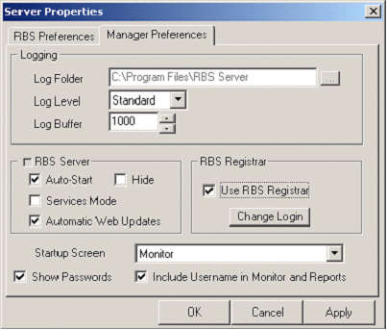

Edit the Login by pressing the Change Login button. This will present the following screen to define the Registration User Login and Password. This User Name and Password is used by all of your clients to gain access to your RBS Registrar. It is the same for all of your clients.

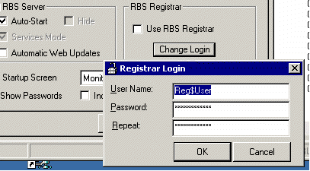

When these options are set, you are ready to begin configuring your Registration Wizard for use.

Initialize the Client Database with Customize Client Installer
The Host Name or IP Address, Port Number, and Account Group used in registration are defined using the Customize Client Installer Screen. To run it, select Tools, Customize Client Installer from the RBS Manager Menu.

Client Registration Configuration Utility
To run the Configuration utility, select Tools, Client Wizard Configuration

The Client Wizard Configuration Utility maintains 2 files that important for your client setup. The files rbackup.ini and rbackup.reg are used during the installation process as follows:

Rbackup.reg - With or without the Registration Wizard, rbackup.reg is used to override registry settings upon installation of the client software. In particular, the Rbackup.reg must be invoked to put in place the Registration Login information. This file contains the distributed start setting for Passive or Active mode transfers.

Rbackup.ini-– This file performs 3 functions. First it triggers the Registration Wizard by its presence or prevents Registration Wizard by its absence from the installation folder or CD. Secondly, it contains settings created either using the Configuration Wizard or Manually with a text editor, and finally, its values override the default values in the Rbackup Client when it adds new Backup Sets.

Configuring the Introduction Panel

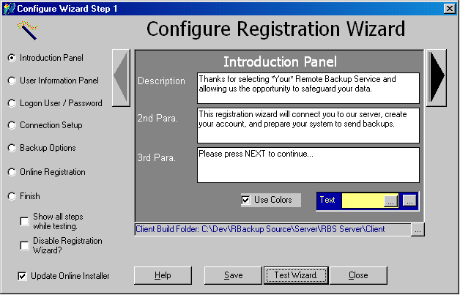

The configuration utility panels provide for entering text in a size approximate to what is available in the Registration wizard. Any time while you are editing your Registration Wizard using this utility you can press the Test Wizard button to check the appearance of the Registration Wizard after making changes.

Enter the introductory message in the three fields provided, and select your choice of colors, or uncheck Use Colors for the standard windows colors as shown below.

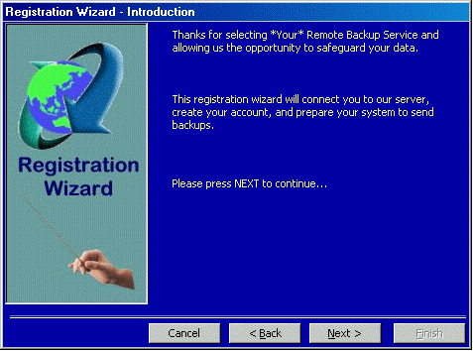

Configuring the User Information Panel
The next panel defines the text shown above the user name, address and other fields.

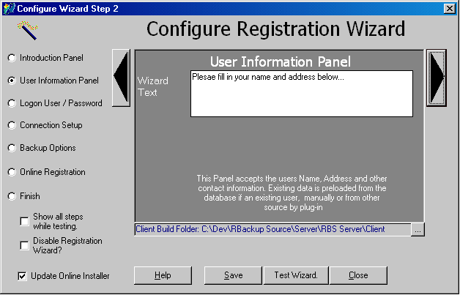

When running the registration wizard in Test Mode, the fields are pre-filled with the word "TEST" and both client and server do not save changes into permanent settings. The labels (Name, Company, Address 1…) on this screen are all customizable.

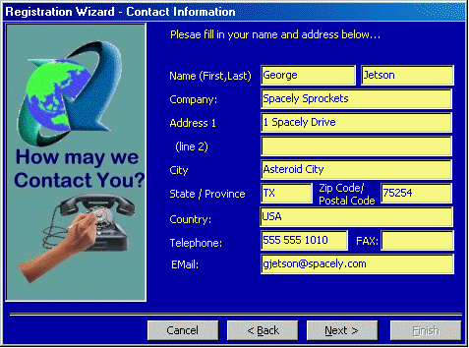

The program remembers your clients' entries here for convenience. If for some reason your client is unable to connect, the next time he attempts these fields will remain filled in. The temporary filename changes by date, so the information may not reappear if retried on a second or subsequent day.
To edit/change the label captions, use Windows Notepad to edit the file rblabel.ini in your \RBS Server\Client\ folder and the Online Installer folder on your server if you own the Online Installer PlugIn. If the rblabel.ini file does not exist, create it with Notepad.
Below is the text in the rblabel.ini:

[Labels]
0=Name(First,Last):
1=Company:
2=Address:
3=(line 2)
4=City:
5=State / Province:
6=Zip / Postal Code:
7=Telephone:
8=FAX:
9=EMail:
10=Country:

To edit the labels you need to change the corresponding text in this file. For example, if you want to replace "Country:" with "University/College:", then edit the rblable.ini file like this:

[Labels]
0=Name(First,Last):
1=Company:
2=Address:
3=(line 2)
4=City:
5=State / Province:
6=Zip / Postal Code:
7=Telephone:
8=FAX:
9=EMail:
10=University/College:

Configure User Name and Password Assignment Method
The next panel shows the client's Username and Password if the method used requires entry by the user. If not, it is all handled behind the scenes.

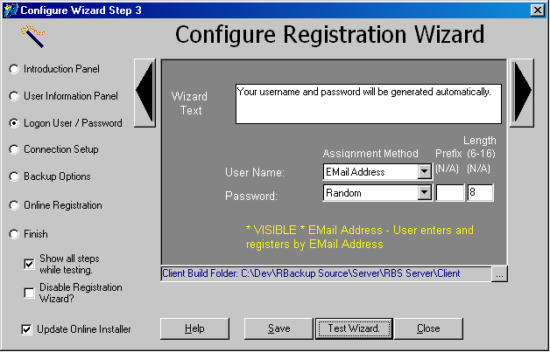

You may choose from the following registration methods:

- Entered By User - Allows user to select Username and Password
- Random - Generates a username / password including optional prefix.
- Sequential - Generates sequential username / password including optional prefix.
- Email Address - Prompts use to enter email address as key and generates random or sequential password
- Predefined on Server - User will be prompted to enter an existing Username and Password which must exist on the server at registration time.

Your text should be presented to best explain the options you have established for the new user.

Connection Setup Panel
This panel allows you to specify which connection options are available for your client. The registration wizard supports LAN, ISP and DIRECT methods. When registration is complete, the client connection will already have been verified.

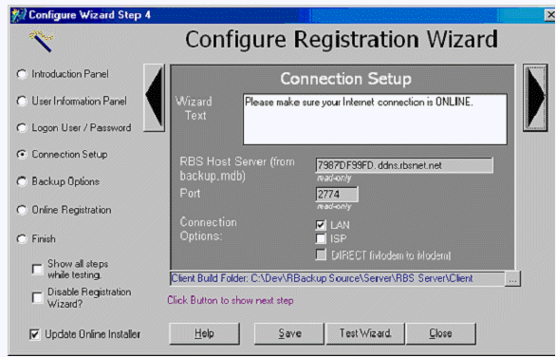

If more than one option is selected, a panel will appear to allow the user to select his preferred connection method.

Configuring Backup / Schedule Options
This panel pre-specifies certain backup options for use when new backup sets are created.

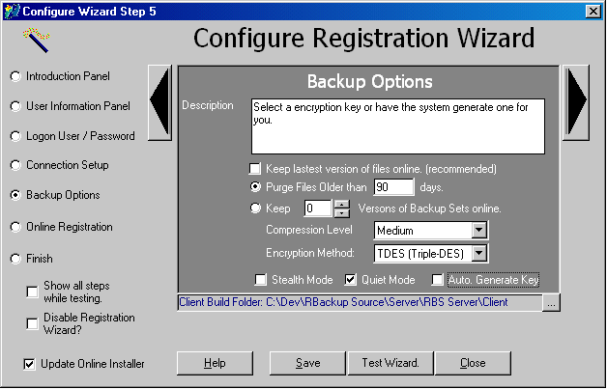

The options set by this panel are mostly not shown to the end user, with the exception of the encryption key. You can select the default encryption method and auto-generate key to bypass the panel in the registration wizard. If Auto. Generate is off, the panel below will show allowing the registering user to choose.

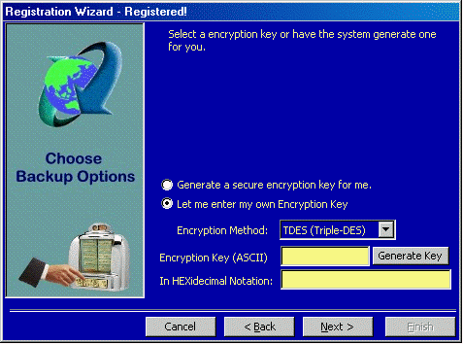

When the user encounters this panel, and Auto-Generate is not selected, the user can choose an encryption method and enter or generate a key. The Next button will not become enabled until all fields are satisfied.

To generate a key, click the Generate Key button:

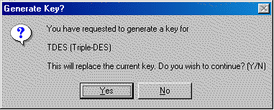

The generated key is then displayed in the fields, similar to how a Triple-DES key is shown below.

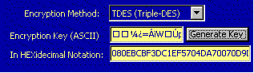

In this example, the user has chosen to enter a textual key

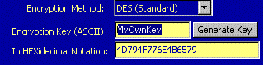

Online Registration Text
This panel allows you to enter the text shown to prompt the user to commence online registration.

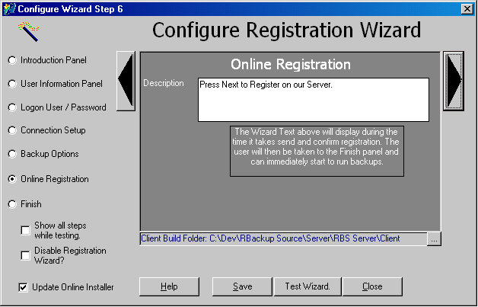

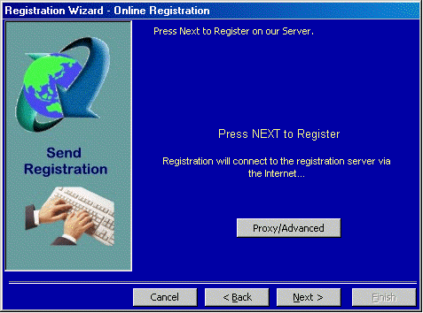

FINISH Text
The final panel presents the text displayed when the registration is complete.

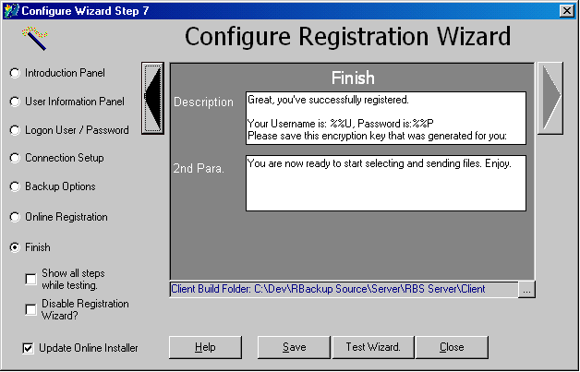

The Finished panel informs your user that the registration is complete, and offers to run the Remote Backup package upon completion. This is an example of the panel displayed upon successful completion.

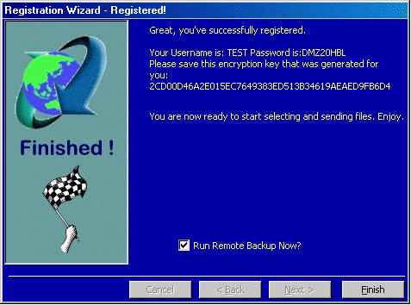

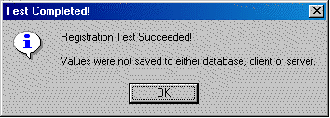

When the Registration Wizard is tested, the Remote Backup system does not save the completed values to either the server or client database, It just pops up this message at the end to inform you that it was not saved. This does not show to your end users.

Files used in the Registration Wizard
The files produced by the configuration utility can be edited manually through any common text editor. Those files, rbackup.ini and rbackup.reg are explained in more detail below. You may choose to do all setup using a text editor since the rbackup.ini file can be completely maintained manually if desired.

Rbackup.reg
The Configuration Utility creates the Registration Username and Password entries because they are encrypted before being written to the file. You’ll notice that in Rbackup.reg, the username and password are unreadable.

The other setting maintained via the Rbackup.reg file is the UsePassive setting which initializes your client to either use or not use a passive connection.

Rbackup.reg can carry a few other optional settings as explained in the table below.

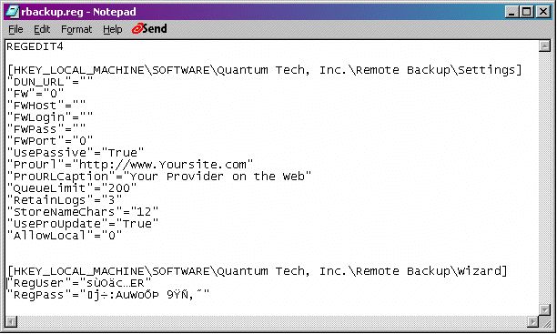
example of rbackup.reg file

Setting | Default | Usage
UsePassive | True | True/ False (If unsuccessful, will always try Passive)
ProURL |  | Website to reference in the help menu
ProURLCaption |  | Caption to show in the help menu
RetainLogs | 3 | Number of days to retain logs, after which they are deleted
StoreNameChars | 0 | Number of characters to preserve from original filename
UssProUpdate | False | Causes client to automatically point WebUpdate to the Server’s root website directory.
AllowLocal | 0 | 0 = Always Available  1 = Only available after login with PASSWORD  2 = Disabled
Table of Optional Entries for Rbackup.reg

Rbackup.ini

This is an example of the Rbackup.ini file with settings used in examples above.

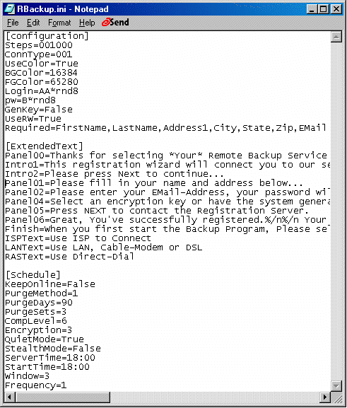

This is the file used to generate the examples in this text. The settings are each explained below.

PanelXX (01 through 06) - the main panel text for each panel.

Intro01 and intro02 - extra paragraphs on the introduction page

Finish - the second paragraph of the finish screen .

Work with the Wizard in test mode and change text to achieve the best presentation.

[Schedule] provides defaults for the creation of new backup sets in the main client and will be observed by the client if this file exists.

[Configuration] group contains the settings used to drive the Registration Wizard itself.

Steps=0000000 These switches allow you to force screens to show. Not all screens will show, yet if required information is missing, the screen for that information will be displayed. This is best set to all zeros in order to allow the Registration Wizard to control the display of screens.

ConnType=001 indicates which connection methods are allowed. If only LAN is selected (As shown here) the screen will not display at all. If two or more positions have "1"s the client will be presented the choice.

Position 1 is RAS (DIRECT) - ConnType=100
Position 2 is ISP - ConnType=010
Position 3 is LAN - ConnType=001

It may be simpler to include some text to instruct the client to be sure he is online and restrict this to LAN to simplify the process. However, if ISP or DIRECT are used, the setup created by Registration Wizard will work for the client right away.

GenKey=False will cause the Backup Options screen to show and allow the client to choose. GenKey=True will cause the encryption panel to not show.

Login and PW. These fields contain the code that instructs the Registrar how to create an acceptable username. The Password settings allowed depend on the Login setting as shown in the table below:

Code | Password types | Usage
*udf | *udf | User Defined, allows freeform selection of username and password. Checks to insure there is not a duplicate, if not, authorizes and creates user.
*pdf | *pdf | Requires the user to enter a pre-existing name setup for him on the server. Use this to provide Username and Password by email or other external method before the client logs in for the first time.
*rnd | *rnd, *seq | Generate RANDOM username with characters in length of 6 to 16 characters. Allows optional prefix. Example: AB*rnd10 would create a username like "ABJYNSUUZZPQ". If the server generates a duplicate, it regenerates until unique, then returns to the client
*seq | *rnd, *seq | Add to the last sequential value used to produce a new unique value.
*email | *rnd, *seq | Prompts the client to enter an email address as a username. Password is generated as either a random or sequential value.

UseColors=True/False - Instructs Registration Wizard to use/not use colors.

BGColor/FGColor = Color Values as selected from the color dialog in the Configuration Utility.

Optional RBackup.ini Settings
[configuration]

UseRW= (True/False) True turns the Registration Wizard ON, False turns it off. Setting UseRW to False has the same effect as erasing the rbackup.ini file altogether.

UseRW=False Setting UseRW to False has the same effect as having no rbackup.ini. It turns off the registration wizard.

AutoSelect= (True/False) Turns ON or OFF the AutoSelect feature.

Required=<List of Required Files, must have data for NEXT button to enable.>

Example: Required=FirstName,LastName,Address1,City,State,Zip,EMail
Additional Text: The following text fields may be added to override the text beside the connection options. They are shown below with some suggested text.

ISPText=Use ISP to Connect
LANText=Use LAN, Cable-Modem or DSL
RASText=Use Direct-Dial (Note: Direct-Dial not support in current version of Registration Wizard)

The following settings set the defaults for the Properties section of the Administrator's Interface of the Client's Schedule screen.

PurgeDays= (0 to 360 days) Specify the number of days to keep a backup set. This will become the default for the Purge Files Older Than

PurgeSets=(#sets to retain) Sets the Number of Backup Sets to keep online.
CompLevel= (0, 1, 6 or 9) Sets the Compression Level to None, Low, Medium or High. The default is Medium.
Encryption (0 or 1) 0 means use default encryption method as defined in the Backup tab, 1 means use NO encryption when creating a new backup set.

RollForwardOption=(0 or 1) If set to 0, RollForwardThreshold will be selected by default. If set to 1, ThresholdSize will be selected.

RollForwardThreshold=(1 to Unlimited) This is the number of BitBackups that will be done before Remote Backup resends the full file again.

ThresholdSize=(25, 50, 75 or 100) The percentage of BitBackup size to full-file size. For example, if set to 50, when the size of the most recent BitBackup archive exceeds 50% of the size of the full file, Remote Backup will perform a Roll-Forward, resending the full file.

Steps=0000000 These switches allow you to force screens to show. Not all screens will show, yet if required information is missing, the screen for that information will be displayed. This is best set to all zeros in order to allow the Registration Wizard to control the display of screens.

Trial Accounts

[Trial] group activates Trial Accounts. If this group is defined here, all users will be added with Trial Accounts.

Days=(#days) Sets the number of days for Trial Accounts to stay active. Trial Accounts will be automatically suspended after the number of days specified here.

The following settings effect the default settings of the Backup Type and Backup Schedule.

BUType= 1 (Incremental), 2 (Differential), 3 (Full) Sets initial value of Backup Type to Incremental, Differential or Full when a new set is created.
StartTime= (3:00) Default start time when a new set is created, 24-hour format
ServerTime= (3:00) Default Server time when a new set is created, 24-hour format
Frequency= (1, 2, or 3) 1 = daily, 2=weekly, 3=monthly
Window=(Window Hours)

Replaceable variables for Registration Wizard Text

When you write the text to be presented to your new users you may replace some of the text with the following variables if needed.
For example, to display the randomly generated user name and password on the FINISH pane, place a comment like.
Your username is %%U and your password is %%P, please record these for future reference.

%%N = Full Name
%%F = First Name only
%%C = Company Name
%%U = Username
%%P = Password
%%E = Users Email
%%K = Character Code version of the Encryption Key.
%%H = ASCII Code Version of Encryption Key. (Important when the character version contains unprintable characters)

Index

C
Configure the wizard using the Client Registration Configuration U 3
Configure User Name and Password Assignment Method 7
Configuring Backup / Schedule Options 9
Configuring the Introduction Panel 3
Configuring the User Information Panel 5
Connection Setup Panel 8
E
Enable the Registrar in Remote Backup Server 1
F
Files used in the Registration Wizard 14
FINISH Text 13
I
Initialize the Client Database with the Client Database Utility 2
O
Online Registration Text 12
R
Registration Wizard 1

