RBackup Client - Simple Interface
Table of Contents
Welcome to Remote Backup version 11 - Simple Interface 1
How does Remote Backup Work? 3
Backup Sets 5
Backup Sets 5
Create New Backup Set 6
Edit Existing Backup Set 7
Copy to Disk 7
Scheduling Backups 9
Backup Types 9
The Backup Schedule Box 10
Windows Account Information 12
Advanced Schedule Settings 12
Selecting Files for Backup 16
Selecting Files for Backup 16
Selecting Files by File Set 16
Selecting Files Using the File Explorer 17
Selecting Files by File Types 18
The System File Type Tab 18
The User Defined File Type Tab 19
Backup Now 23
Test Connection 25
Restore 26
Restore 26
Search for Files to Restore 26
Restore Location and the Change Location Button 27
Restoring the System State 28
Restoring Active Directory 28
Settings 29
Settings 29
How BitBackup Works 34
How BitBackup Works 34
How BitBackup Works 34
BitBackup's Local Data Store 34
Backups with BitBackup 34
Restoring Files with BitBackup 35
BitBackup Efficiency 35
Encryption Standards 37
Encryption Standards 37
DES 37
TDES 37
Blowfish 37
AES 37
Selecting Your Encryption Key 38
Examples of BAD ENCRYPTION KEYS 38

Welcome to Remote Backup version 11 - Simple Interface
[Display Documentation for Advanced Interface]

Remote Backup is the latest in a family of software and services that founded and defined the Remote Backup industry for microcomputers in 1987. It automatically backs up your critical computer files to a secure, off-site location, giving you the confidence and security big companies have enjoyed for decades.
Click the tabs below to find out more about them.

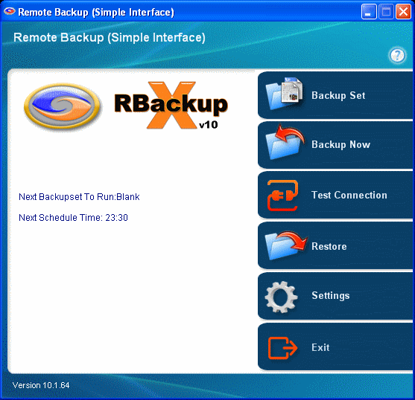

Remote Backup runs on all Windows operating systems from Windows 2000 to the latest version, including Workstations and Servers, 32 bits and 64 bits. It runs in the background, and will not interfere with other programs you run. Through Remote Backup's simple and intuitive user interface, you can control which of your files are backed up, and on what schedule.
Remote Backup operates by defining Backup Sets, which are sets of files and a schedule for backing up those files. You can add new Backup Sets, Delete, Copy, and Save them. Backup Sets are automatically executed by Remote Backup according to their schedules.

How does Remote Backup Work?
Remote Backup works basically like regular data backup software, with one important difference. Instead of sending backups to a tape drive or other media attached to the computer it is backing up, Remote Backup sends the backup over the Internet, regular telephone lines or network connections to another computer safely offsite. It does this (usually) at night while your computers aren't being used.
It's completely automatic. In fact, you may even forget it's working. Most businesses put their lives on the line every night and don't realize it. With businesses depending more and more on the data stored in their computers, proper backups are becoming much more critical.
Remote Backup accomplishes several essential steps that are often overlooked or done improperly by other backup software - especially in the regular non-automated backup systems.
Backups are done on schedule. Most businesses don't do this. For one reason or another, they don't keep a regular backup regimen. Usually it's because the person responsible for doing backups (if there is one) is too busy doing something else, or someone is using the computer when it's time for a backup, or they simply forget. Since Remote Backups are done with automated software usually at night, when nobody is using the computer, backups are always done on schedule.
The correct files are backed up. Ordinary backup software is often installed with a list of files to be backed up. This set of files usually represents the state of the system when the software was installed, and often misses critical files. Further, it often fails to back up files that get added later. Compounding this problem, VERY few businesses take the trouble to reset their backup software regularly to include new files.
Remote Backup solves this problem by constantly reevaluating your computer system, adding files to the backup as needed. Multiple copies of files are stored using a sophisticated version control system unavailable in most other backup software of any kind. This is much too important to overlook.
The general definition of proper backups requires redundancy. One must keep multiple copies of the same files at different points in their development, called versions. As an example, you should have a different copy of each backed-up file for each backup session. Further, you should be able to easily restore any of your files up to any given point in time. Banks do it, big corporations do it, and so should small businesses. Only Remote Backup has such an easy to use version control system.
Backups are encrypted for complete security. Would you want someone to be able to slip one of your backup tapes into a pocket and take it to your competitor? It happens all the time. Tape backups are not generally encrypted, so anyone can read them and gain access to your client database, billing records, payroll, tax info, and everything else on your computer.
Remote Backup encrypts its backups for complete security so nobody, not even your RBS Service Provider can read your files. Finally and most importantly - Backups are immediately sent offsite and stored safely away from your computer and your business. This is where almost every business makes its biggest mistake. Even if you do everything else perfectly, your backups are of little use if your building burns, or you are unable to physically recover your tapes from the premises. Most small companies who do backups leave the tapes in the building with the computer, where they can be destroyed right along with the computer.
Of course, you can see that this would be a problem in a fire or flood or an earthquake. But it's also useful in emergencies where businesses are forced to evacuate their offices quickly. Even businesses that do backups and have good, undamaged tapes have to shut down. Many go out of business simply because they don't have access to their data.
Remote Backup solves this problem by automatically storing this valuable data at more than one site. So, a business can be back up and running with new computers and their latest data no matter what catastrophe happens.

Backup Sets

Backup Sets

Remote Backup saves most of the information it needs in Backup Sets. Each Backup Set can define a set of files to backup, exclude, or ignore. It contains a schedule for backing up those files, and other options. Remote Backup runs its Backup Sets like programs, all at the same time. You can define Backup Sets with an almost unlimited combination of files, schedules, and options. Remote Backup will run each Backup Set on schedule, independently.

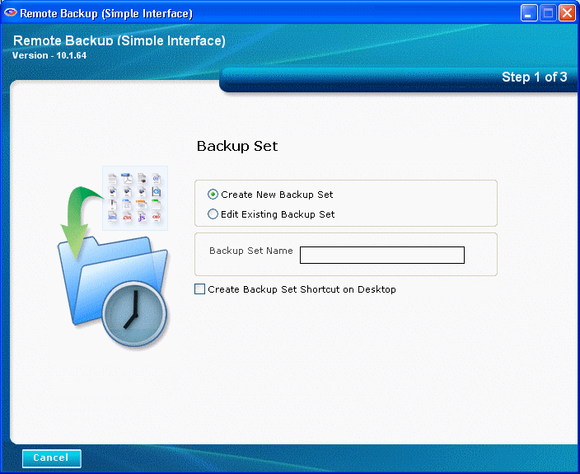

Create New Backup Set
To create a new backup set, select Create New Backup Set and type the name of your new backup set. Then press the Next button.
If you want to place a shortcut on your desktop which will run this backup set, also select the Create Backup Set Shortcut on Desktop option.
Click the Next button on the screen below to view the next screen.
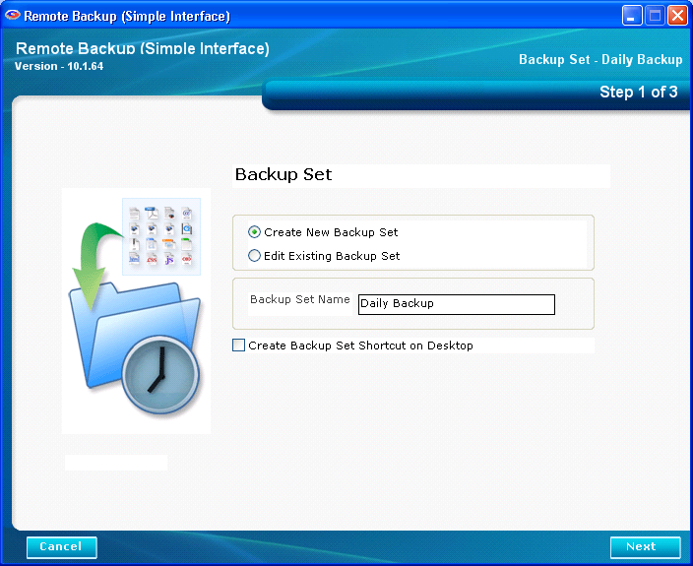
Click the Next button above to see the next screen.

Edit Existing Backup Set
Here you can edit existing backup sets and run a Copy to Disk session.
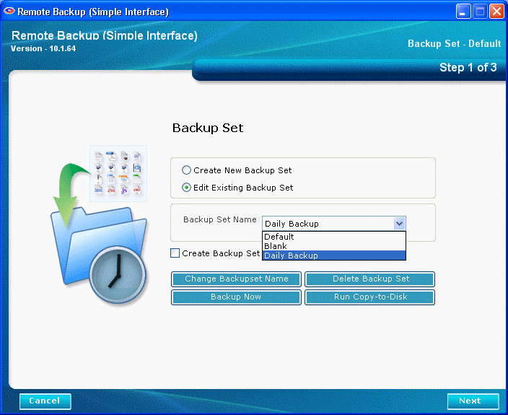
To edit a Backup Set, select the Backup Set you want to edit and click the Next button.
To run a Copy to Disk operation, select the Backup Set you want to run and click the Run Copy-to-Disk button.
To run a backup now, select the Backup Set you want to run and click the Backup Now button.

Copy to Disk
The Copy to Disk function runs a backup using the currently selected Backup Set, but rather than sending it to the RBS Server, it sends it to a portable hard drive, CD, or DVD. This is useful when sending a large amount of data to the RBS Server as a first backup, which might take too long if sent over the Internet.
The archive files it places on a local drive are in the format required by the RBS Server. This function communicates with the RBS Server and sets up all the proper directories and resources to receive these files later, when they are copied onto the RBS Server from a portable hard drive, DVD, or CD.
To copy files to a CD or DVD, they must first be copied onto a hard drive, usually in a folder of a drive in the computer running Remote Backup. Then use your regular CD or DVD burning software to copy the files from the hard drive to the CD or DVD.
To get them onto the RBS Server, send the portable hard drive, CD, or DVD to the Remote Backup Service Provider, who will copy them onto the RBS Server. The files will then be immediately available for online restore.

Select Copy to Disk button, and select the location where you want to send your backup files.

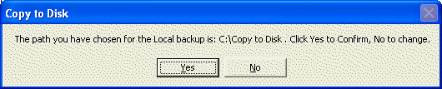
Confirm the location. The backup will begin, like a regular backup.

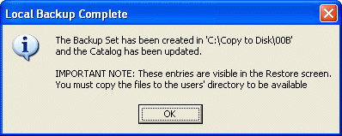

After the backup is complete, Remote Backup will tell you where it copied your files, and give further instructions.

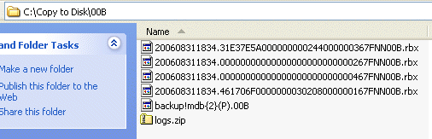
It is important to immediately copy these files to removable media and send them to the RBS Server as soon as possible. Although they now show up in the Restore screen, they will not be available to restore until they are copied onto the RBS Server.

Scheduling Backups
This is where you define the schedule for your Backup Set to run, and the type of backup.

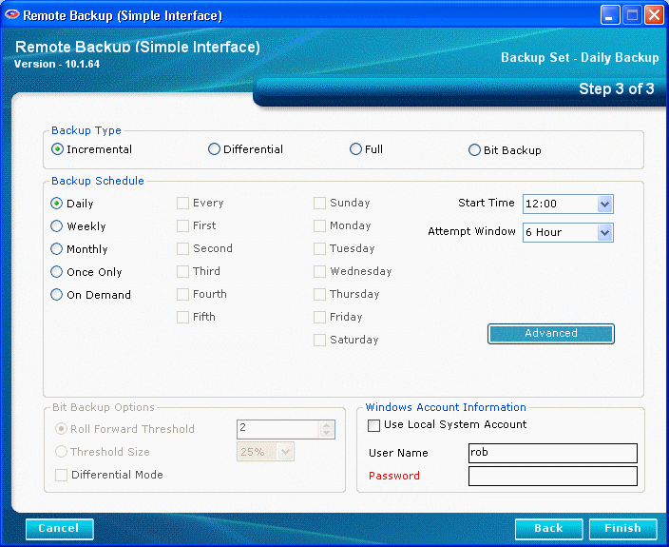

Backup Types

Incremental
Files will be backed up which have been modified since the last backup. Then, after they are backed up, the files will be marked on the disk as having been backed up. This is the default and most widely-used way to back up data files.

Differential
Files will be backed up which have been modified since the last backup, the same as Incremental. However, after the files are backed up, they will not be marked as having been backed up. The reason for this option is in case you also want to do tape backups as well as Remote Backups. Your tape backup software relies on the marks placed on the files to determine which files need to be backed up. So, you don't want to remove them with your Remote Backup.

Full
Files will be backed up regardless of whether they have been changed since their last backup. This is the least-used option because it results in the largest Backup Sets and longest on-line times.

BitBackup
Only the parts of files that have changed will be backed up. This option creates sub-file or "patch" backups. This creates the smallest backups that take the least amount of time. See How BitBackup Works for more information.

There is also a box labeled Backup Schedule. Here you can select different schedule types.

The Backup Schedule Box

Daily
Selecting this option will launch a backup every day, seven days a week.

Weekly
This schedule lets you select which days of the week to do a backup. You can select to do a backup every Monday, Thursday, and Saturday.

Monthly
On this schedule you can select the first, second, third, fourth or fifth of any day of the week. Here are some examples: You can pick the first and third Wednesdays of each month. You can select the second Tuesday and Thursdays. There are a lot of possible schedules you can use here.

Once Only
This schedule will launch a single backup session, one time only, on a specified date you can pick from a pull-down menu containing a calendar.

On Demand
Pick this selection if you want this backup set to be launched On Demand only - not through the scheduler. You can then launch this backup set through the Run Now option on the Run Menu.

Start Time
For each of these schedules you can select a Start Time and an Attempt Window. Please be aware the Start Time is on a 24-hour schedule, and that anything after midnight is the next day. What this means is that if you want to back up Friday's work, and you want the backup session to take place after midnight, you should select a time early in the morning of Saturday, not Friday.

Attempt Window
The Attempt Window is the number of hours Remote Backup will attempt to perform the backup. Selecting a start time of, for example, 1:00am will not necessarily cause the backup session to start at 1:00am, although it might. Remote Backup might not be able to perform a backup for a variety of reasons - the Server is too busy, files are locked, the computer is not turned on.
In the event that Remote Backup cannot perform a backup at the selected Start Time, it will attempt the backup session some time during the next period of time determined by the number of hours you select here.

BitBackup Options
BitBackup is a special kind of backup that backs up only the changed parts of files instead of the full files. It is sometimes called "sub-file" backup or "patch" backup. BitBackup is especially useful for very large files when only small parts of the files change between backups.
For a complete explanation of how BitBackup works, see the section on How BitBackup Works.
For example, if only a five-character word changes in a 2 megabyte document, BitBackup will back up only five characters. This can save large amounts of storage space on the Server, and it can significantly speed up the time needed to do a backup.
BitBackup always backs up a full file the first time. Thereafter, it backs up only the changed parts of the file. Each of the BitBackup backups sent after a full backup can restore the file up to the point in time when that backup was done, called cumulative backups. So, as time goes on, BitBackup archives become larger as they contain more changes.
Periodically, BitBackup needs to reset - a process called Roll-Forward. To do this, Remote Backup sends the full file again, and then resets BitBackups, which reduces their file size back to the minimum. This process cycles according to the settings at the bottom of this screen.

Roll-Forward Threshold
This is the number of BitBackups that will be done before Remote Backup resends the full file again.

Threshold Size
The percentage of BitBackup size to full-file size. In the example on this screen, when the size of the most recent BitBackup archive exceeds 50% of the size of the full file, Remote Backup will perform a Roll-Forward, resending the full file. Using the Threshold Size feature instead of the Roll-Forward Threshold setting takes more time during preparation of a backup, because Remote Backup needs make a BitBackup archive to compare its size to the full file.

Differential Mode
Select this checkbox to have BitBackup backups act like normal Differential backups. Files will be backed up which have been modified since the last backup, which is the normal way BitBackup works. However, after the files are backed up, they will not be marked as having been backed up. The reason for this option is in case you also want to do tape backups as well as Remote Backups. Your tape backup software relies on the marks placed on the files to determine which files need to be backed up. So, you don't want to remove them with your Remote Backup.

Windows Account Information
Enter the login name and password of the Windows account to use when this Backup Set runs. You may also select Local System Account.

Advanced Schedule Settings
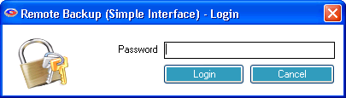
The Advanced Schedule Settings are for the user of your Remote Backup Service Provider and rarely need to be edited. If your Service Provider had given you the password for Advanced Schedule Settings, you can enter it here.

The Purge / Retention Options Tab
The Version Control System keeps multiple copies of your files on the Server. It NEVER over-writes a file. If a you want to restore a file from two weeks ago, you can, back to a specific date - as long as you still have that data on the Server.
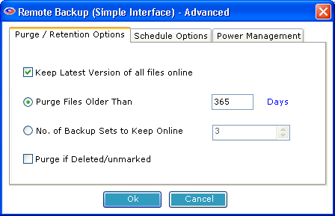
You can set your software to rotate files. It can erase the oldest backup files by the length of time they have been on the Server. So, if you like, you can set the system to delete all files that are 30 days old (as an example). This would mean that the software would automatically erase data as it hit 31 days old and the latest session is written to the disk, effectively keeping the most current 30 days of data online. (or 14 days, or 60 days - whatever) Or, you can turn this feature off and keep all data.
The powerful Restore features can rebuild (in real-time at the time of restore) a full file set containing all the latest versions of files from multiple backup sets for Full, Incremental, Differential, and BitBackup backups.
You can also have the software set to keep files of which it has only one copy, regardless of how old it is. So, files of which you only have one backup copy are never erased.

Keep latest version of all files online.
Check this setting if you want to keep the most recent version of a file regardless the other settings on this screen. For example, assume you have set Purge Files older than: to 30 days. If you only have a single copy of a file within that time frame, and you do not checkmark this option, that file will be erased when its age is over 30 days. If you checkmark this option, that file will be retained regardless of its age until a more recent one appears at your RBS Server.

Purge Files older than:
Use this setting to set the retention period of the files in this Backup Set to a number of days. In this example, files will be retained for 30 days and then erased from the RBS Server.

Number of Backup Sets to keep online:
This setting is mutually exclusive of the Purge Files older than setting. You can only use one or the other, not both. Setting Purge Files older than to zero turns this setting on. Using this setting, the file retention period is not determined by date, but by the number of backups sets on the RBS Server.

Purge if Deleted/Unmarked
Select this checkbox to automatically delete files from the Server at the end of their retention period if they are deleted from the Client or if they are deselected (unmarked) by the Client.

The Schedule Options Tab
The Schedule Options tab contains the following settings.

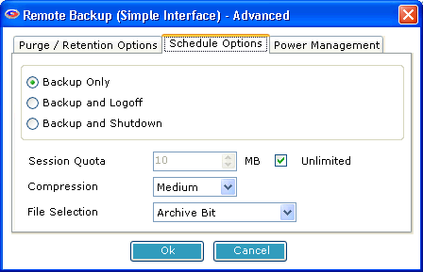
Backup Only
Do nothing after a backup.

Backup and Logoff
Log off the current user after the backup.

Logoff and Shutdown
Log off the current user and shut down the computer after the backup.

Session Quota
The number of megabytes that can be sent to the Server in one session.

Compression
The degree of compression to use.

File Selection
The method to use for selecting files for backup. See your Service Provider for information.

The Power Management Tab
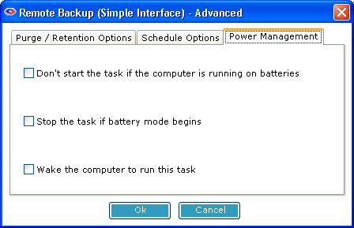
The Power Management Tab contains options that can help extend the battery life of laptop computers.

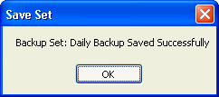
When you are finished with this screen, click the Finished button. Your Backup Set will then be scheduled to run.

Selecting Files for Backup

Selecting Files for Backup
Use this screen to select files for backup.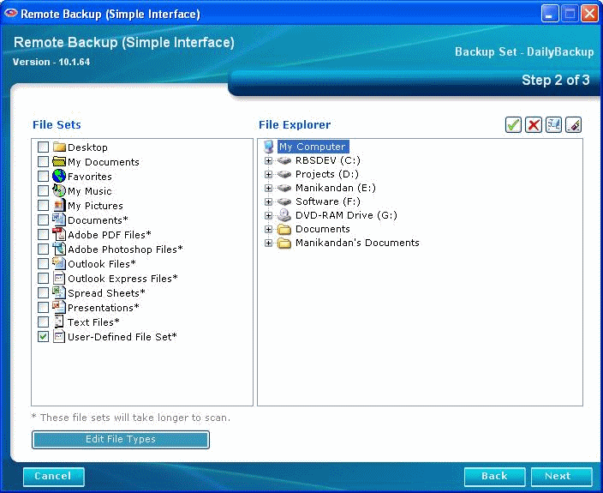

Selecting Files by File Set
You can use all three file selection methods. Do this by first selecting files by File Set and/or File Type, and then pruning your file selections using the File Explorer.
File Sets are predefined groups of files. They could be your Favorites, or your My Documents, or Spreadsheets. File Sets are listed in the left pane of the File Selection window. To select File Sets for backup, place a checkmark in the box next to the file set name. As you select file sets, you will see checkmarks appear over the corresponding files and folders in the File Explorer in the right pane.
File sets with an asterisk beside them search the entire hard drive for files, and so they take longer to execute during a backup. Selecting one of these file sets turns on the Edit File Types button. Click it to edit.

Selecting Files Using the File Explorer
You can select individual files and folders using the File Explorer in the right pane. To select a file or folder for backup, click it to highlight it and then pick one of the File Selection Buttons in the upper right of the screen.

Selecting a File or Folder - Green Checkmark

To select a file or folder for backup, place a green checkmark over it. You can do this by highlighting the file or folder, and then selecting one of the File Selection buttons in the upper right of the screen. OR you can right-click on an item and select Include, Exclude, or Clear from the pull-down menu.

Excluding a File or Folder - Red X
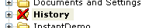
To exclude a file or folder from the backup, place a red X over it by selecting the Exclude button, or Exclude from the right-click menu.

Clearing a Selection
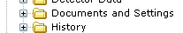
To clear all file selection marks, select the Clear button, or Clear from the right-click menu.

Clearing All Selections
You can clear all file selections by selecting the Clear All button.

The Right-Click File Selection Menu
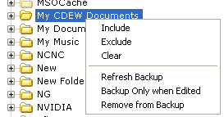
The Right-Click File Selection Menu contains choices used to select and exclude files from backup.
Include - Include in the backup
Exclude - Exclude from the backup
Clear - Clear File Selection marks.

Refresh Backup
Files are usually backed up if they have been edited or changed since their last backup. (This behavior can be changed in the Schedule Screen, but for purposes of this section of the documentation, assume that's the way it is set.) If you want to back up a file or folder, even though it has not changed since its last backup, you can select Refresh Backup and it will be backed up with the next session.

Backup Only when Edited
The opposite of Refresh Backup, this option tells the software to drop the selected item from the next backup even though it has been changed or edited since the last backup.

Remove from Backup
This option tells the software to remove the selected item from the Backup Set. The file or folder will not be backed up, and all File Selection marks will be removed.

Selecting Files by File Types
Your computer contains many types of files, usually defined by which applications they belong to, and characterized by file extension (the part of the file name to the right of the period.) For example, your computer defines a file that ends in ".DOC" as a Microsoft Word Document. These are called "System File Types" because your computer system knows what kinds of files they are.

The System File Type Tab
This tab lists all the file types recognized by your computer system. You can select file types for backup and for exclusion from backup.
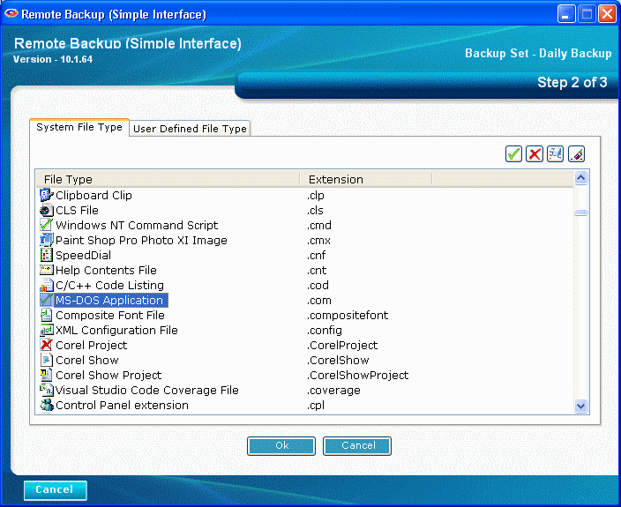
To include a file type, place a green checkmark over your choice. To exclude a file type, place a red X. You can select multiple choices using the regular Windows selection keys - Shift/Click and Control/Click. As with other file selection methods, you can also use the right-click menu.

The User Defined File Type Tab
Your computer system knows about most file types, but not all of them. Some file types may have been added by your Service Provider for special use. These are listed in the User Defined File Type Tab. Here you can add, edit, and delete your own file types.
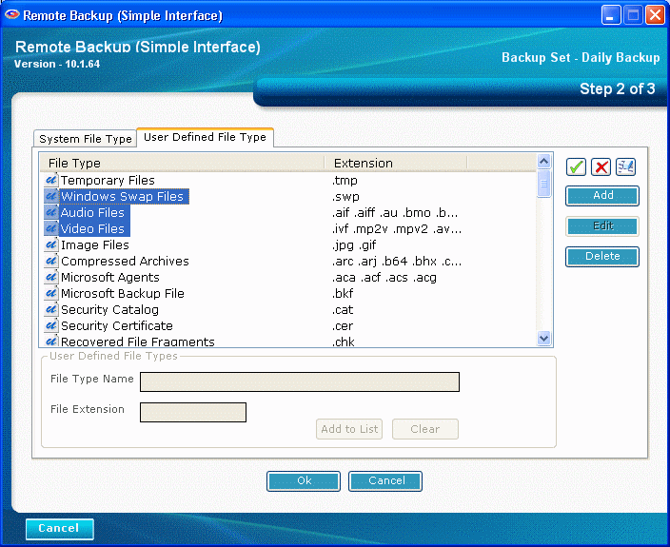
To include a file type, place a green checkmark over your choice. To exclude a file type, place a red X. You can select multiple choices using the regular Windows selection keys - Shift/Click and Control/Click. As with other file selection methods, you can also use the right-click menu.

Adding User Defined File Types
To add a new User Defined File Type, Select the Add button
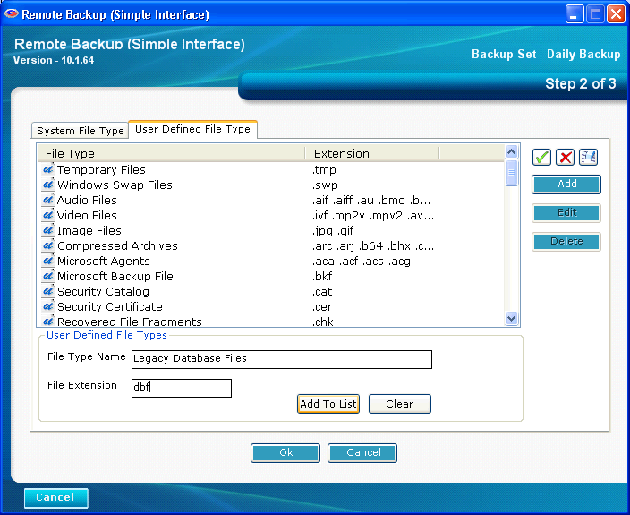
Type the name of your new file type, and its File Extension. Then click the Add To List button. You can then select your new file type from the list, and Include, Exclude, or Clear it. When you are finished, click the OK button.

Editing User Defined File Types
To edit a User Defined File Type, highlight the file type in the list and click the Edit button.

Deleting User Defined File Types
To delete a User Defined File Type, highlight the file type in the list and click the Delete button.

Backup Now

You can start a backup any time you like, regardless of the schedule. Select the Backup Now button.

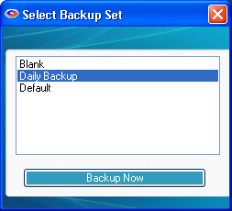
Then select the Backup Set you want to run and click the Backup Now button..

Your backup will start, and the Backup Progress screen will display.
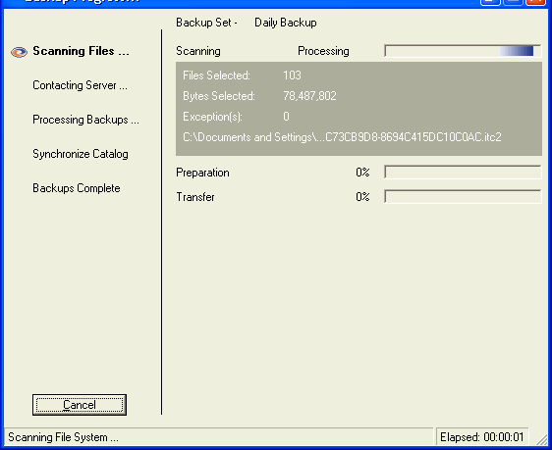

Test Connection

Use the Test Connection button to test your connection to the Backup Server.

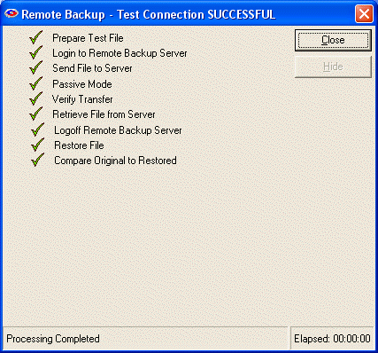

Restore

Restore
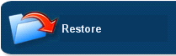
Select this menu choice when you want to restore files. The menu choices allow you to search through all your backed up files and select files to restore. You can also specify a location to redirect your files, in case you want to put them somewhere other than where they came from when they were backed up.

This is the main Restore screen. The left pane contains the file selection criteria. The right pane contains the files you have found in the search. Select files to restore in the right pane. The bottom pane shows the progress and results of your restore operation.

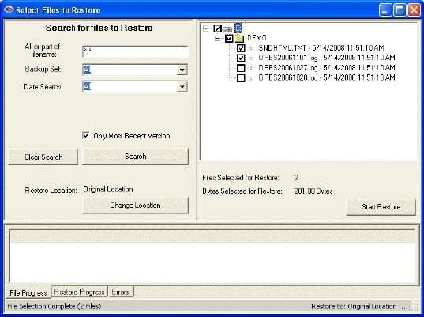

Search for Files to Restore

All or part of filename

Enter any part of the file name or folder name to search for files, or leave this as *.* to search through all files.

Backup Set
Select which backup set to search though, or select All backup sets.

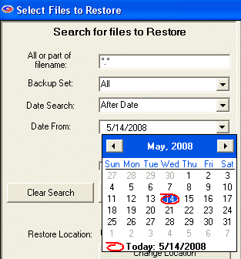
Date Search
Select On Date, Before Date, After Date, Between Dates, or All.

On Date: Selects files backed up on a date.
Before Date: Selects files backed up before a date.
After Date: Selects files backed up after a date.
Between Dates: Selects files backed up between two dates.

Date
Select the date from a drop-down calendar to use in the search. If you select Between Dates, there will be two Date fields. Note: The calendars will only let you select dates for files that have been backed up.

When you have entered your search criteria, press the Search button. The files found in your search will appear in the right pane. You may now enter other search criteria to find more files, which will be added to the right pane.
To clear your search and start over again, press the Clear Search button.
After you have searched for your files, and have selected the ones you want to restore by checkmarking them in the right pane, press the Start Restore button to begin the restoration.

Restore Location and the Change Location Button
In the left pane, near the bottom, the current Restore Location is listed. The default is Original Location so the restored files will be placed in the same locations from which they were backed up. To restore to a different location, select the Change Location button to select another location.
Remote Backup will create the original folder structure at the new location and restore your files there.

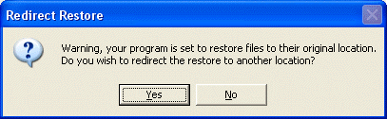
This screen displays if you have selected to restore files to their original location (which is the default) and asks if you want to redirect the restored files to another location. If you want to over-write your current files in their original locations, answer NO to this prompt. Otherwise, answer YES, and the software will allow you to select another location for the restored files.

Restore Progress Screen

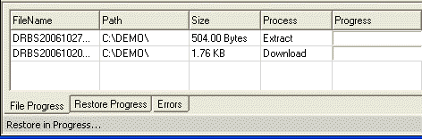

During the restore process you will see this progress screen in the bottom pane.

Restoring the System State
NOTE: This restore cannot be redirected. It will always overwrite existing System State.
System State can be restored like any file. Simply select it for restore. After restore, the computer must be rebooted for the restore to take effect.

Restoring Active Directory
NOTE: This restore cannot be redirected. It will always overwrite existing Active Directory.
- Restart the computer in Directory Services Repair Mode.
- Start Remote Backup
- Restore Active Directory using the Remote Backup Restore interface
- Restart the computer in Normal Mode.

Settings

Settings

The Settings Screen contains settings that enable the software to contact the Server. There are only two settings on this screen that you can change.

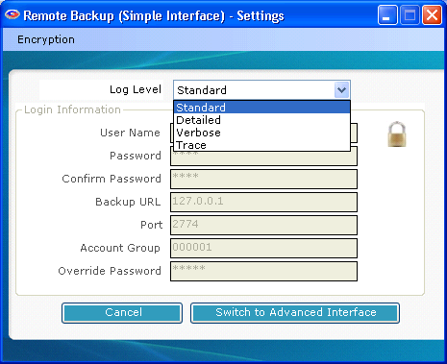
Log Level
This determines the level of detail stored in the log files. Change this only on the advise of your Service Provider.

Switch to Advanced Interface
Press this button to switch the User Interface to Advanced mode. Advanced Mode has more functions to control the way backups and restores are done.

Change Encryption Key
When you change your Encryption Key, write it down in a safe place. If you forget it, you may not be able to recover your data.
It is usually advisable to change your Encryption Key periodically. Your Encryption Key is literally the key to your data. It is used to lock up your data so nobody else can see it, and like a regular key, if you forget it, you may not be able to recover your data.

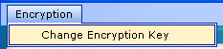
Click the word Encryption at the top of the screen to change your encryption key.

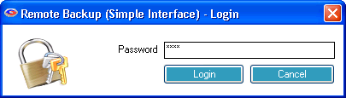
Enter your password. Your User password or the Administrator's password will work here.

This is the Encryption Options screen. Here you can change your Encryption Key and Encryption Method.
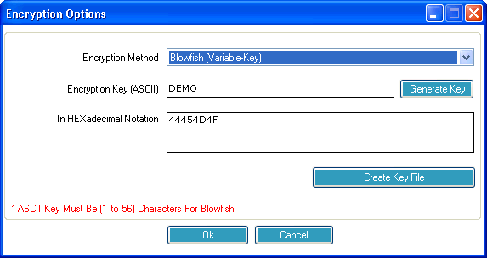

Encryption Method
Select from several Encryption Standards to use to encrypt your data files.

Encryption Key (ASCII)
Enter your Encryption Key. Read more about how to select a good Encryption Key in the chapter, Selecting Your Encryption Key.

Generate Key
Selecting this button will generate a statistically perfect Encryption Key using the most secure rules. While this is the best way to generate Encryption Keys, it always generates a key that is difficult to remember.

In HEXadecimal Notation
Your Encryption Key is stored in hexadecimal notation. This is sometimes easier to enter during a Disaster Recovery operation than a complex key containing sometimes unprintable characters.
There are two ways to change your Encryption Key. The first is to select a word or phrase that you can remember. For rules on selecting your encryption key, see the section on Selecting Your Encryption Key.
The second way is to let Remote Backup generate one for you by selecting the Generate Key button.
Remote Backup has a way to automatically generate "statistically perfect" encryption keys - the most secure keys. If you want the very highest security, do not pick your own key. Allow Remote Backup to generate it for you.
The way Remote Backup generates a key depends on which encryption standard you have chosen. All of Remote Backup's encryption standards may not be available in your version of Remote Backup.
If you pick "DES (8.3 Standard)" Remote Backup will generate a 128 bit key, represented as sixteen letters and numbers.

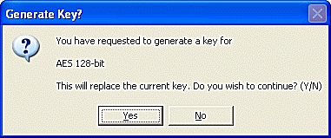
Since these "perfect" encryption keys are hard to remember, it is recommended that they be recorded on paper and kept in a safe place.

Whenever an Encryption Key is changed it is advisable to create a new Key Disk using the Key Disk button.

When generating a key for Blowfish encryption, you will see an additional screen asking how long you want the key to be. Blowfish varies from one to 56 characters. A "character" is eight bits. So, Blowfish varies from eight bits (1 x 8) to 448 bits (56 x 8)

When a new key is created you will have the opportunity to print the new key. Print it or write it down and save it in a secure location.
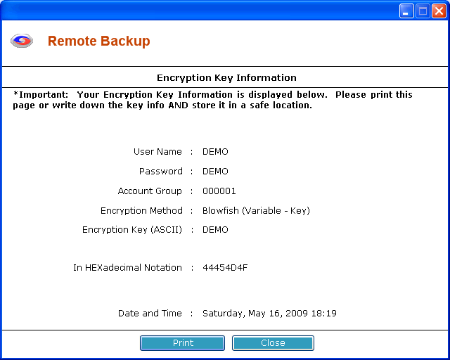

Whenever you change your encryption key or any other setting that is critical in restoring your data, Remote Backup will prompt you with one or more messages indicating an action you should take.

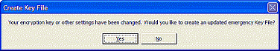
When prompted to create an updated encryption key file, answer Yes. Remote Backup will place the key recovery files on the device you select.

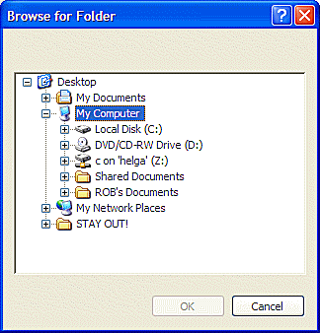
Select a diskette drive or a network drive to store the Key Files away from the computer they protect.

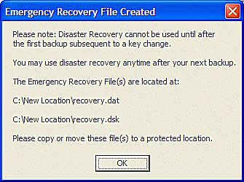
This screen will be displayed, indicating the file name(s) that were created.

How BitBackup Works

How BitBackup Works

How BitBackup Works

BitBackup technology can do backups and restores many times faster than traditional methods while using far less storage space on the RBS Server by backing up only the small parts of files that have changed since the last full backup. It's local Data Store insures that multiple copies of the most recent backup files are maintained for added safety and failsafe operation.

BitBackup results in a reduction in backup size by an average of 99.77%

BitBackup's Local Data Store
BitBackup maintains copies of the most recent versions of the files it backs up to the RBS Server in a local Data Store. Restoring from the local Data Store is automatic and VERY fast - the speed of the local Network or disk buss. The most common restores are done from the local Data Store instead of from the RBS Server.
BitBackup is far more reliable and failsafe than traditional online backup methods. It's local Data Store acts as a "hot spare" for backups, mirrored to the RBS Server. Restores are done first from the local Data Store, and fail over to the RBS Server only if the requested files are not available in the local Data Store.
Restores done from the local Data Store do not contact the RBS Server at all, and do not require an Internet connection. Therefore, in an emergency that takes the RBS Server offline, or brings down the Client's Internet connection, restores from the local Data Store can still be done.
The local Data Store can be maintained on each local computer, or it can be shared by all computers in a network on a network device.

Backups with BitBackup
The first time a file is backed up using BitBackup technology, the entire file is backed up to the RBS Server, and a snapshot of the file is stored in the local Data Store.
Subsequent BitBackups of the same file compare the most current "live" version of the file to the snapshot stored in the local Data Store. Copies of the changes between the two files (called Patches) are created and backed up to the RBS Server.
Since these Patches contain only the changes made to the "live" file since the Reference File was made, they are often very small - just a few words or a paragraph out of a large document.
Patches are cumulative. Every patch has the ability to restore a file from the date of the most current Reference copy to the date of the Patch. Thus, BitBackup technology needs only one patch and one Reference copy to restore a file to any point in time.
Since Patches are cumulative, they tend to grow larger with time. At some point in time a Patch may approach the size of the original file, if that file is modified frequently. When that happens, BitBackup technology refreshes the Reference file in the local Data Store and on the RBS Server through a process called Roll-Forward. This reduces the size of the Patches to their minimum size again.
Thresholds for Roll-Forward can be set in two ways - by number of backups since the most recent full-file backup, or by the size of the Patch relative to the Reference file. When one of these thresholds is reached, BitBackup technology performs another full-file backup and (depending on the Purge/Retention Settings) erases the previous full-file backup, all its Patches, and the older Reference copy stored in the local Data Store.
BitBackup's Roll-Forward procedure is fully compliant with all the Purge/Retention Settings that are used with Incremental, Differential, and Full backup methods.

Restoring Files with BitBackup
From a user's perspective, restoring files with BitBackup works the same way as the other backup methods, only much faster. From a technical perspective, however, it is quite different.
BitBackup first determines which files are needed to restore a full file by determining the Patch file needed to restore the selected version. It then looks up the Patch file and its associated Reference file in the local Data Store.
If both the Reference file and the Patch exist in the local Data Store, BitBackup restores them from the local Data Store without downloading them from the RBS Server. If they are not the correct versions (or they don't exist in the local Data Store), BitBackup downloads the correct versions from the RBS Server.
If the correct version of the Reference file exists in the local Data Store, but the correct version of the Patch does not, BitBackup downloads only the Patch from the RBS Server.
BitBackup then applies the Patch to the Reference file, converting it to a full file of the selected version, and copies it into its original location, or an alternate location if selected.

BitBackup Efficiency
The following table illustrates some typical file types and the tested percentage of file size reduction using BitBackup. Your actual results may vary, depending on many factors including the type of data stored, the number and size of changes applied, various user-controlled settings in the software, pre-backup file processing by applications out of Remote Backup's control, and the methods used by application software to modify the target files.
Because there are so many variables that can affect the size of BitBackup backups, RBS cannot guarantee that you will achieve these results.

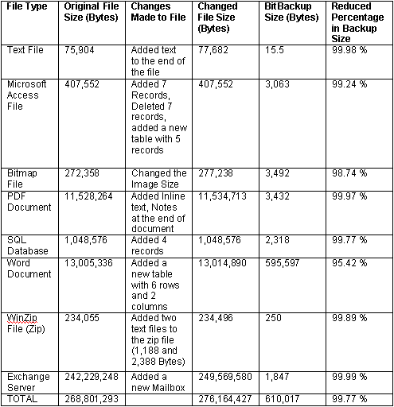

Encryption Standards

Encryption Standards
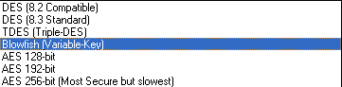
Remote Backup allows you to use various Encryption Standards. Depending on the country you are in and the version of Remote Backup you have, some of these standards may not be available to you.

DES
The old US Federal Standard

TDES
A much more secure form of DES

Blowfish
Probably the most secure of all. It uses a key length that is variable from four bits to 448 bits.

AES
The new US Federal Standard. Remote Backup supports three levels of AES from 128 bits to 256 bits. 256 bit AES is very secure, but it is also slow.

Selecting Your Encryption Key
It is VERY important that you select a proper Encryption Key. This is literally the key to your data security. Remote Backup uses the industry's most secure encryption technology. However, even the latest, most secure encryption technology can be compromised by using a bad Encryption Key. There are some rules.

- Never use your name, your dog's name, ANYONE'S name, or part thereof.
- Never use any part of your telephone number, address, or any other identifying information about yourself.
- Never use a properly spelled common word or proper noun.
- Never use a key shorter than ten characters.
- Never use the same encryption key and/or password for different services.
- Never use the brand of your favorite car, horse, motorcycle, vacation spot, etc.
- DO use a key with more than ten characters. The more the better.
- DO use a key with mixed letters and numbers.
- If you use actual words, misspell them.
- Add unnecessary punctuation marks to the end of actual words or phrases.

Remember - the longer and more complex your encryption key is, the more secure your data. There are several ways to crack encryption - guessing, using a Dictionary program, brute force, or hardware-related methods.
Guessing - Hackers use this method first. They try to guess your encryption key by using combinations of information they know about you. Your name, your address, your phone number, your dog's name, your spouse's pet name - all are common encryption keys that can be guessed. If someone who wants to hack your password gains access to your desk, they will look around at your pictures, your stuff, and try to guess your password based on what they see. They may even look up the middle names of your children and other info about you in public records.
Dictionary Program - An attack with a dictionary program uses a database of words from the dictionary to try to crack your encryption key. If you use a common word or phrase, spelled properly, a Dictionary attack may take only a matter of minutes using a regular home PC.
Brute Force - This method requires an enormous amount of computing power, time, and manpower. But, it has been effective in cracking some low-level encryption techniques. Remote Backup uses extremely high-level encryption technology. In Brute Force attacks, hackers use high-speed computers to try many different combinations of letters and numbers until maybe, some day, one of their combinations work. This is the ONLY way to attack most high-level encryption techniques.
Sniffers - Less common than any of the other three methods, this method and other similar hardware-related methods seem to be born out of science fiction. But, they ARE real. Unauthorized visitors to your company can leave behind devices that send everything on your network or computer to a remote location. There's even a device that can be built out of common electronic parts that lets someone read everything on your computer monitor from as much as 100 meters away - without the need to actually see the monitor. They pick up the electronic pulses generated by your computer monitor as you type and translate them to screen images on the hacker's terminal. Amazing.

Examples of BAD ENCRYPTION KEYS
- Robert (my name)
- Larry (my dog's name)
- 555-1212 (my phone number)
- Jaguar (my favorite car)
- Blackboard (just a regular word)

Examples of GOOD ENCRYPTION KEYS
- theAzoRes# (a proper noun, mixed case, and with a trailing punctuation mark)
- FrAn1klen-mAKes$-great%-breaD# (a phrase, misspelled, with punctuation and mixed case)
- birds!of)a(featuer#flock^together (same as above)
- asdASDLFJ#*sdfk98-98-0sdfk;jwq89ASDF3dsfkj9j30kld##cx (absolutely random - the best)
- rooleftthetheatrethenwentforawalkdownbytheriver# (a phrase with punctuation mark)

Note: DO NOT use any of these examples!

