Printed Documentation
Table of Contents
Web Manager Default Website 1
Web Manager Default Web Site 1
The Flash Component 5
The End User License Agreement 6
Login Widget 8
The My Account Page 9
The Buy Now Page 10
The Order Form 10
Introduction 15
Accounts Menu 19
Account Groups 19
Users 22
Monitor 29
Dashboard 31
Reports 35
User Summary 35
User Sessions 36
User Quotas 37
Disk Resources 38
Transaction Report 39
User Listing 40
Executive Summary 41
Setup Menu 43
Coupons 43
Customize Installer 44
EMail Notifications 80
Payment Gateway Setup 89
Plans 97
Properties 101
Storage Price 103
Test Server 103
Web Manager Setup 104
Orders 109
Help 111
Support Central 111
Web Manager Help 111
RBS Server Help 112
RBS Client Help 112
Download/Re-download Help 112
Download Disk Restore 113
Download WebRestore 113
About 114
User Remote Management 115
The Remote Management Console 115
The Remote Helpdesk 123
End User Login 125
User Login Console 125
My Account Menu 126
Change Storage Plan 126
Buy More Space 126
Cancel Account 127
Restore 129
Disaster Recovery 129
Reports 130
Help 130
Installation 131
Translating for Different Languages 153

Web Manager Default Website

Web Manager Default Web Site
The Web Manager PlugIn comes with a default web site that you can edit as HTML files and graphics. You must edit the web site before posting it for the public. We have made it simple to edit. You can use a text editor or an HTML editor.

The components that make up the site include HTML files, graphics files, and ASP pages. There is little you can edit in the ASP pages. They are delivered as compiled files. However, they use INCLUDES and CSS to create most of their look and feel, and you can edit these files.

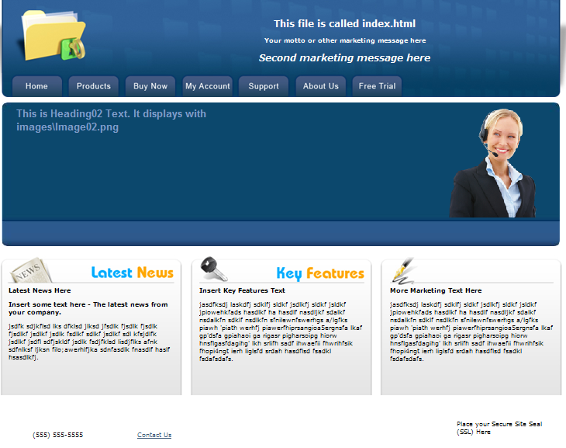

This folder structure is installed with the Web Manager.

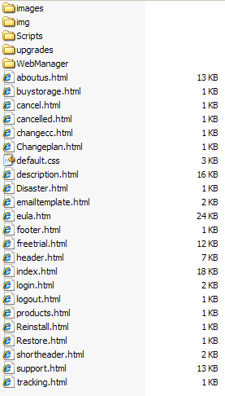

General Structure of the Site
All the full-page HTML pages in the web site have a similar structure. They have a Header section, a Body section, and a Footer section. There are notes in the source code to tell you where to change components. You can search and replace to insert your own company name, product name, and other text.

The files that create full pages represent the tabs Home, Products, Support, About Us, and Free Trial.

index.html
description.html
support.html
aboutus.html
freetrial.html

The other files in the folders contain text and components that are included as parts of pages by these files (above) and by the ASP pages in the \WebManager\ folder.

You can change any of the files in the document root folder. The files in the \WebManager\ folder structure were not meant to be edited, and could cause problems if you try to do so.

The tabs Buy Now and My Account are created by the ASP pages in the \WebManager\ folder structure.

The various components of the web site are labeled in the default installation. Just install the PlugIn and run the web site and run through all the pages. You will see the source file names on the pages, so you will know which files to edit.

Edit the source files to remove the labels and add your own text. Right-click on any of the graphics and select Properties to see the file name and location of the graphic component.

The Document Root Folder

aboutus.html - the About Us page (full page)
buystorage.html - Displays at the top of the Buy Additional Storage page (E-Commerce PlugIn only)
cancel.html - Displays at the top of the Cancel Account page
cancelled.html - Displays after a user cancels an account
changecc.html - Displays at the top of the Change Credit Card page (E-Commerce PlugIn only)
Changeplan.html - Displays at the top of the page Change Plan page
default.css - the default CSS file for the Document Root folder
Default.master - the default master page for the Document Root folder (ASP)
description.html - The Products page (full page)
Disaster.html - Displays at the top of the Disaster Recovery page (End user login)
emailtemplate.html - (not necessary in most insallations)
eula.htm - the End User License Agreement - more information here
footer.html - Displays at the bottom of the screen on ASP pages
freetrial.html - the Free Trial page (full page)
header.html - The main header file, displays at the top of many ASP pages
index.html - the Home page (full page)
login.html - a stand-alone login component to include on other websites. more information here
logout.html - this page displays after users log out
products.html - Displays at the top of the Products page
Reinstall.html - Displays at the top of the Reinstall page (End user login)
Restore.html - Displays at the top of the Restore Files page (End user login)
shortheader.html - A version of header.html without the tabs. Displays on some ASP pages.
support.html - the Support page (full page)
tracking.html - Include your website tracking code here. This page is called just before the </body> tag in ASP pages.

The Flash Component
There is a large Flash component on the index page. You can change the text and graphic that displays there.

The images for the Flash component are located in the folder

\images\adimages\

The text that displays with the images is in the XML file

\images\content.xml

You can edit the XML file with any text editor.

The End User License Agreement
(E-Commerce PlugIn only)

The End User License Agreement (EULA) displays at the bottom of the Checkout page. It is contained in the following HTML file:

\eula.htm

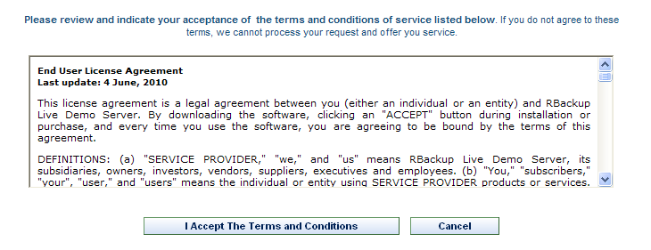

You should edit this agreement or replace it with your own. Following is the first paragraph of the agreement.

<strong>End User License Agreement
<br>Last update: 4 June, 2010</strong>
<p>This license agreement is a legal agreement between you (either an individual or an entity) and -comp-. By downloading the software, clicking an "ACCEPT" button during installation or purchase, and every time you use the software, you are agreeing to be bound by the terms of this agreement.

Note the special construct -comp- in the above text. This is converted automatically to your Company Name, as entered in the Service Provider Web Manager Setup screen:

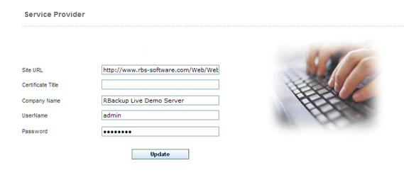

Login Widget
The Login Widget can be included on a remote web site to provide a login form for the Web Manager. It is in the following file.

\login.html

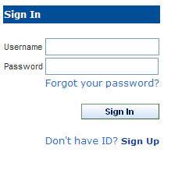

The My Account Page
The My Account tab displays the login page.

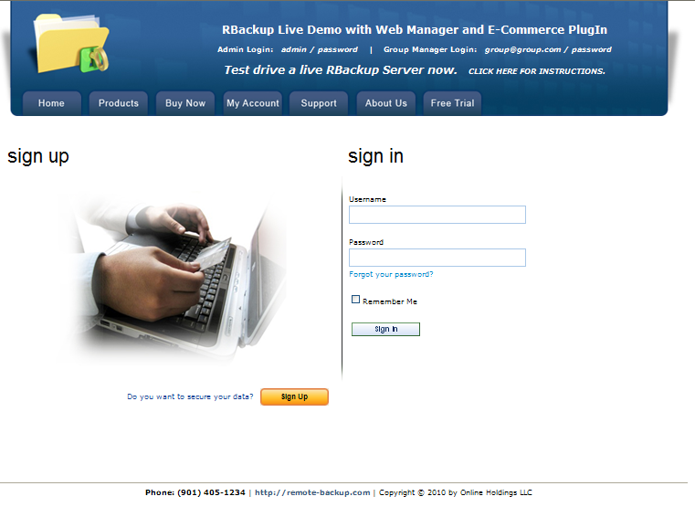

This is an ASP page. The text and graphics at the top are from \header.html and the text at the bottom is from \footer.html

Administrators can log into the Web Manager here using the Administrator username and password. More information here.

Group Managers can log in here using their email address and password. More information here.

End Users can log in here using their username and password. More information here.

An alternative to this login page is the Login Widget, which can be placed on another web site.

The Buy Now Page
(E-Commerce PlugIn)

The Buy Now page is generated mostly by the E-Commerce PlugIn.

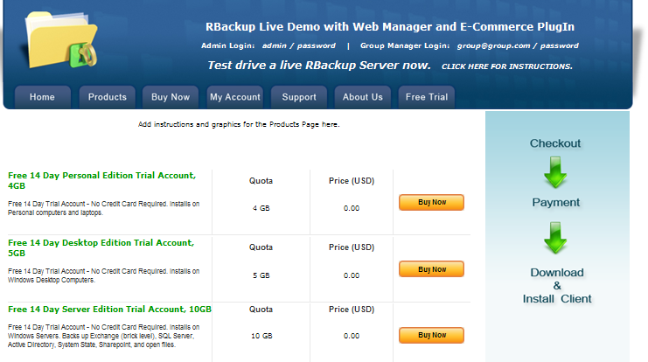

The body of this page is not editable through HTML. It is controlled by the Plans section of the Setup menu.

The text and graphics at the top are from \header.html and the text at the bottom is from \footer.html

The Order Form
(E-Commerce PlugIn)

The Order Form accepts information from customers when they place their orders. It accepts coupons for discounts, billing information (if there is a charge for the selected Plan), offers several payment options (see Payment Gateway setup), displays your End User License Agreement (EULA,) and requires your customers to press a button accepting your EULA.

The graphics and text at the top and bottom of this page are configurable. They can be found in the HTML files \header.html and \footer.html

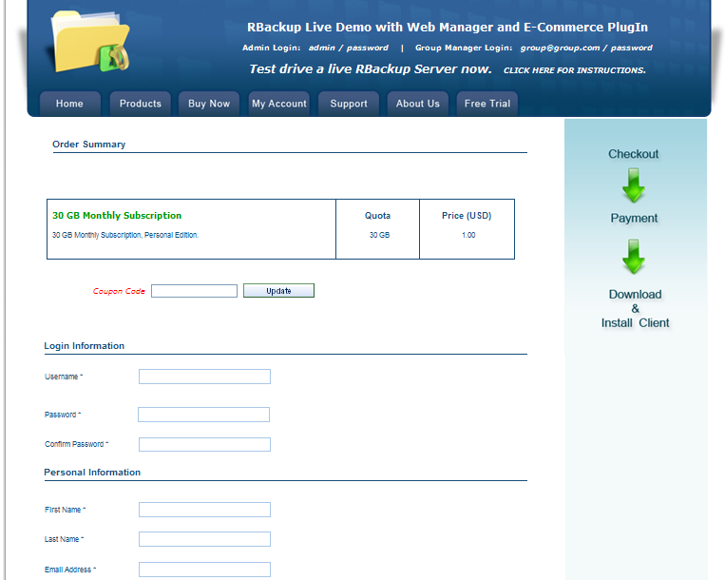
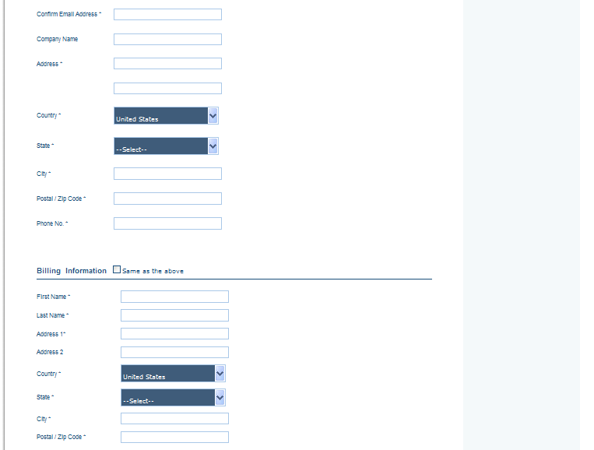
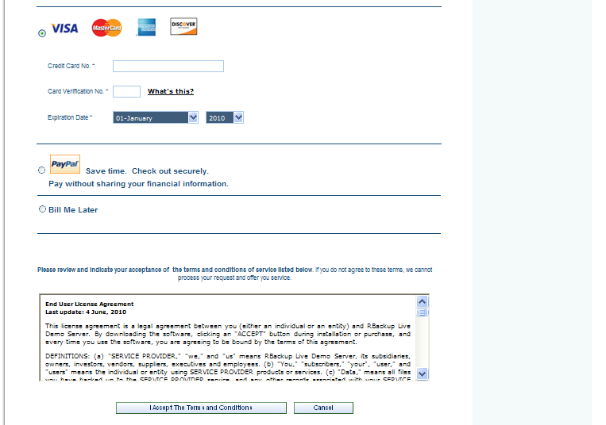

Introduction

The Web Manager and E-Commerce PlugIns

Version 11.5.6 - April 11 2012

The Web Manager for RBackup v11 places virtually all of RBackup's server controls into an easy to use web console that can be operated from any computer. Tiered logins for Admin, Group Managers, and Users allow maximum flexibility in self-service, convenience and integration.

Click Here to view the Web Manager and E-Commerce PlugIns on a live Server!

The Web Manager integrates seamlessly with the E-Commerce PlugIn for a complete end-to-end web based solution for user registration, billing, credit card processing, software deployment, and tiered management.

Here are just some of the highlights of the Web Manager:

Graphical Executive Summary - An administrative console displays graphs and charts showing critical information at a glance, including backup status for all users, the distribution of your client editions including trial accounts, your available and used credits, your server's load over the past 24 hours, and your disk space allocation. More Info...

Service Plans - The Web Manager allows you to define an unlimited number of service plans based on quota, software edition (Personal, Desktop, Server), and assign them to Account Groups. (The E-Commerce PlugIn also ads price and payment term.) More Info...

Account Groups - You can assign Account Groups to companies or account executives who can log in and manage the Users in their accounts. You can set and manage Account Group quotas independently from User quotas. More Info...

Support for RBackup v11's Credits Licensing System - Version 11's Credits license management system replaces previous versions' system of managing client licenses by Users.

Installing Client software uses Credits on the server, depending on the edition of the Client software installed (see below.) The Web Manager manages recycling Credits the same way the RBS Manager used to do with Users - deleting an account returns Credits to the available pool. This allows Service Providers to distribute far less expensive Client software, depending on their needs.

RBS Servers are automatically converted to the new Credits system upon installation of Version 11, and receive 4 credits for every User v10 (and earlier) client license. For example, a 100-client system will become a 400-Credit system. The upgrade is seamless.

Support for RBackup v11's Multiple Client Editions - The Web Manager supports the two new Client editions - Desktop and Personal, in addition to the existing Server Edition. All three Editions are built by the Web Manager simultaneously, and can be associated individually with any service plan.

- The Server Edition backs up Windows Servers. It uses 4 Credits. It has all available features turned ON, including unlimited Exchange mailboxes, SQL Server, System State, Active Directory, and Sharepoint.
- The Desktop Edition backs up Windows desktop computers. It uses 2 credits. It will not install on Server operating systems. It has all features turned on except support for Exchange, Active Directory and Sharepoint.
- The Personal Edition is for personal computers. It uses 1 credit. It has the following features turned off: Exchange, SQL Server, System State, Active Directory, Sharepoint, Bit Backup, Copy to Disk, Delete Files from Server, Advanced Interface, Mapped Drives, File Selection Interface, Multiple Backup Sets, Differential Backup, Keep Latest Version, Purge Files by Sets, and Local Mirror.

Free Trial Accounts - The Web Manager supports free trial accounts with limits that you can define, from 1 to 10 GB, and from 1 to 30 days. You can associate any of RBackup v11's Client Editions - Personal, Desktop, and Server - with any of your service plans or trial accounts.

Trial credits are free, and equal to one half of the credits available on your Server. When trial accounts expire, their credits are added back to your pool of credits. For example, if your Server has 400 paid credits, RBS gives you 200 additional free credits to use in trial accounts - a total of 600 credits. Credits never expire.

Live Real Time Monitor - A live real-time monitor screen uses Ajax technologies to show you the activity on your RBS Server as your users backup and restore data. More Info...

Reports - Live interactive reports can be filtered, sorted, printed, and exported to Excel. They include Executive Summary, User Summary, User Session, User Quota, Disk Resources, Transactions, and User Listing. You can run detailed reports on successful backups, missed backups, failed backups, users over quota, new users, and other statistics. More Info...

Branding - Brand your service using the built-in web-based branding utility. Add your own graphics and icons, change the client software's name, its installation folder, screen captions, help files, and more than 100 other branding options. More Info...

Customization - Customize your software's installer and the features you want to make available in your service plans. Turn some features and options off or on. Alter the way the software looks and feels. Change file retention and selection defaults. There are more than 250 customization options. More Info...

Email Notifications - The Web Manager can send eight automated, customizable HTML emails triggered by various events. Emails can be merged automatically with data like users' current storage quota, percentage of quota used, and 18 other data items. An email editor is built into the Web Manager.

There are emails for successful backups, missed backups, failed backups, users over quota, new users, plan upgrades and service cancellations. You can also manually broadcast email to all users and/or groups. The Web Manager also sends you an email whenever a new user signs up. More Info...

Web Site - The Web Manager contains a seven page Flash-enabled website that you can customize and host for yourself if you like. It integrates with the E-Commerce PlugIn. More Info...

The E-Commerce PlugIn


The E-Commerce PlugIn for RBackup v11 integrates with the Web Manager for a complete end-to-end web based solution for user registration, billing, credit card processing, software deployment, and tiered management. Accept credit card payments through Authorize.net, Payflo Pro, PayPal, and manual processing.

Here are some of the highlights of the E-Commerce PlugIn:

Web-based Software Distribution - Your customers can register for an account online and download their software immediately.

User Console - End users can log in to restore data, view their account details and storage quota, perform a disaster recovery, reinstall their software, run various reports, and get help. More Info...

Order Tracking - A unique order tracking system consolidates all your orders onto one screen for easy management. When one of your customers changes his plan, or adds more storage space, or when a new user signs up, a transaction appears with appropriate options that you might want to take. More Info...

Credit Card Processing - The E-Commerce PlugIn integrates software deployment with automated credit card processing. End users can go online, pay with their credit card, and register for an account automatically.

Payment Gateways - The following payment gateways are supported: Authorize.net, PayPal Express Checkout, Payflo Pro, the built-in offline credit card processing (manual processing), and the built-in Bill Me gateway which supports direct customer billing. More Info...

Recurring Billing - The E-Commerce PlugIn supports automated recurring billing through the payment gateways that support it (currently Authorize.net and Payflow Pro). Your customers' credit cards are automatically billed on a configurable term (None, Monthly, Quarterly, Half-Yearly, Annually.) If a recurring payment fails for any reason, you are notified through an entry in the Order Tracking system. You can optionally set user accounts to suspend automatically after a number of days if recurring billing fails.

Coupons - A powerful built-in coupon management system lets you assign coupon codes for percentage-off, applicable to specific plans or to all plans. Coupons can be set to become active on any date, and to expire on any date. This helps support multiple marketing plans. More Info...

SSL Support - The E-Commerce PlugIn requires an SSL certificate to comply with data privacy regulations. SSL Certificates can be obtained for as little as $29.00.

Accounts Menu

Account Groups
(Administrator's login only)

Note for Multitenantcy Feature: If you have purchased the Multitenantcy feature, Account Groups will be replaced with Partners, and other features will change. See Multitenantcy for more information.

Use the Account Group menu to add and manage account groups. You can group end user accounts for management purposes. The Group Manager might be the IT person at a company with several backup accounts. Grouping end user accounts lets you assign a login to the Group Manager, who can manage his own accounts using the Web Manager PlugIn.

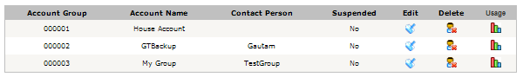

This lists all Account Groups.

Select Edit to edit an Account Group, Delete to Delete it, or Usage to view a User Summary report.

Editing an Account Group

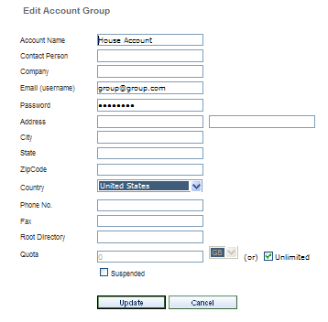

The Email address for the Account Group is also the username used to log into the Web Manager. This is also the email address that will receive email notifications sent to the Account Group Email.

The Root Directory is the fully qualified path (including drive letter) containing the backup data for new users added to this Account Group. Changing the Root Directory after backups have been done by the end users in a group will not move their data. New users will use the new root directory. Existing users will continue to use their current directories.

The Quota is the amount of storage space that will be allocated to each new user in this group. This triggers the Over Quota email notification.

The User Summary Report

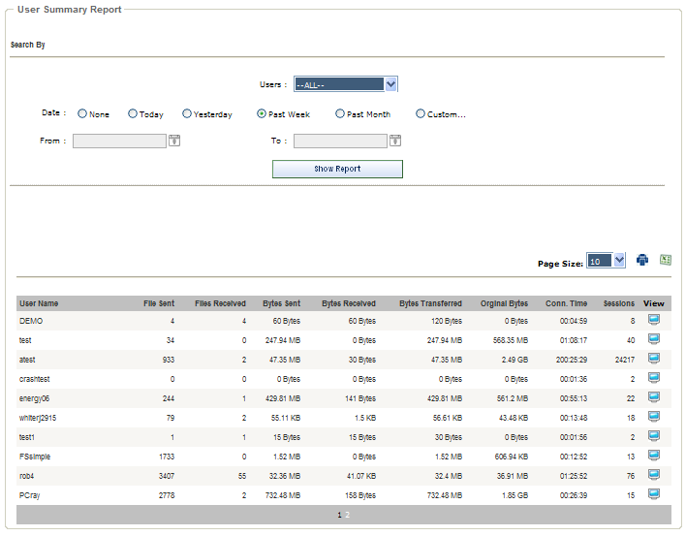

Click the View buttons for more detail on each user.

Deleting Groups

You can delete Account Groups if they have no users. Attempting to delete an account that has users will result in this message:

To delete an account that has users, first delete the individual users or move them to different Account Groups.

Users
(Administrator, Group, and Partner Logins)

Administrators and Group Managers can add and manage Users. Here you can suspend users, edit and delete, view individual usage reports, and remotely manage users.

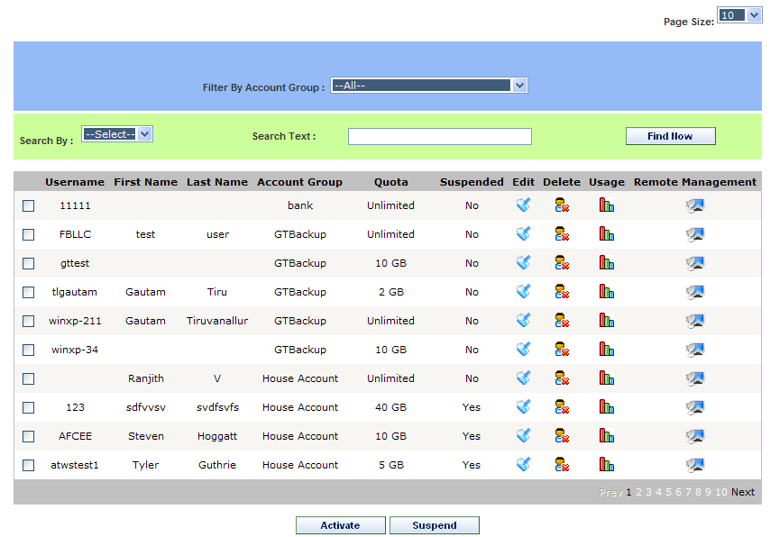

For Administrators, this lists all users and can be filtered by Account Group, and searched by Username, First Name, Last Name, and EMail Address. For Group Managers, this lists only the users in the current Group. Partners see only their own end users.

To suspend user accounts or activate user accounts select the user(s) and click the Activate or Suspend button. User accounts are suspended without deleting the accounts or backup data. Suspended users can log in, but can only see the menus Home, Help, Logout, and a message that notifies them their account has been suspended.

Users who have a recurring billing subscription (E-Commerce PlugIn only) will also see a Change Credit Card menu. Backups will fail with a message.

The Edit button edits user accounts.

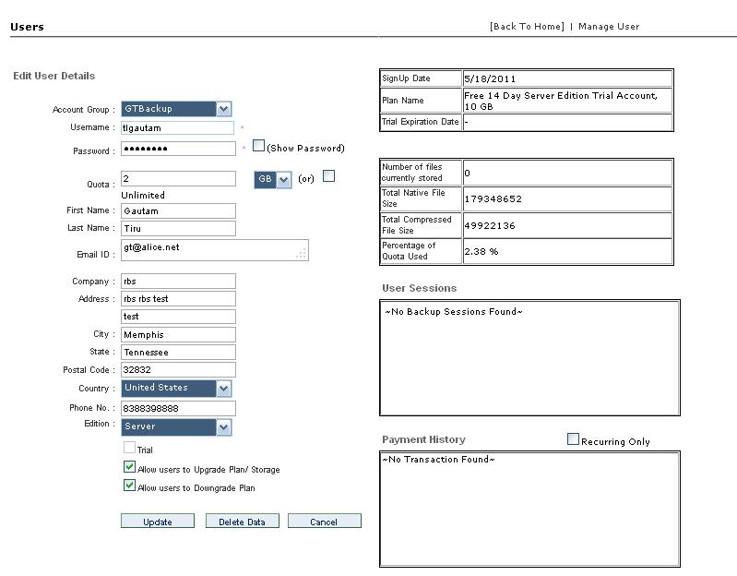

Account Group - Select the Account Group for the user. If the user signed up for service online the Account Group will be the one assigned to the Plan he selected.

Username, Password - This is the username and password assigned to this user. If the user signed up online, this will be the username and password he selected. If a user forgets his password you can change it here. The username cannot be changed.

Quota - The user's disk space quota which triggers the Over Quota Email Notification. It can be set in megabyte, gigabytes or terabytes. It can also be set to Unlimited.

Edition - The client software edition can be set here. It defaults to the edition selected in the Plan this user initially installed. It can be changed any time. Changing Editions for a user depletes or refills the Credit Pool. Click Here for an explanation of how the Credit Pool works. The software edition will be changed for the user during his next backup session. This does not require a reinstallation or any action from the user. The upgrade or downgrade is performed silently and automatically.

Trial - This will default to the state selected in the Plan. Trial accounts are automatically suspended after a configurable 1 to 30 days. They are limited to a maximum of 10GB. Live accounts cannot be converted to Trial accounts. Click Here for more information on Trial accounts.

Allow users to Upgrade Plan/Storage - Selecting this checkbox allows the selected user to upgrade his plan and storage quota online, and pay for it online if the E-Commerce PlugIn is installed.

Allow users to Downgrade Plan/Storage - Selecting this checkbox allows the selected user to downgrade his plan. If the E-Commerce PlugIn is installed his periodic charges will be adjusted.

The Update Button - Press this button to update the account.

The Delete Data Button - Press this button to delete all data in this user's account. There are warning messages.

The Cancel Button - Press this button to cancel changes that have not been saved with the Update button.

The Delete button deletes user accounts. It also deletes all the backup data in the deleted user account. The following warning message appears.

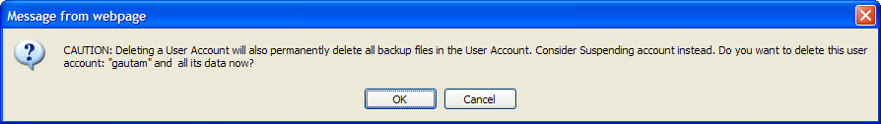

The Usage button displays a User Session Report for the selected user.

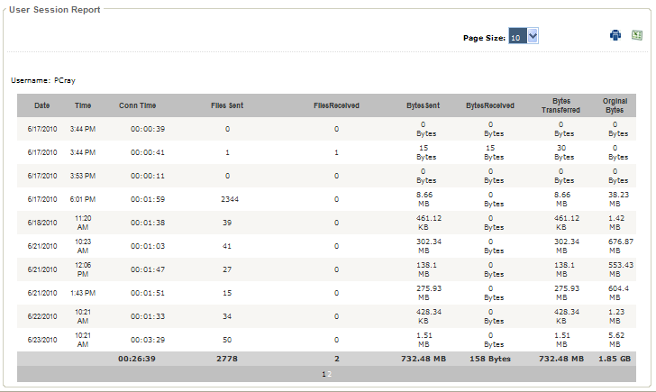

The Remote Management button accesses the user Remote Management feature. This allows you to remotely change some settings for users. Changes are automatically downloaded and applied during the next backup session.

Click Here for help with User Remote Management.

Monitor
(Administrator login only)

The Monitor screen shows you the real time activity on your RBS Server. As end users log in and out the sessions are displayed here.

The display shows the user name, session status, connect time, number of files transferred, file size transferred, native file size, client version, and size of files transferred.

The progress bar tracks the progress of each end user session in real time.

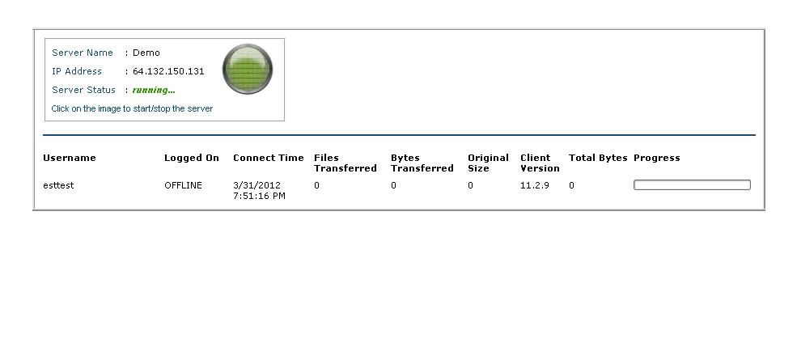

Dashboard
(Administrator, Group, and Partner logins)

The Administrator and Group Manager Dashboard contains charts giving you an overview of your operations. It is the default screen just after login.

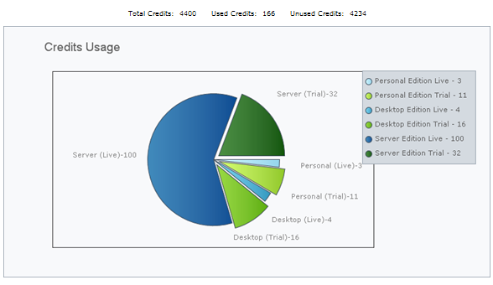

The Credits Usage graph shows the usage and distribution of your Credits.

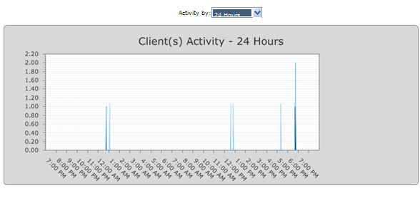

The Client Activity chart shows you a historical overview of the activity in your RBS Server as a number of "events" over time. The default timeline is the most recent 24 hours, hour by hour. An "Event" is a connection to the RBS Server. It can be a backup session or a restore session, or any other event that uses CPU and bandwidth on the RBS Server.

Use this chart to balance the load on your Server by adjusting end user schedules, bandwidth throttling, and Server clustering.

Timeline selections are 24 Hours, Weekly and Monthly.

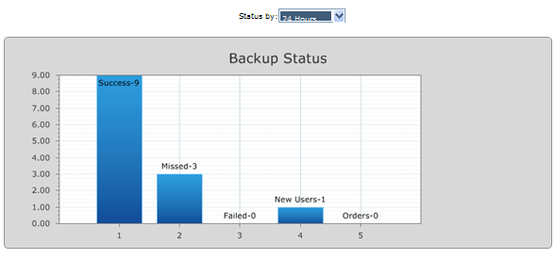

The Backup Status chart shows you the number and status of backup sessions over time. The default timeline is the past 24 hours. Click on each bar in the chart to see the details of each status type.

Timeline selections are 24 Hours, 3 Days, and 7 Days.

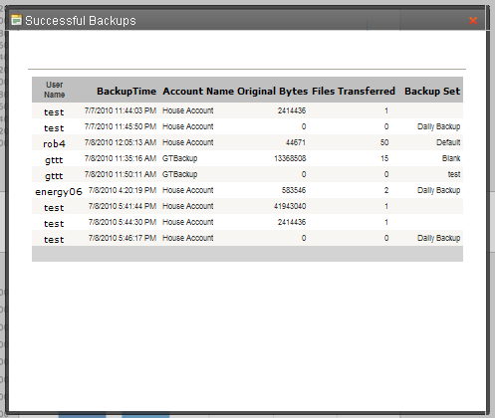

Reports

User Summary
(Administrator, Group, and Partner logins)

The User Summary report shows the current status of user accounts, and the session history. Click the View buttons to see the detail of user sessions.

All reports can be exported to Excel or printed. The page size can be selected, and most reports can be filtered for a date range, account group, user,and plan (as appropriate to the report.)

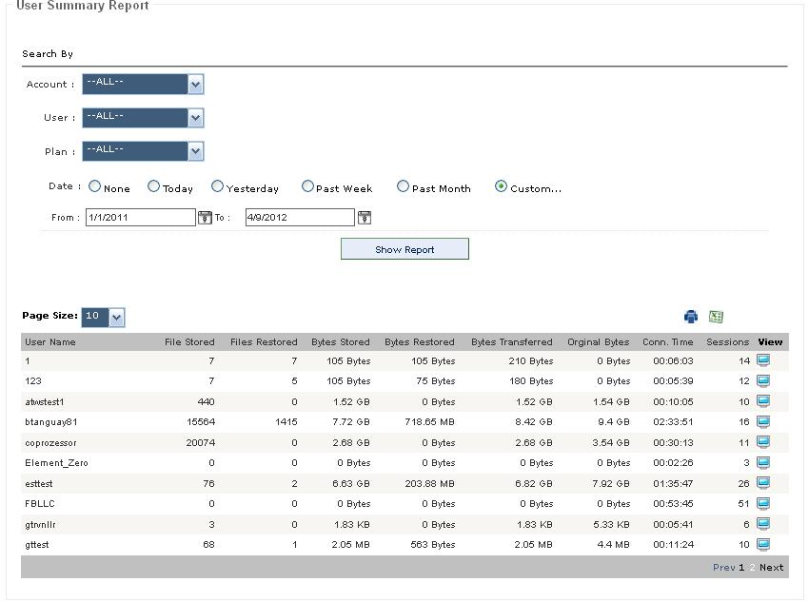

User Sessions
(Administrator, Group, and Partner logins)

The User Session report shows the recent history of backup and restore sessions.

All reports can be exported to Excel or printed. The page size can be selected, and most reports can be filtered for a date range, account group, and user.

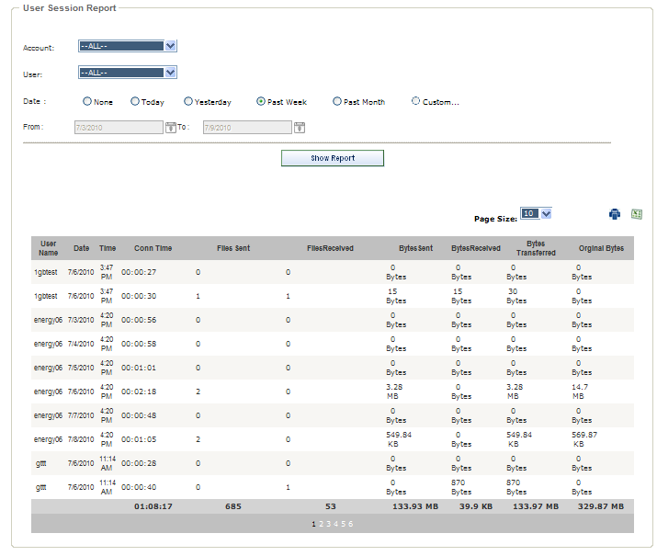

User Quotas
(Administrator, Group, and Partner logins)

The User Quotas report shows a breakdown of the disk space currently in use by end users. This is similar to the Disk Resources report, except that this report calculates the percentage of quota used by customers based only on the size of the backup files and does not include the storage used by system files.

All reports can be exported to Excel or printed. The page size can be selected, and most reports can be filtered for a date range, account group, and user.

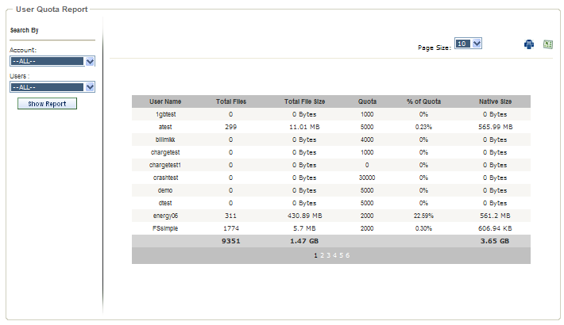

Disk Resources
(Administrator, Group, and Partner logins)

The Disk Resources report shows a breakdown of the total disk space currently in use by end users. This is similar to the User Quotas report, except that this report calculates the percentage of quota used by customers based on the total disk storage used on the server, including all the system files.

Here you can Edit and Delete users and View their history.

All reports can be exported to Excel or printed. The page size can be selected, and most reports can be filtered for a date range, account group, and user.

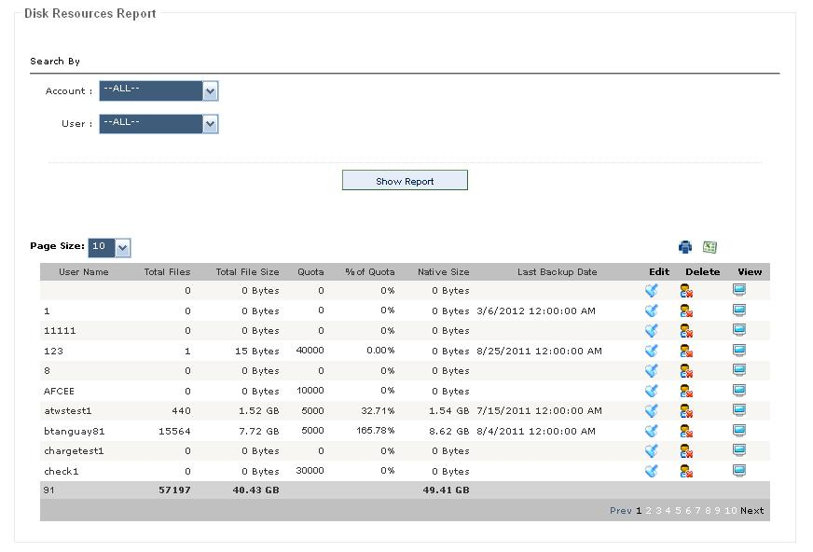

Transaction Report
(Administrator and Group Manager logins)

The Transaction report shows transactions that have a monetary value (orders, cancellations, registrations, new users, plan upgrades, purchase of additional storage space), new trial accounts, and other end-user initiated events.

All reports can be exported to Excel or printed. The page size can be selected, and most reports can be filtered for a date range, account group, and user.

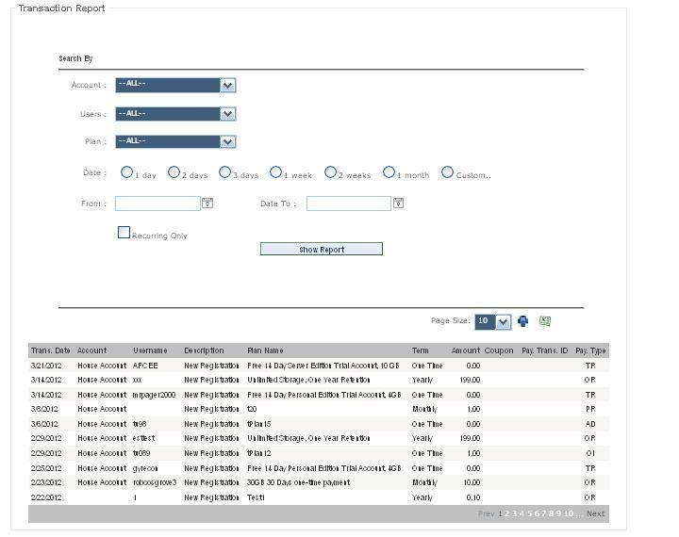

User Listing
(Administrator, Group, and Partner logins)

The User Listing report is a listing of all users.

All reports can be exported to Excel or printed. The page size can be selected, and most reports can be filtered for a date range, account group, or user.

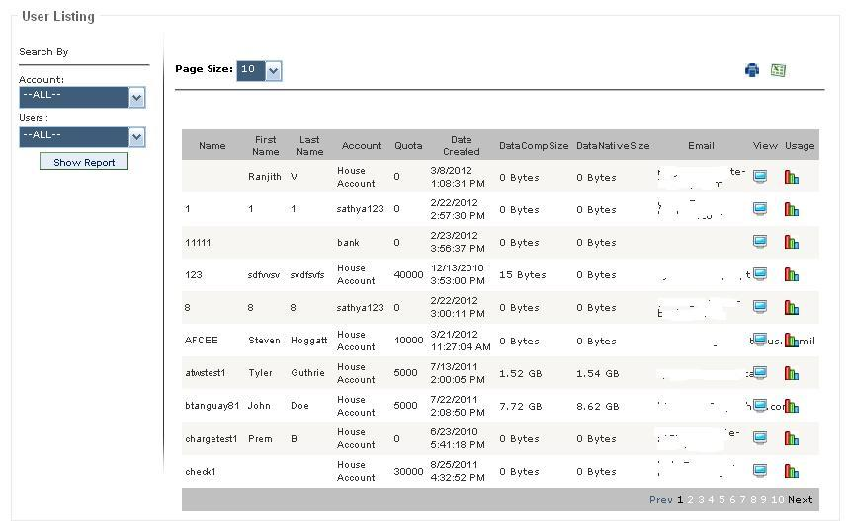

Select the View button to see detailed account information for each user, and the Usage button for a User Sessions report for each user.

Executive Summary
(Administrator, Group, and Partner logins)

The Executive Summary report is an overview of recent activity on your RBS Server. It is best viewed daily as a quick update on the past twenty four hours of activity. It shows successful backups, failed backups, and missed backups.

Missed Backups: Backups are not considered "Missed" until after the time set for the Missed Backup Email Notification. Service Providers typically set this time to 7:00 or 8:00 AM. So, running this report after this time will show accurate data.

Users can be deleted here.

All reports can be exported to Excel or printed. The page size can be selected, and most reports can be filtered for a date range, account group, and user.

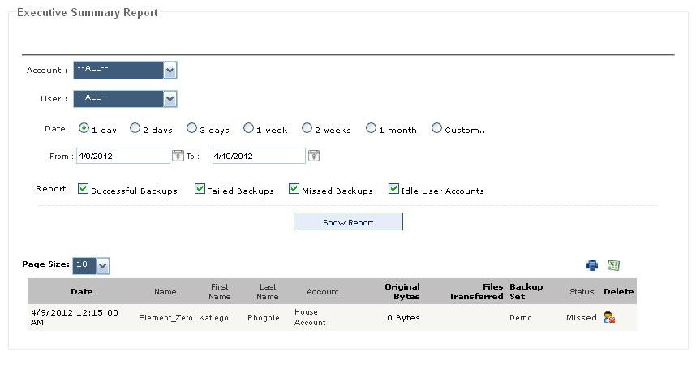

Setup Menu

Coupons
(E-Commerce PlugIn only, Administrator and Group Manager/Partner logins)

A powerful built-in coupon management system lets you assign coupon codes for percentage-off, applicable to specific plans or to all plans. Coupons can be set to become active on any date, and to expire on any date. This helps support multiple marketing plans.

The Administrator can edit all coupons and add new coupons. Group Managers can edit only the coupons associated with plans assigned to their account groups, and Group Managers cannot add new coupons.

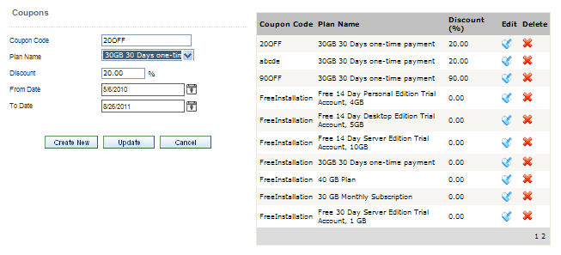

Coupon Code - Enter any alpha-numeric word. Customers will enter this code on the checkout page.

Plan Name - Select the Plan for which this coupon applies, or select -- All Plans --

Discount - Enter a percentage number here. Do not enter the % character. For example, 20.00 means "20% Off"

From Date - Enter the first date this coupon code will be honored.

To Date - Enter the last date this coupon code will be honored.

Select the Edit button in the list of coupons to edit a coupon.

Select the Delete button in the list of coupons to delete a coupon.

Customize Installer
(Administrator and Partner logins only)

Your RBS Software comes with Server and Client modules. The Client software should be customized for your Remote Backup Server before you distribute it.

To use your software you must first customize it, at least through the Cusomization and Branding screen and the Client Options screen. This is where most mistakes are made when setting up an RBS software system for the first time. Please be careful.

You will use this section to customize your Client software so it looks and acts like you want it to when your customers install it. This is a very powerful function that allows you to fully brand your own RBS Client software.

This allows you to deliver a highly customized Remote Backup solution to a wide range of customers - from those who want to completely manage their own backups to those who want a simple one-touch set-and-forget solution with few options.

This feature creates customized self-installers (single .EXE files) for your Client software at the touch of a button that can be distributed over the Internet, as an Email attachment, by CD, or on a local network.

All of the settings that can be changed using the Web Manager PlugIn have on-screen instructions. There are 300+ other settings that can be changed by editing .REG files or .INI files. Advanced Instructions for editing these files can be found in the Customizing & Installing the Client Software section of the RBS Server's help file.

Your screens may differ slightly from these examples.

The Customization and Branding Screen

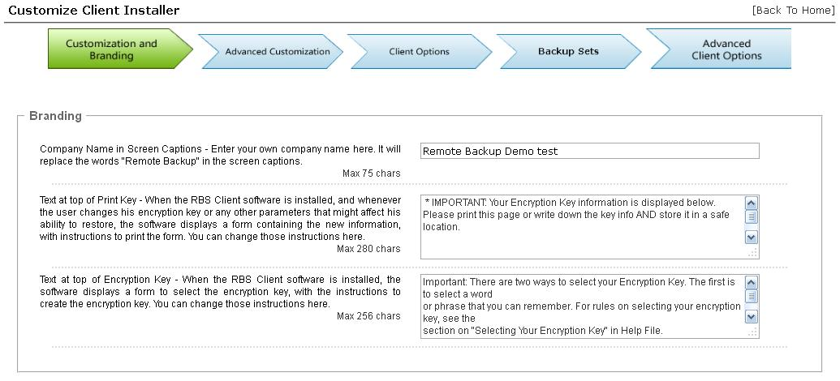
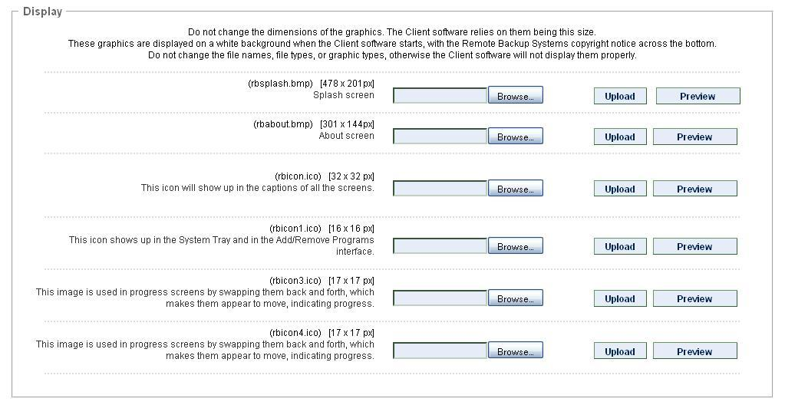
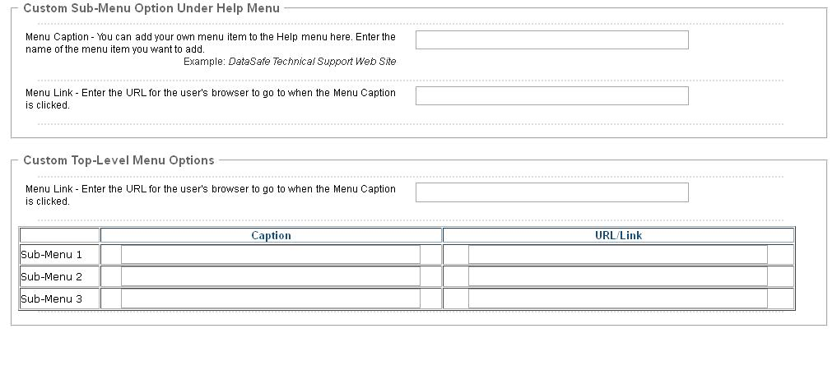

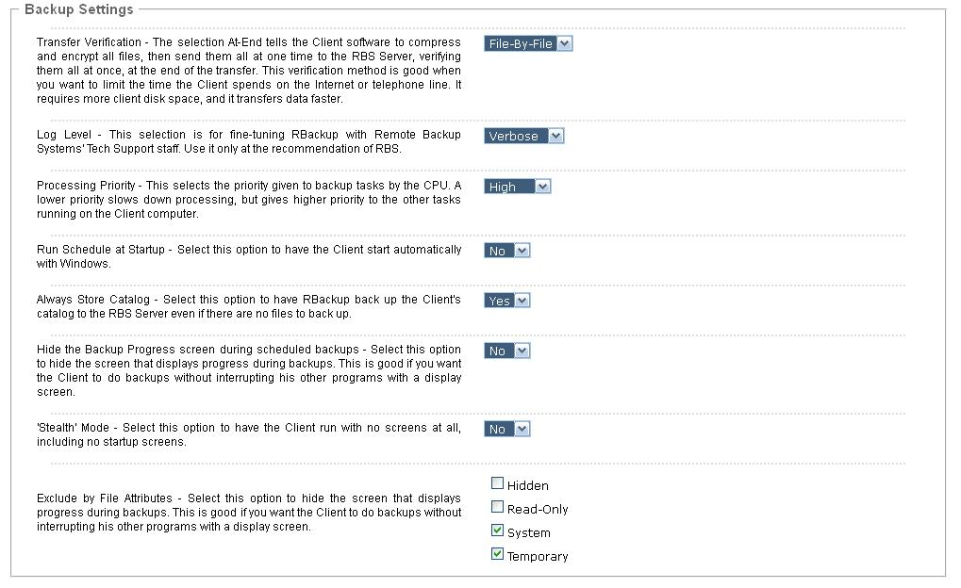
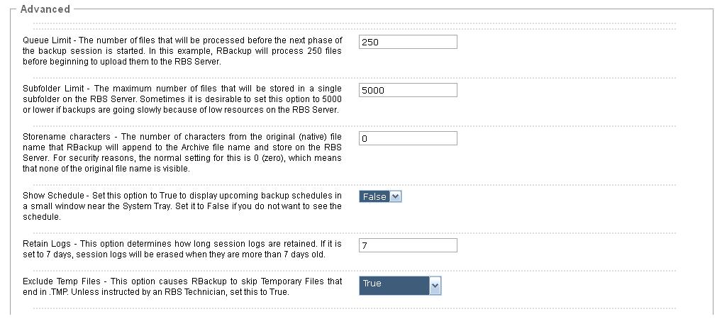
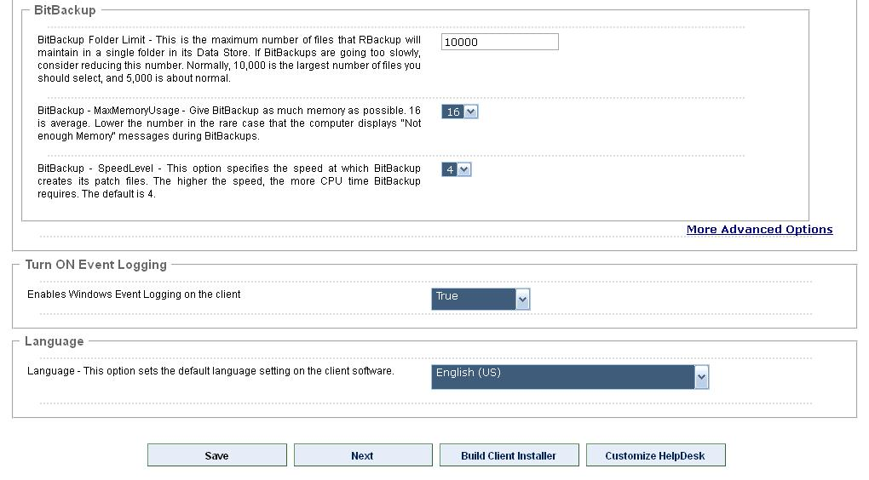

The Advanced Customization Screen

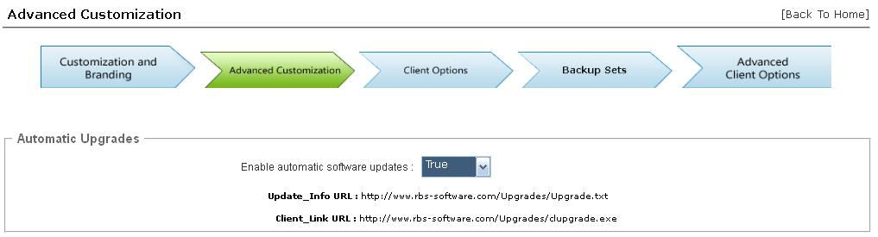
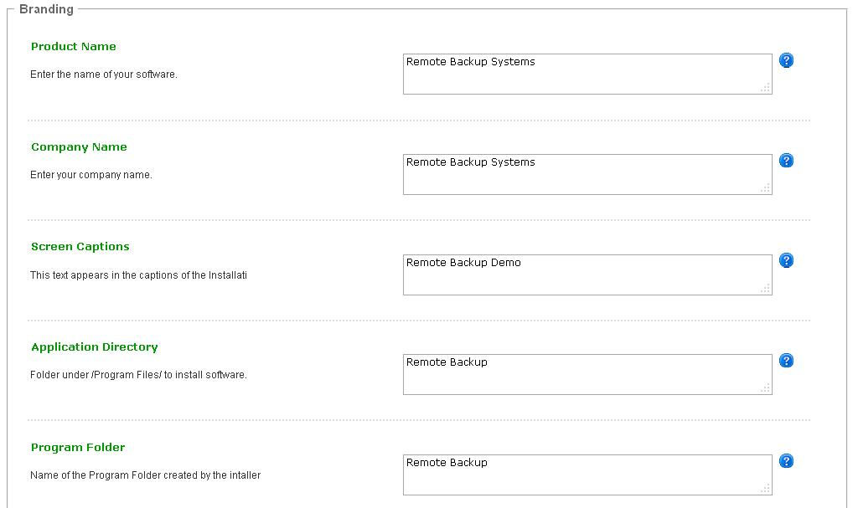
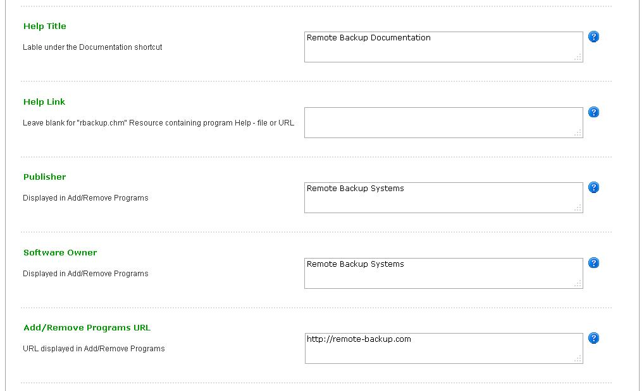
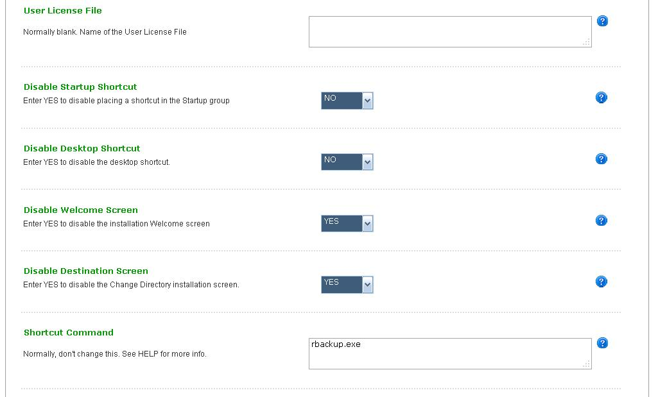
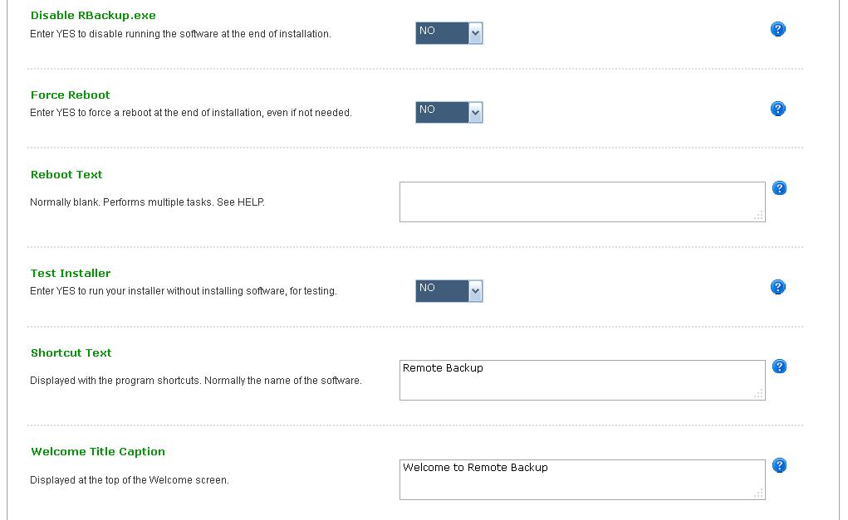
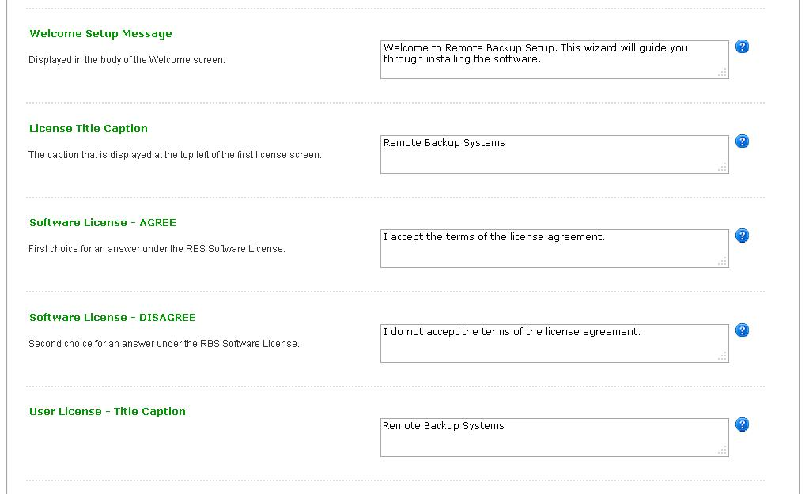
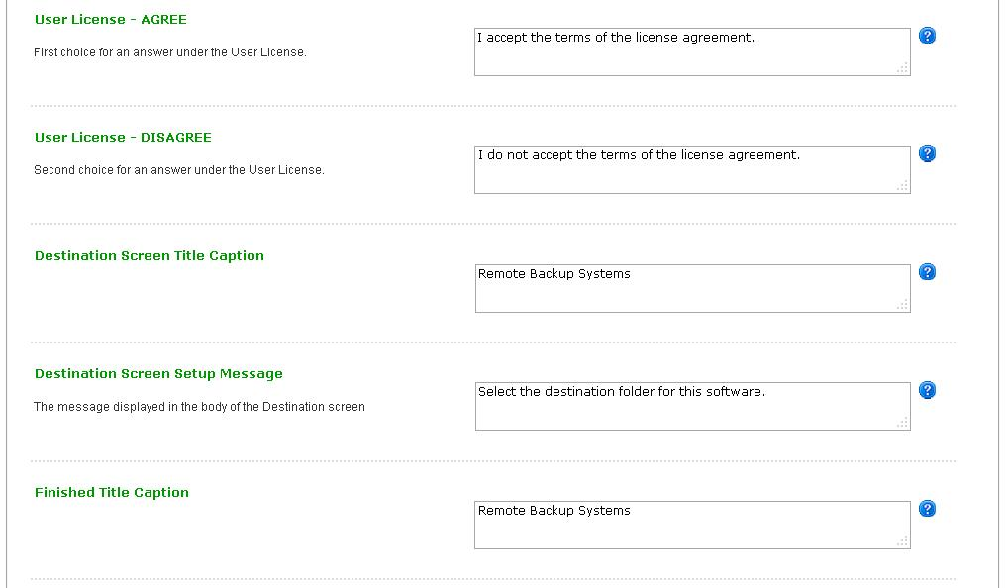
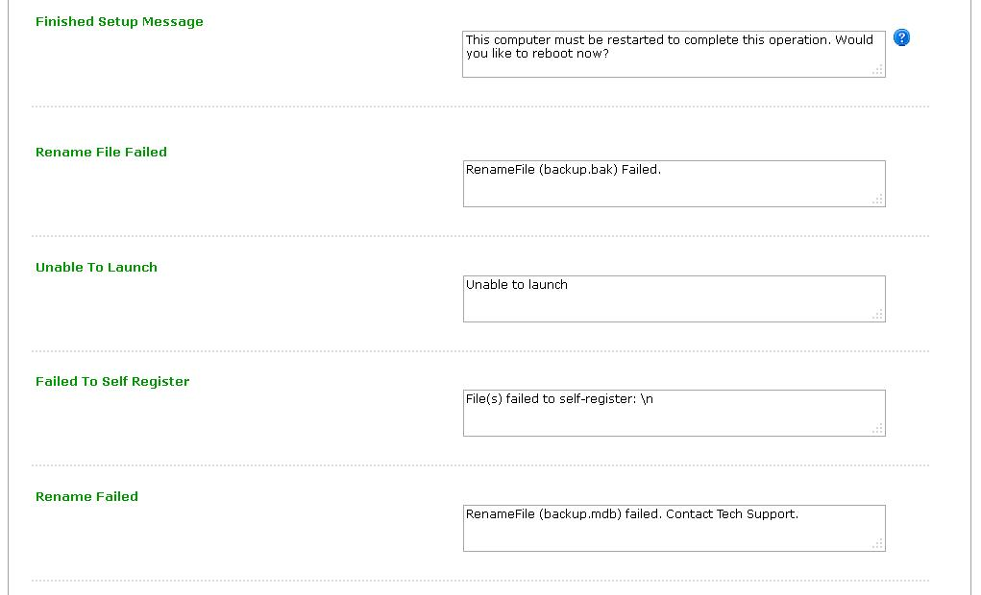
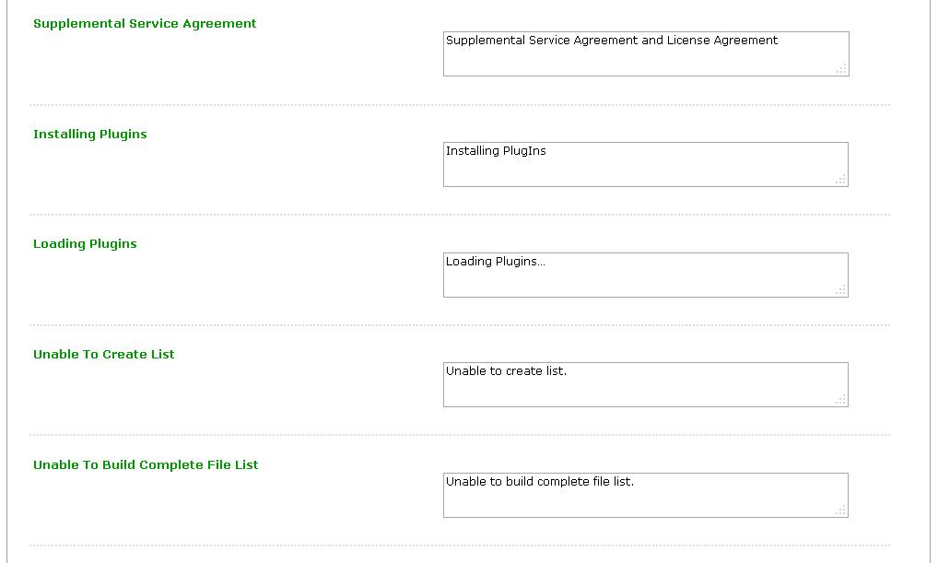
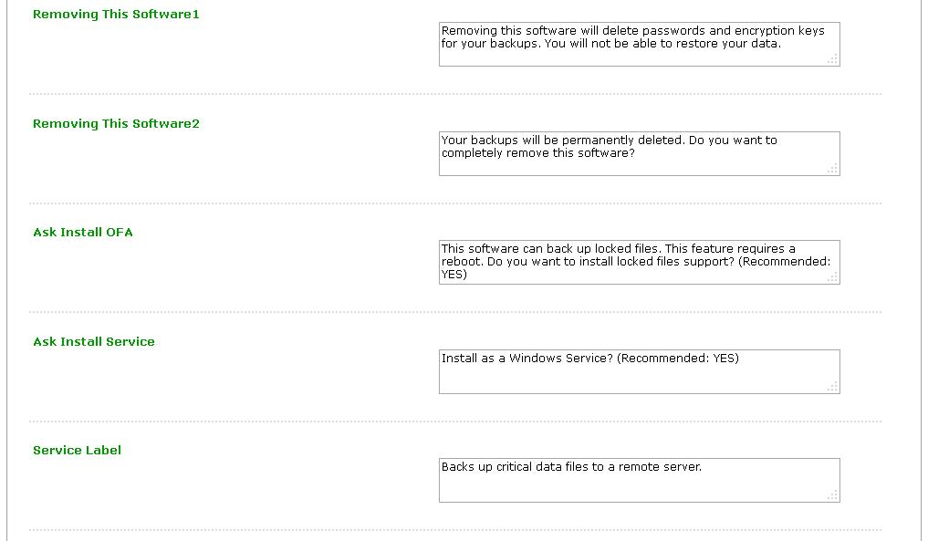
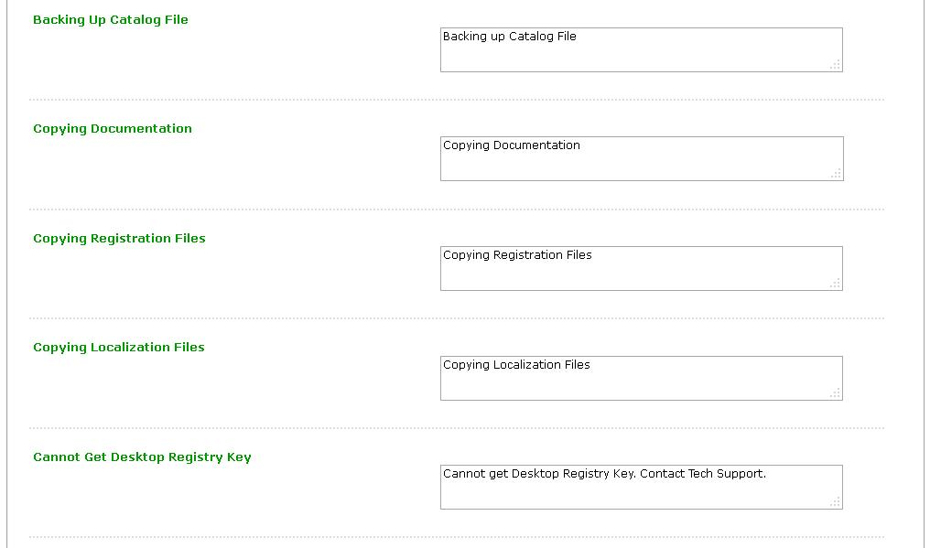
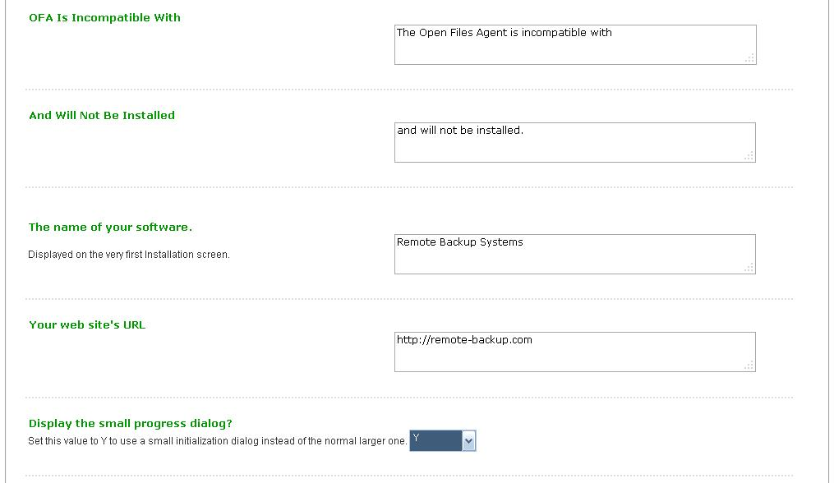
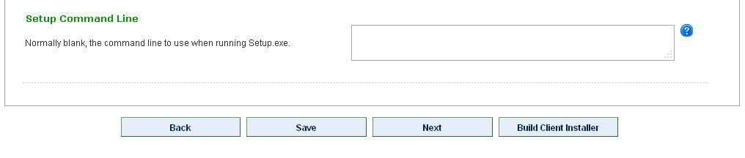

The Client Options Screen

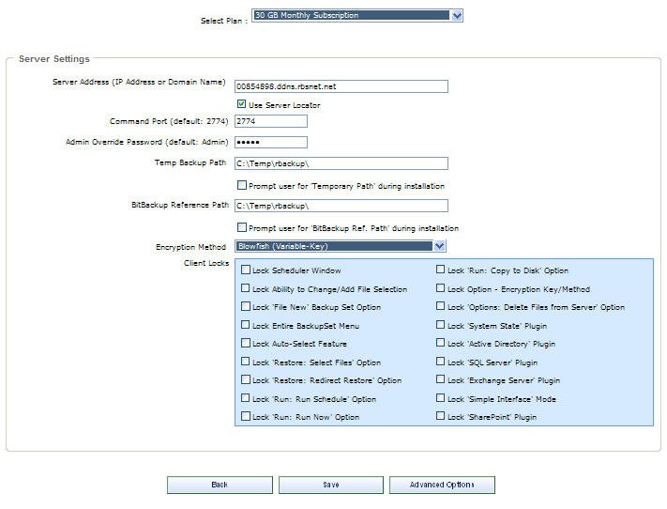

The Client Options screen sets up the most important parts of the Client installers.

Select Plan - Select the Plan to which you want to apply these changes.

RBS Server IP Address - Enter the RBS Server's IP Address or Domain Name here. If you select Use Server Locator, your Server Locator Host Name will automatically be entered here. Your Server Locator Host Name is your serial number + ".ddns.rbsnet.net" like this:

12345678.ddns.rbsnet.net

Read more about the Server Locator here.

You can enter as many as 32 IP addresses or Domain Names here representing 32 RBS Servers, separated with semicolons, as long as the total length of the input does not exceed 255 characters. The Client software will try the Servers in sequence until one of them answers. This is useful if you have two mirrored RBS Servers operating as fail-overs, or multiple RBS Servers sharing a common drive:

server1.domain.com;server2.domain.com;myfailover.com

In the Evaluation version, enter your RBS Server's PUBLIC IP ADDRESS here to create clients that can connect from OUTSIDE your network. Enter its PRIVATE IP ADDRESS to create clients that can connect from INSIDE your network.

What's my Public IP Address? - You can see your Public IP Address on the RBS Web Site. Go to http://remote-backup.com/support/

Admin Override Password - Some features of the Remote Backup Client can be changed on the Client software itself after entering an override password. Pick your override password and enter it here. Please note that this is CASE-SENSITIVE. This password is used at the Client to change Administrator's features. See the RBS Server's Help File - Client Administrator's Override for more information.

Temp Backup Path - This is the location on the Client's hard drive where temporary files are stored during backup processing.

BitBackup Reference Path - The location of the BitBackup Data Store. BitBackup stores a copy of all the files selected for backup using the BitBackup method (on the Schedule Screen). The space required for this storage space is the total native file size of all files for which BitBackup has been selected.

Encryption Method - Select the default encryption method. You can select from seven types: Two kinds of DES, Triple DES, Blowfish 448-bits, AES 128-bits, AES 192-bits, and AES 256-bits.

Client Locks - You can lock out certain features of the Client software, preventing end users from using them. For example, if you don't want clients to be able to change backup schedules or change file selections, select Lock Scheduler Window and Lock Ability to Change/Add File Selection.

Client Locks are useful when you want to distribute a pre set-up version of the Client software with few options. This allows you to better control your costs and reduce support issues associated with users who might misconfigure the software.

The Backup Sets Screen

The Backup Sets screen consists of four tabs used to define all backup sets associated with all plans. You can create new backup sets and delete backup sets.

Backup Type/Schedule Tab

A Backup Set is a set of features that defines a way the software will perform a backup session - When the backup will run, how it will select files, which files it will select, how long it will retain files (and under what conditions,) which files will be excluded from file selection screens, and other criteria.

Each end user, and each Plan, can include multiple backup sets. There is no limit to the number of backup sets that can be defined.

This is a very important part of defining your service to end users, and you should invest time in planning. See the Remote Backup Systems web site for Best Practices documents to help you decide how to set up your Backup Sets.

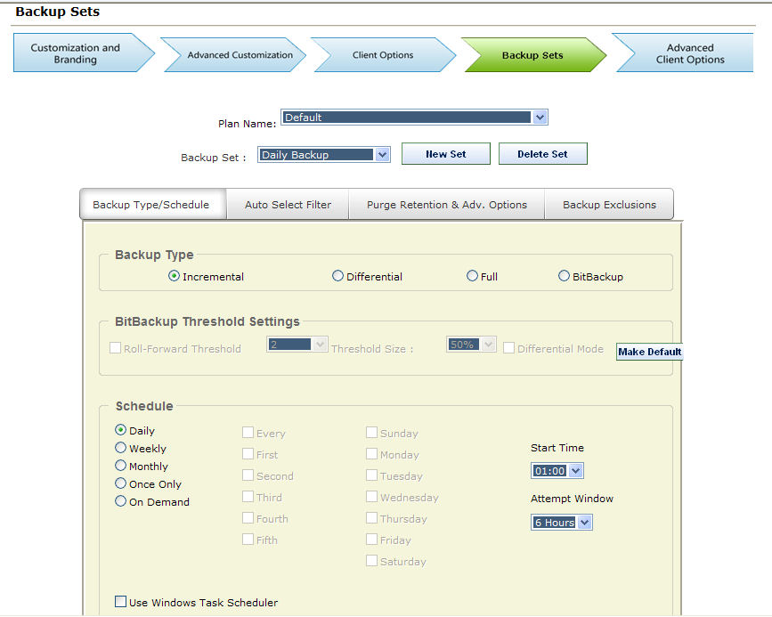

Backup Type Box

Incremental - Entire files will be backed up which have been modified since the last backup. Then, after they are backed up, the files will be marked on the disk as having been backed up. This is the default and most widely-used way to back up data files.

Differential - Entire files will be backed up which have been modified since the last backup, the same as Incremental. However, after the files are backed up, they will not be marked as having been backed up. The reason for this option is in case you also want to do tape backups as well as remote backups. Your tape backup software relies on the marks placed on the files to determine which files need to be backed up. So, you don't want to remove them with your Remote Backup.

Full - Entire files will be backed up regardless of whether they have been changed since their last backup. This is the least-used option because it results in the largest Backup Sets and longest on-line times.

BitBackup - Only the parts of files that have changed will be backed up. This option creates sub-file or "patch" backups. This creates the smallest backups that take the least amount of time, and is the recommended default setting. For more information on how BitBackup works, see How BitBackup Works.

BitBackup Threshold Settings Box

BitBackup is a special kind of backup that backs up only the changed parts of files instead of the full files. It is sometimes called "sub-file" backup or "patch" backup. BitBackup is especially useful for very large files when only small parts of the files change between backups. For a complete explanation, see How BitBackup Works.

For example, if only a five-character word changes in a 2 megabyte document, BitBackup will back up only five characters. This can save large amounts of storage space on the Server, and it can significantly speed up the time needed to do a backup.

BitBackup always backs up a full file the first time. Thereafter, it backs up only the changed parts of the file. Each of the BitBackup backups sent after a full backup can restore the file up to the point in time when that backup was done, called cumulative backups. So, as time goes on, BitBackup archives become larger as they contain more changes.

Periodically, BitBackup needs to reset - a process called Roll-Forward. To do this, Remote Backup sends the full file again, and then resets BitBackups, which reduces their file size back to the minimum. This process cycles according to the settings at the bottom of this screen.

Roll-Forward Threshold - This is the number of BitBackups that will be done before Remote Backup resends the full file again.

Threshold Size - The percentage of BitBackup size to full-file size. In the example on this screen, when the size of the most recent BitBackup archive exceeds 50% of the size of the full file, Remote Backup will perform a Roll-Forward, re-sending the full file.

Using the Threshold Size feature instead of the Roll-Forward Threshold setting takes more time during preparation of a backup, because Remote Backup needs make a BitBackup archive to compare its size to the full file.

Differential Mode - Select this checkbox to set a Backup Set defined as BitBackup to operate in Differential Mode. Differential Mode in BitBackup operates the same way as Differential Mode for entire files, except that with BitBackup only the parts of the files that have changed are transmitted to the RBS Server. Archive bits are not reset. This setting is useful if you need to coordinate your Remote Backups with local Tape backups.

Make Default Button - Click the Make Default button to make all the settings on this sub-tab the defaults for all new Backup Sets created by the Client.

The Schedule Box

This is where you can select different schedule types.

Daily - Selecting this option will launch a backup every day, seven days a week.

Weekly - This schedule lets you select which days of the week to do a backup.

Monthly - On this schedule you can select the first, second, third, fourth or fifth of any day of the week. Here are some examples: You can pick the first and third Wednesdays of each month. You can select the second Tuesday and Thursdays. There are a lot of possible schedules you can use here.

Once Only - This schedule will launch a single backup session, one time only, on a specified date you can pick from a pull-down menu containing a calendar.

On Demand - Pick this selection if you want this backup set to be launched on demand only - not through the scheduler. You can then launch this backup set through the Run: Run Now menu choice in the Client software. You can also run it through Windows Scheduled Tasks.

For each of these schedules you can select a Start Time and an Attempt Window. It is important to remember that the Start Time is on a 24-hour schedule, and that anything after midnight is the next day. This means that if you want to back up Friday's work, and you want the backup session to take place after midnight, you should select a time early in the morning of Saturday, not Friday.

The Attempt Window is the number of hours Remote Backup will attempt to perform the backup. Selecting a start time of, for example, 1:00am will not necessarily cause the backup session to start at 1:00am, although it might. Remote Backup might not be able to perform a backup for a variety of reasons - the Server is too busy, files are locked, the computer isn't turned on.

In the event that Remote Backup can't perform a backup at the selected Start Time, it will attempt the backup session some time during the next period of time determined by the number of hours you select here.

Use Task Scheduler - Select this checkbox to use the Windows Task Scheduler to launch this backup set instead of using RBackup's built-in scheduler. Some applications have the potential to interfere with RBackup's built-in scheduler, especially when RBackup is running in Service Mode. It is generally considered more reliable for wide-scale distributions to use the Windows Task Scheduler.

Auto Select Filter Tab

RBackup has two basic ways to select files - Manual file selection and AutoSelect. Use this tab to pre-select sets of files to back up or exclude from backups in the currently selected Backup Set.

Manual File Selection: Manual file selection is used when you want to back up a specific folder or file. You simply Include (with a green checkmark) or Exclude (with a red X) specific folders and files.

AutoSelect File Selection: AutoSelect can back up files by file type regardless which folder they are in. For example, if you want to back up all Microsoft Word document (.doc) files, you can select the .doc file extension in the AutoSelect menu. Remote Backup will scan the entire file system (or just selected parts of it) and will back up Microsoft Word document files wherever they are found.

AutoSelect is especially useful for quick, end user installations when files are not kept strictly in specific folders.
AutoSelect can be turned ON or OFF for each Backup Set. To turn it ON, select Turn ON. To turn it OFF, select Turn OFF.

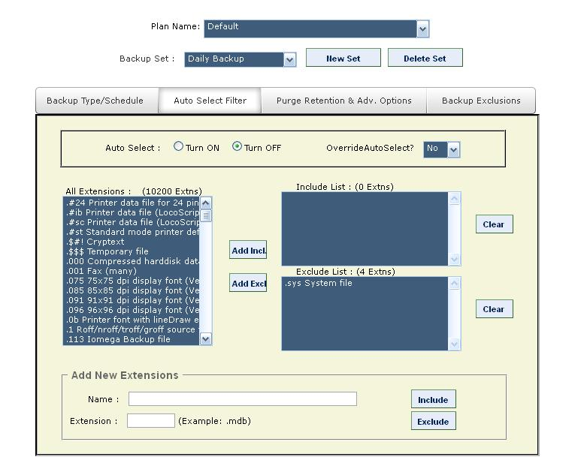

Override AutoSelect - By default, AutoSelect scans all hard drives that are not specifically excluded by a Red X, beginning at the root of the drive and working its way through all folders. You can override this behavior and make AutoSelect scan only folders that are selected with a Green Checkmark. This will speed up the scanning process and limit file selection, at the expense of missing files that are not in the included folders.

You may want to do this if your users will be backing up only files contained within certain folders, like My Documents. It could shorten backup times and lower the amount of storage space required.

To override AutoSelect's default method of scanning all attached drives, and have it scan only folders marked with a green checkmark, select YES for Override AutoSelect.

To pre-select file types to back up, simply select the file type from the List Of All Extensions list, and click the Add Incl button to Include the file type, or the Add Excl button to Exclude the file type.

If you don't find file type you need in the List Of All Extensions, you can add it yourself using User-Defined Extensions.
When you are finished editing the AutoSelect Filters, click the Apply button.

Purge Retention & Adv. Options Tab

This tab contains advanced options for backup sets.

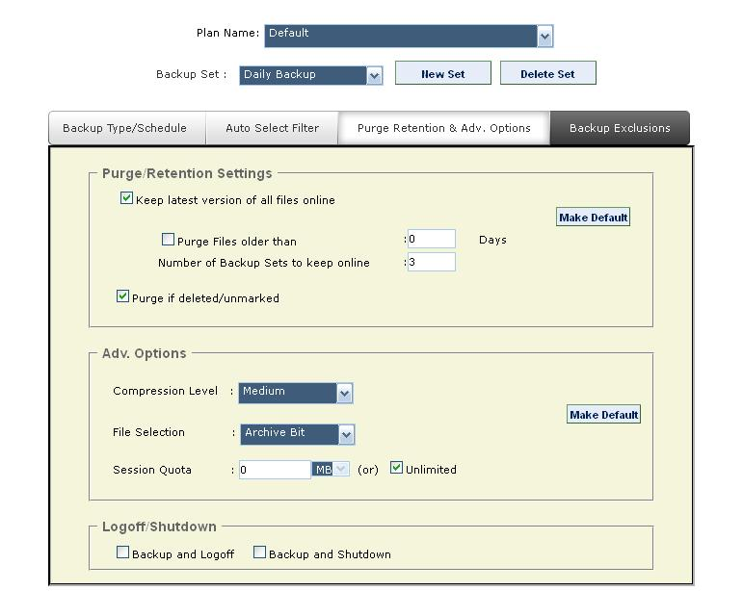

Keep latest version of files online - Check this setting if you want to keep the most recent version of a file regardless the other settings on this screen. For example, assume you have set Purge Files older than to 30 days. If you only have a single copy of a file within that time frame, and you do not checkmark this option, that file will be erased when its age is over 30 days. If you checkmark this option, that file will be retained regardless of its age until a more recent one appears at your RBS Server.

Purge Files older than - Use this setting to set the retention period of the files in this Backup Set to a number of days. In this example, files will be retained for 30 days and then erased from the RBS Server.

Number of Backup Sets to Keep Online - When Purge Files Older Than is not selected, this option becomes available. You can select a number of backup sets to keep online, and have the Client software delete old backup sets (all the files in a backup set) in a First-In-First-Out method. For example, if you have this set to 7, when the 8th Backup Set is stored, the oldest backup set will be deleted.

Purge if deleted/unmarked - Select this checkbox to automatically delete files from the Server at the end of their retention period if they are deleted from the Client or if they are deselected (unmarked) by the Client.

Compression Level - Set the desired compression level for the files in this backup. Normally, leave this at Medium unless instructed to do otherwise by an RBS technician.

File Selection - This sets the way RBackup selects files for backup. The recommended setting for most backup sets is Fast Pick.

Archive Bit - If set to Archive Bit, RBackup will select files that have changed since the last backup, according to the archive setting for the file. This is a very fast way to select files. However, if another program resets the archive bit before the backup, the file might not be selected for backup.

Modified Date/Time - Setting the File Selection Criteria to Modified Date/Time has two advantages and one disadvantage: It can select files for backup regardless of the archive bit, so it's generally more reliable; and it will always do a first full backup, then automatically switch to Incremental Mode (a very handy feature). Its disadvantage is that during a backup session the file selection process is slower than using the archive bit - sometimes quite a bit slower. This might not matter, however, if backups are done at night when nobody is using the computer.

Fast Pick - This method is designed to speed up the Scanning process (or File Selection process), especially in cases where there are many thousands of files to scan, (greater than 50,000) and where Archive Bit Selection is not appropriate.

Fast Pick relies on the last successful backup's Date/Time Stamp. For the first backup, Fast Pick will always do a full backup. For subsequent backups, files that have been added or changed since the last backup (selected by date/time) will be backed up.

This method of selection is useful when you are backing up a file sever (for example) that has many thousands of files that need to be scanned, or in cases where archive bit cannot be used for file selection (like a Samba/Linux box).

IMPORTANT: If, after the initial backup using Fast Pick, you make changes to File Selection, (include a new file or folder to backup), the Modified Date/Time must be reset for these new inclusions. Otherwise, these files will not be selected for backup. If users change file selections with Fast Pick turned on, they will be prompted to change the date, and the software will do it for them.

Session Quota - You can set a limit on the amount of data an individual Backup Set can send to the Server in a single session. You might want to do this to limit a first backup from a Client who has a large amount of data, so that it sends the first backup over a series of backup sessions rather than all at once. You can also use this to help define different backup plans for sales and pricing purposes. Select the Session Quota in megabytes or gigabytes, OR set the Session Quota to Unlimited with the checkbox.

LogOff/Shutdown - You can set the Client computer to either log off the current user or shut down the computer at the end of the backup session.

Backup Exclusions Tab

This tab is used to set default Exclusions for the selected backup set. Default Exclusions are files and folders that cannot be selected for backup, and do not appear in the file view. Files and folders are excluded based on wildcards and Virtual Folders, and are customizable by backup set.

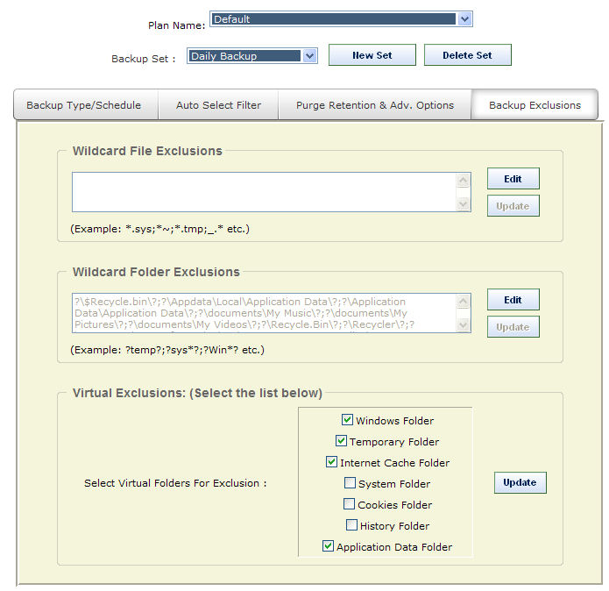

Wildcard File Exclusions

Use this option to exclude files using Wildcards. Separate exclusions with semicolon (;). File and folder names are not case-sensitive. Click on Edit to add wildcards. To save, click on Update. Note: Files that match these wildcards will NOT be displayed on the client interface.

This feature accepts the following formats:

Files starting with: (Format: starting {chars} of the filename followed by *)
Examples:
~* This will exclude all files whose filename starts with tilde (~).
Temp* This will exclude all files whose filename starts with ‘Temp’.

Files ending with: (Format: * followed by ending {chars} of the filename)
Example:
*temp This will exclude all files whose filename ends with ‘temp’

By file extension: (Format: * followed by a period (.), then the file extension)
Example:
*.sys This will exclude all files with .sys extension.

By Wildcards: (Format: * followed by {chars} to match, and then ending with a *)
Example:
*tmp* This will exclude all files whose filename has the string ‘tmp’

Wildcard Folder Exclusions

Use this option to exclude folders using Wildcards. Separate exclusions with semicolon (;). Not case-sensitive. Click on Edit to add wildcards. To save, click on Update.

Note: Folders that match these wildcards will NOT be displayed on the client interface.

This feature accepts the following formats:

Folders that exactly match with: (Format: ? followed by ‘foldername’ followed by ?)
Example:
?Windows? This will exclude files where the folder name matches ‘Windows’ anywhere in the entire file path.

Folder name starts with: (Format: ? followed by starting chars of folder name followed by *?)
Example:
?Sys*? This will exclude files where the folder name starts with “sys”

Folder name ends with (Format: ? followed by * followed by ending chars of folder name followed by ?)
Example:
?*32? This will exclude files where the folder name ends with “32”

Folder name LIKE: (Format: ? followed by * followed by chars to match followed by * followed by ?)
Example:
?*temp*? This will exclude files where the folder name is LIKE “temp” anywhere in the file path.

Virtual Exclusions

Use this section to select standard Windows virtual folders for exclusion. Virtual Folders are folders that might not have the same name from computer to computer, but are defined by these virtual names.
Select the following virtual folders to exclude from backup:

Note: Virtual folders marked for exclusion will NOT be displayed on client interface.

Windows Folder
C:\Windows or C:\Winnt

Temporary Folder
System Temp folder. Example: C:\Documents and Settings\Administrator\Local Settings\Temp

Internet Cache Folder
Temporary Internet Files: C:\Documents and Settings\Administrator\Local Settings\Temporary Internet Files

System Folder
Windows System folder. Example: C:\Windows\system32

Cookies Folder
Cookies folder. Example: C:\Documents and Settings\Administrator\Cookies

History Folder
Example: C:\Documents and Settings\Administrator\Local Settings\History

Application Data Folder
Example: C:\Documents and Settings\Administrator\Local Settings\Application Data

The Advanced Client Options Screen

This screen contains advanced options for the Client installer. The default selections are the most popular and appropriate for most backup sets.

For information on the Pre Batch File and Post Batch File see the documentation for the RBS Manager.

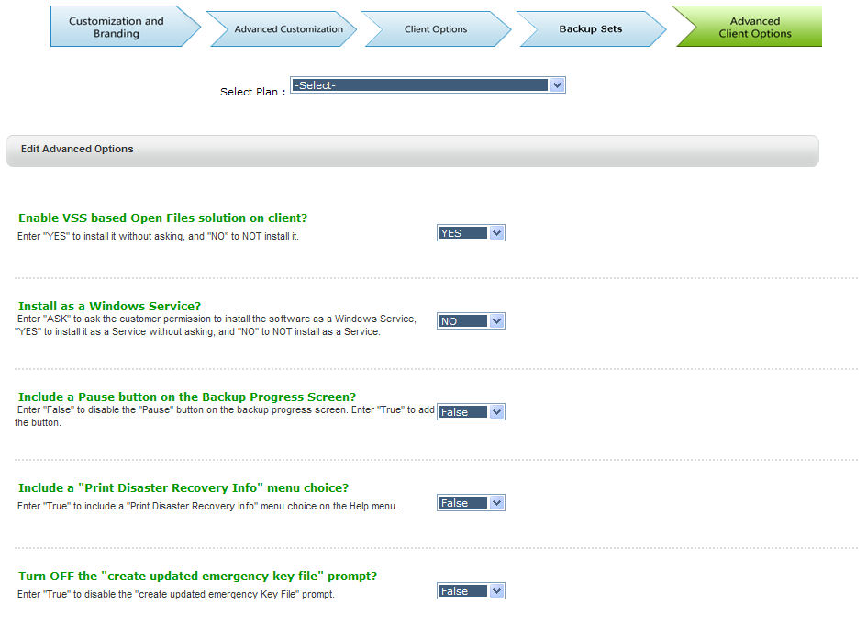
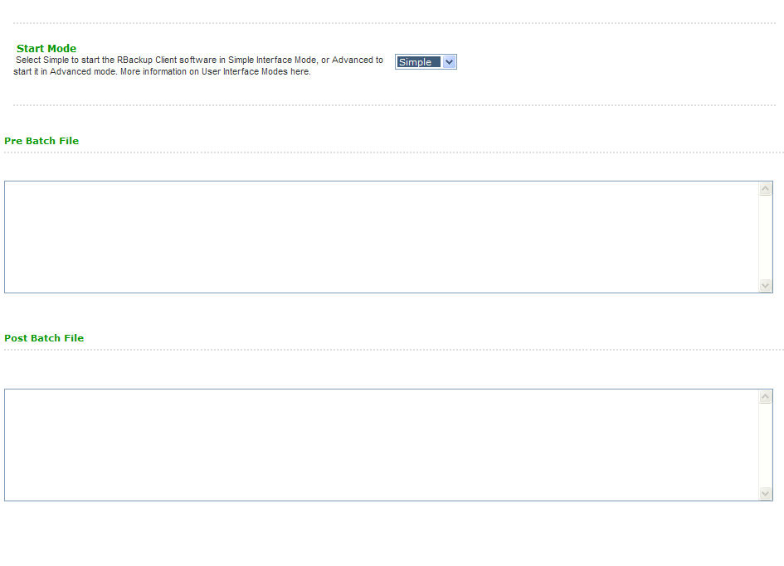

EMail Notifications
(Administrator and Partner logins)

The RBS Server can send EMail Notifications triggered by events. Each of the emails can go to multiple addresses, and can be individually configured and mail-merged using templates. Emails are sent as HTML, and can include fonts, images, and colors. Emails can also be sent to appear as plain text.

As with the body of the emails, you can also customize the Subject, From Address, CC Address, and the Bcc Address.

Fifty eight macros can be included in the body of the emails, which are replaced with data just before the email is transmitted. So, emails can contain information such as the number of files backed up, the size of backup sessions, time, percentage of quota used, and more.

Example of a Successful Backup Email

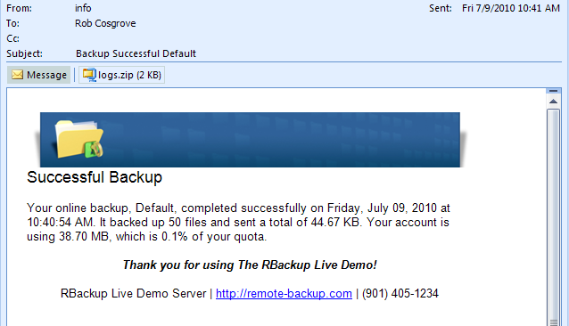

Configuring the Email Server

Email Notifications are configured on the Setup menu. The first section is the Email Server Setup. Check with your ISP or web hosting provider if you don't know this information.

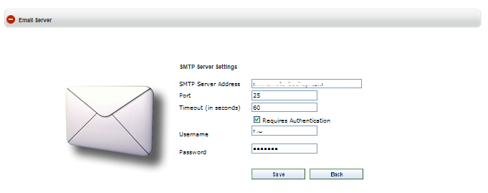

SMTP Server Address - The URL or IP address of your SMTP (outgoing) mail server.

Port - The port number to connect to your SMTP server. The default is 25.

Timeout - Usually 60

Requires Authentication - Select this and enter username and password if your SMTP server requires authentication.

Username - A username for logging into your SMTP server.

Password - A password for logging into your SMTP server.

Configure Email Notifications

Use this section to configure the individual email notifications.

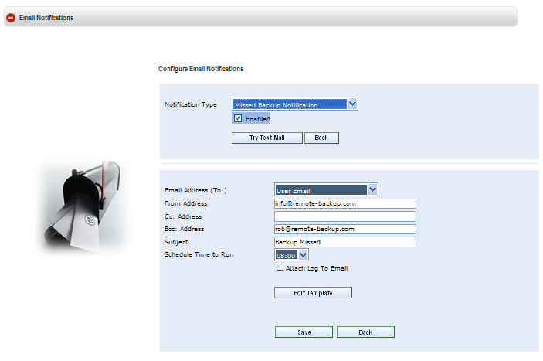

Notification Type - This pull-down menu lets you select the email notification type you want to edit.

Enabled - Select this checkbox to enable this email notification for all accounts.

Try Test Mail - Select this button to send a test email.

Email Address - Select the email address to receive this email.

- User Email - Send to the email address in the end user's record.
- Account Group Email - Send to the email address of the Group Manager.
- Type One - Enter an email address.

From Address - Enter the address from which to send this email. This address appears in the FROM section of the email after it is received. Use standard email address formats (see below.)

Cc: Address - To send a copy of this email to another address, enter an email address here.

Bcc: Address - to Blind copy this email to another address, enter an email address here.

Subject - Enter the subject of the email here. A few variables can be used here. See below.

Schedule Time to Run - (Only in some Email Notifications) Some notifications (like Missed Backup and Over Quota) have to run at a scheduled time daily. Enter the time to run these notifications. Most Service Providers select a time early in the morning, after all backups should have run for the night.

Attach Log to Email - (Only in some Email Notifications) Some notifications can have log files attached. These log files are in standard .ZIP format. They can be large, and they might not get through spam filters.

Standard Email Address Formats

Email addresses can be entered two ways, depending on how you want them to appear in the FROM field of the email after it is received.

me@mydomain.com - An email address entered in this format will appear in the FROM field as "me@mydomain.com"

"Me, Myself, and I" <me@mydomain.com> - This email address will appear as "Me, Myself and I"

Edit Template - Select the Edit Template button to edit email notification templates.

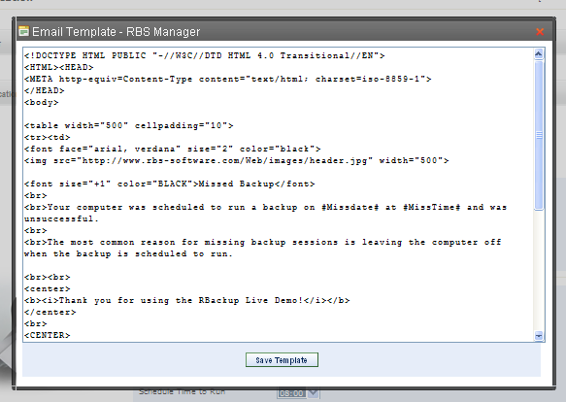

Email Notification Templates are in HTML format. They can use any HTML construct that works in HTML-aware email clients. There are some subtle differences in the way web browsers and email clients render content.

<!DOCTYPE HTML PUBLIC "-//W3C//DTD HTML 4.0 Transitional//EN">
<HTML><HEAD>
<META http-equiv=Content-Type content="text/html; charset=iso-8859-1">
</HEAD>
<body>
<table width="500" cellpadding="10">
<tr><td>
<font face="arial, verdana" size="2" color="black">
<img src="http://www.rbs-software.com/Web/images/header.jpg" width="500">
<font size="+1" color="BLACK">Successful Backup</font>
<br><br>Your online backup, #setname#, completed successfully on #date# at #time#. It backed up #files# files and sent a total of #bytes#. Your account is using #diskspace#, which is #quota#% of your quota.
<center>
<br><b><i>Thank you for using The RBackup Live Demo!</i></b>
</center>
<br><CENTER>
<font size="-1">RBackup Live Demo Server | <a href="http://remote-backup.com">http://remote-backup.com</a> | (901) 405-1234</font>
</center>
</font>
</td></tr>
</table>
</body>
</html>

The above Email Template created this email:

Inline Macros

Fifty eight macros can be used in the body of Email templates, which will be replaced with data when Emails are sent. Some are available in only certain templates. To use these macros, just include them in the body of the email template wherever you want the data to appear.

Body macros are always bracketed in octothorps (#) like this: #date#

Subject macros (used in the email subject only) begin with % like this: %F (see the table below Body Macros)

Success - the Successful Backup notification
Failed - the Failed Backup notification
Missed - the Missed Backup notification
Quota - the Over Quota notification
New - the New User notification
Welcome - the Welcome New User notification
Update - the Update Plan Verification notification
Cancel - the Cancel Subscription verification nofication
ALL - available in all Email notifications

Body Macros (Use in the body of the emails.)

#date# | current date | Success, Failed, Missed,New, Quota
#time# | current time | Success, Failed, Missed,New, Quota
#username# | user's username | Success, Failed, Missed,New
#setname# | current backup set name | Success, Failed, Missed
#setid# | current backup set ID | Success, Failed, Missed
#status# | status of the backup (SUCCESSFUL,FAILED) | Success, Failed, Missed, Quota
#files# | number of files backed up | Success, Failed
#bytes# | backup size (Native size, Bytes, KB, MB, GB) | Success, Failed
#diskspace# | disk space used (Native size, Bytes, KB, MB, GB) | Success, Failed, Quota
#quota# | percentage of disk quota used | Success, Failed, Update
#excp# | number of file exceptions | Success, Failed
#frequency# | frequency of this backup set (Daily, Weekly, etc.) | Success, Failed, Missed
#missdate# | date backup was scheduled to run | Missed
#misstime# | time backup was scheduled to run | Missed
#quotaavail# | disk space remaining in the quota | Quota
#accountgroup# | account group this user belongs to | New
#root# | root folder for this customer's data | New
#first# | user's first name | New, Welcome
#last# | user's last name | New, Welcome
#company# | user's company | New, Welcome
#address# | user's address | New, Welcome
#city# | user's city | New, Welcome
#state# | user's state | New, Welcome
#zip# | user's zip or postal code | New, Welcome
#country# | user's country | New, Welcome
#phone# | user's phone number | New, Welcome
#email# | user's email address | New, Welcome
#trial# | if this is a trial account, "YES" | New
#CC# | the middle 8 characters of the credit card number | New
#subscription# | name of the user's subscription plan | Welcome, Update
#oldplan# | name of the user's previous subscription plan | Update
#newplan# | name of the user's new subscription plan | Update
#newquota# | quota of user's new subscription plan | Update
#price# | price of the new subscription plan | Update
#term# | term (month, quarterly, yearly, etc) of the new plan | Update
#userfirstname# | user's first name | ALL
#userlastname# | user's last name | ALL
#usercompany# | user's company name | ALL
#useraddress# | user's address | ALL
#usercity# | user's city | ALL
#userstate# | user's state | ALL
#userzip# | user's zip or postal code | ALL
#usercountry# | user's country | ALL
#usertelephone# | user's telephone number | ALL
#userfax# | user's fax number | ALL
#userquota# | user's quota | ALL
#useremail# | user's email address | ALL
#userversion# | version number of the user's client software | ALL
#accountcompany# | company name for the user's group | ALL
#accountgroupname# | group name for this user | ALL
#accountaddress# | address for the user's account group | ALL
#accountcity# | city of the user's account group | ALL
#accountstate# | state of the user's account group | ALL
#accountzip# | zip or postal code for the user's account group | ALL
#accountcountry# | country for the user's account group | ALL
#accounttelephone# | telephone number of the user's group manager | ALL
#accountfax# | fax number of the user's group manager | ALL
#accountemail# | email address of the user's group manager | ALL
#accountquota# | the group quota for the user's account group | ALL

Subject Macros (Use in the Subject field only.)

%F | First Name
%L | Last Name
%U | Username
%E | Email
%A | Account Group
%C | Company
%T | Trial Account

The Notification Log

The Email Notification Log is a report of the Email notifications that were sent over the past period of time. Like other reports, the Notification Log can be exported to Excel or printed. The page size can be selected, and it can be filtered for a date range, account group, and user.

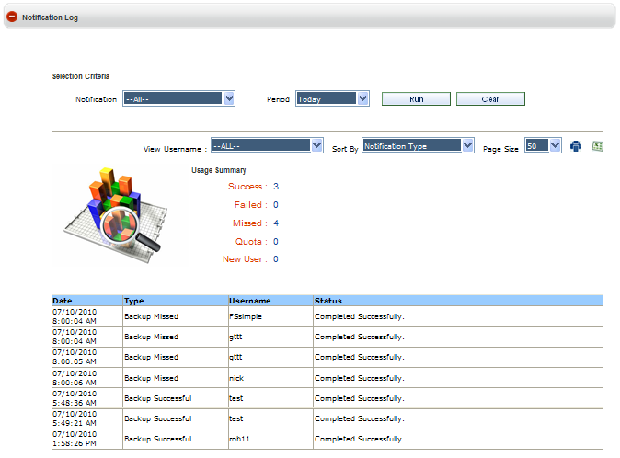

Broadcast Email

The Web Manger PlugIn allows you to broadcast Email to end users.

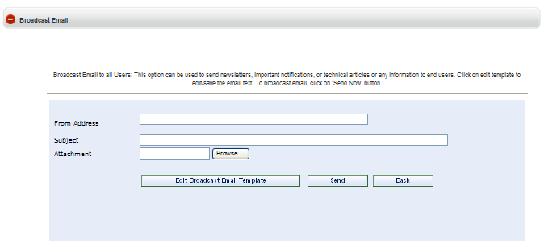

From Address - Enter the address from which to send this email. This address appears in the FROM section of the email after it is received. Use standard email address formats.

Subject - Enter the subject of the email.

Attachment - Browse for an attachment to the Email. (optional)

Edit Broadcast Email Template - Edit the Broadcast Email template.

Send - Send the Broadcast Email.

Payment Gateway Setup
(E-Commerce PlugIn only, Administrator and Partner logins)

This section is used to set up your Payment Gateways in the E-Commerce PlugIn. The Payment Gateways supported by the PlugIn are listed on the right. There may be different Gateways in your version of the PlugIn than in this example.

This is where you tell the E-Commerce PlugIn how to accept payments, and what payment options to offer your customers. You can accept payments from credit cards and debit cards (in some countries,) PayPal (in some countries,) and direct billing.

Note: You must have Payment Gateway account(s) with your Payment Processor(s) (authorize.net, PayPal, etc.) to process payments automatically. The E-Commerce PlugIn has built in APIs for some Payment Processors, and two built-in Payment Gateways that do not require a Payment Processor.

Attaching the E-Commerce PlugIn to your automatic Payment Processing Account requires advanced knowledge of online payment processing, and may require selecting specific options in your Payment Processing Account. Contact your Payment Processor for help.

PLEASE NOTE: RBS cannot help you set up your Payment Processing Account(s). If you are applying for a new Payment Processing account, we recommend authorize.net if is available to you.

Only one credit/debit card gateway can be active.

The gateways that you set as "Active" show up on the Payment section of the Order Form. In this example of the Order Form we have selected the Payflow Pro and PayPal gateways. Customers can select either payment method.

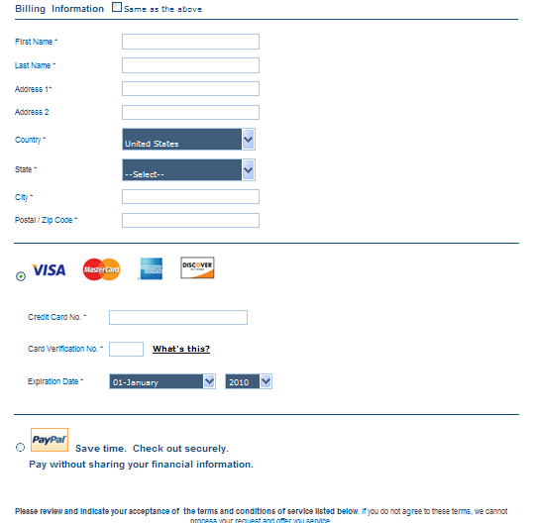

Define your Payment Gateway options here.

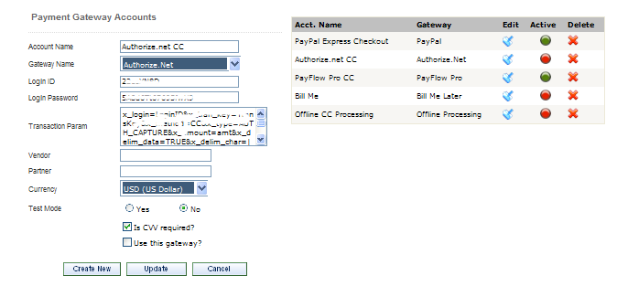

Account Name - Give your Payment Account a name.

Gateway Name - Select the Payment Gateway from the list of pre-programmed interfaces.

Login ID - Enter the login ID of your Gateway account (from your payment processor)

Login Password - Enter the login password of your Gateway account (from your payment processor)

Transaction Param - Enter the Transaction Parameters code (if any) given to you by your payment processor.

Vendor - If required, enter the Vendor ID (from your payment processor)

Partner - If required, enter your Partner ID (from your payment processor)

Currency - Select the currency in which to accept payments.

Test Mode - If selected, transactions will be approved by the PlugIn, but not processed through the Payment Processor.

Is CVV required? - Select to require customers to enter the CVV code. (Check with your Payment Processor.)

Use this gateway? - Select to activate this gateway. Note that only one credit/debit card gateway can be active.

Create New - Select to create a new Payment Gateway.

Update - Select to update an existing Payment Gateway.

Offline Processing Payment Gateway

The built-in Offline Processing Gateway is for use with Payment Processors not supported automatically by the E-Commerce PlugIn, and when you want to process your credit/debit card payments manually.

When the Offline Processing Gateway is selected the credit card payment section appears on the Order Form.

All credit cards with valid numbers (according to their embedded self-validating checksums) and valid dates are approved. Software is deployed and backup accounts are created and activated. Entries are made in the Orders worksheet. New User Welcome Email notifications are sent to the customer.

The PlugIn does not validate credit card numbers or contact Payment Processors.

Customers can use their accounts immediately.

As the Service Provider, you may suspend accounts any time at your discretion.

The New User notification Email is sent (usually to the Service Provider or the Group Manager.) Following is an example of a typical New User notification Email. You can edit this template in Email Notifications.

In the below example, note that the partial credit card number (CC Number) is included.

To remain compliant with the rules governing the use of credit card numbers by merchants, the E-Commerce PlugIn never sends the complete credit card number in an Email, nor does it store the complete credit card number with the CVV code and date or display it online in a web page.

CC Number:=XXXX11111111XXXX

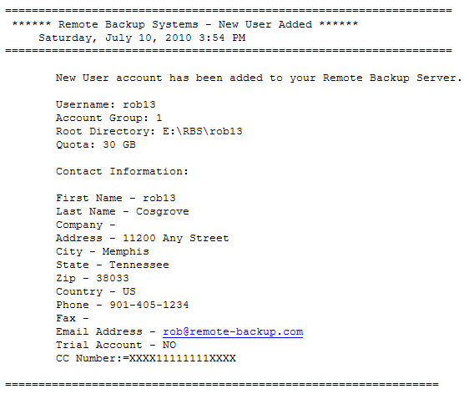

Instead, the E-Commerce PlugIn sends the middle eight characters of the credit card number in an email, and stores the rest of the number in its database, which displays in the Orders worksheet:

To process a credit card payment manually, reconstitute the credit card number from the Email and the Orders worksheet, and charge it manually using your manual or virtual credit card terminal. If you are going to recur billing for this account, set that up manually, too.

If the charge is approved, enter the Authorization Code (Auth Code) in the Orders worksheet, select the Paid checkbox, and select the Update button to mark the order as Processed.

Transactions are clearly marked as Paid or not Paid in the Orders worksheet.

Note: For testing purposes, the Offline Processing Gateway always approves a transaction using the following credit card information:

Card Number: 4111111111111111
CVV Code: Any 3 Digit Number
Date: Any date beyond today's date

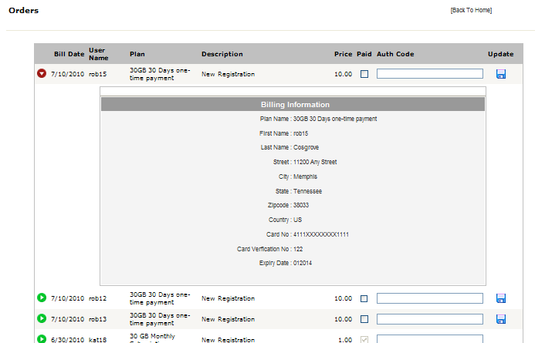

Bill Me Payment Gateway

The built-in Bill Me Gateway is for use when you want to offer to bill your customers directly.

When the Bill Me Gateway is selected a Bill Me choice appears on the Order Form.

All orders are approved. Software is deployed and backup accounts are created and activated. Entries are made in the Orders worksheet. New User Welcome Email notifications are sent to the customer.

Customers can use their accounts immediately.

As the Service Provider, you may suspend accounts any time at your discretion.

The New User notification Email is sent (usually to the Service Provider or the Group Manager.)

Configuration of the Bill Me Payment Gateway is slightly different from the other gateways.

The text entered in the Transaction Param field will be displayed on the Order Form with the Account Name. Use this field to give your customers special instructions.

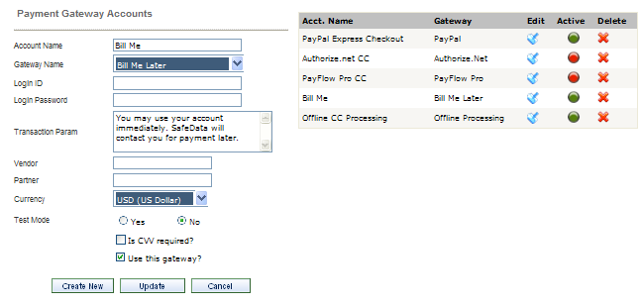

Recurring Billing

The E-Commerce PlugIn can set up automated recurring billing through Payment Processors that support this feature. You can turn on recurring billing for individual Service Plans at the Plans screen by selecting a Payment Term.

If the customer pays through a Payment Gateway attached to an automated Payment Processor, his credit card will be charged on the renewal date of his subscription, as defined by the Payment Term you select. (Your Payment Processing account must support Recurring Billing.)

At the time of the order the E-Commerce PlugIn instructs your Payment Processor to automatically charge a customer's credit card or PayPal account on the Payment Term defined in the Plans screen.

It is important to note that the Payment Processor performs the automated recurring billing - not the E-Commerce PlugIn. The E-Commerce PlugIn verifies the recurring payment and reports the result by issuing a query to the Payment Processor. You must log into your Payment Processing account to manage your recurring billing.

Plans
(Administrator and Group/Partner logins)

Use the Plans Setup screen to define your Service Plans. The list of defined plans appears on the right. Click the Edit button to edit a plan, hover over the Link button to display the Purchase Link, and select the Delete button to delete a Plan.

Plans appear on the Buy Now page, and a direct link to the Order Form for this plan is generated that can be placed on other web sites.

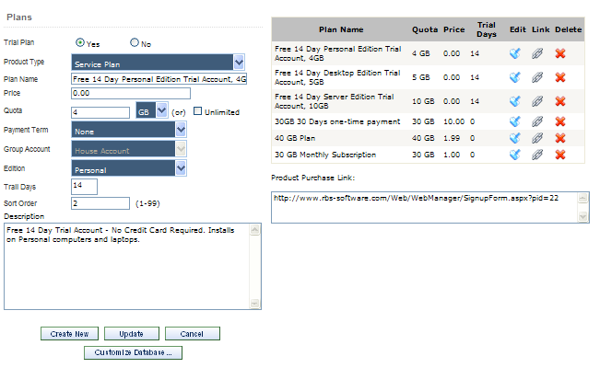

Trial Plan - Select "Yes" if this is a trial plan.

Product Type - Select Service Plan if this is a Remote Backup Service Plan. Otherwise select Product or Service.

Plan Name - Give your Plan a name.

Price - Give your plan a price.

Quota - Give your plan a disk space quota, or set it to Unlimited. This setting will trigger the Over Quota Email notification, and may stop backup sessions depending on other settings. Trial Plans are limited by your RBS license to specific maximum space.

Payment Term - If you select None, this will be a one-time charge that will not recur. Selecting any other option turns on Automatic Recurring Billing. For more information see Payment Gateway Setup.

Group Account - Select the Group Account to which to assign Users who have this Plan.

Edition - Select the Client Edition (Server, Desktop, Personal) to use with this Plan.

Trial Days - If this is a Trial plan, select the number of days to allow for the Trial account. Trial Days are limited by your RBS license to a specific maximum.

Sort Order - The order that this plan appears on the Buy Now Page.

Description - The description of this plan as it appears on the Buy Now Page and the Order Form.

Product Purchase Link - Move the cursor over the Link button for each plan to display its product purchase link. You can also click the Link button to display the Order Form. This URL can be placed on other web sites or sent in an Email.

Create New Button - Select this button to create a new Plan.

Update Button - Select this button to update an existing Plan.

The Customize Database Button

Press the Customize Database button to edit more advanced features for this Plan.

Select Plan - (Normally do not change this.) This will default to the currently selected plan.

RBS Server IP Address - (Normally do not change this. It may have been set elsewhere.) Enter the RBS Server's IP Address or Domain Name here. If you select Use Server Locator, your Server Locator Host Name will automatically be entered here. Your Server Locator Host Name is your serial number + ".ddns.rbsnet.net" like this:

12345678.ddns.rbsnet.net

Read more about the Server Locator here.

You can enter as many as 32 IP addresses or Domain Names here representing 32 RBS Servers, separated with semicolons, as long as the total length of the input does not exceed 255 characters. The Client software will try the Servers in sequence until one of them answers. This is useful if you have two mirrored RBS Servers operating as fail-overs, or multiple RBS Servers sharing a common drive:

server1.domain.com;server2.domain.com;myfailover.com

In the Evaluation version, enter your RBS Server's PUBLIC IP ADDRESS here to create clients that can connect from OUTSIDE your network. Enter its PRIVATE IP ADDRESS to create clients that can connect from INSIDE your network.

What's my Public IP Address? - You can see your Public IP Address on the RBS Web Site. Go to http://remote-backup.com/support/

Admin Override Password (Normally do not change this. It may have been set elsewhere.) - Some features of the Remote Backup Client can be changed on the Client software itself after entering an override password. Pick your override password and enter it here. Please note that this is CASE-SENSITIVE. This password is used at the Client to change Administrator's features. See the RBS Server's Help File - Client Administrator's Override for more information.

Temp Backup Path - (Normally do not change this. It may have been set elsewhere.) This is the location on the Client's hard drive where temporary files are stored during backup processing.

BitBackup Reference Path - (Normally do not change this. It may have been set elsewhere.) The location of the BitBackup Data Store. BitBackup stores a copy of all the files selected for backup using the BitBackup method (on the Schedule Screen). The space required for this storage space is the total native file size of all files for which BitBackup has been selected.

Encryption Method - Select the default encryption method. You can select from seven types: Two kinds of DES, Triple DES, Blowfish 448-bits, AES 128-bits, AES 192-bits, and AES 256-bits.

Client Locks - You can lock out certain features of the Client software, preventing end users from using them. For example, if you don't want clients to be able to change backup schedules or change file selections, select Lock Scheduler Window and Lock Ability to Change/Add File Selection.

Client Locks are useful when you want to distribute a pre set-up version of the Client software with few options. This allows you to better control your costs and reduce support issues associated with users who might misconfigure the software.

Properties
(Administrator login)

The Properties screen is used during initial setup of the RBS Server. These settings can be changed here, but they are usually initially set up in the RBS Server's installation using the RBS Manager console applicatin rather than in this PlugIn's installation. See the RBS Server's documentation for more information.

Changing any of these settings requires rebooting the RBS Server software.

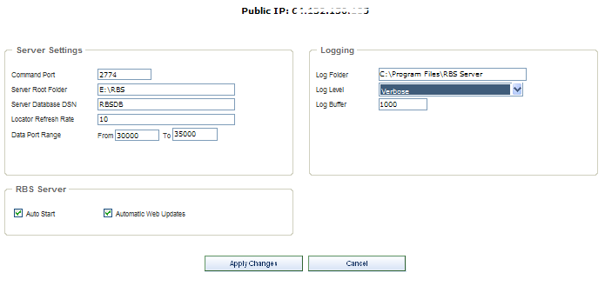

Public IP - Your RBS Server's public IP address is displayed at the top of the screen.

Command Port - The RBS Server requires a Command Port and multiple Data Ports. The default is 2774, a port number registered to RBS by IANA, the Internet authority that controls top level domains and number assignments. This port number should not be changed after you have distributed Client software, unless you re-install the Client software with the new port number.

Server Root Folder - The default root folder for the Data area. All new users' backup files will be placed here. Changing this folder after users have already done backups will not move their data. This will only establish a new root folder for all subsequent new users.

Server Database DSN - The Database DSN for the RBS Server's main database.

Locator Refresh Rate - The number of minutes between updates of the Server Locator. Normally do not change this. The minimum is ten minutes.

Data Port Range - This is the range of data ports that will be assigned to Clients when they contact the Server for backups and restores.

For maximum speed under most conditions the data port range should include three ports per simultaneous user. The default is the range of ports that begins at 29001 and ends at 29100

After you restrict the port range you can open only that range of ports through your firewall, if necessary.
Reducing the number of available ports too much can result in slow transfer speeds.

Changing the Data Port range is a Server-side operation only. It is not necessary to redistribute Client software if you change the Data Port range.

For more information on how to use Ports and how to configure routers and firewalls, see the Knowledge Base on the remote-backup.com website.

Log Folder - This is the folder in which to maintain the Server logs.

Log Level - Set to Standard, Detailed, or Verbose for increasing levels of logging. Normally set to Standard.

Log Buffer - the number of lines to buffer the Server log in RAM, normally 1000. The buffer will be flushed to the logs after this number of entries has been accumulated in memory.

Auto Start - Normally selected, this turns on the RBS Manager's failsafe monitoring system, which monitors the RBS Server's health and restarts it if necessary.

Automatic Web Updates - Checks with the RBS Upgrades Server daily to see if a software update is available. If it is, a message will pop up without interrupting the Server's operation.

Apply Changes Button - Click this button to apply your changes.

Storage Price
(E-Commerce PlugIn, Administrator and Partner logins)

Set the storage price for additional space (in gigabytes) here. This price is used on the Order Form when end users select Buy More Space.

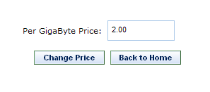

Test Server
(Administrator and Group Manager/Partner logins)

Select this option to test the RBS Server. You may need to enter the Server's IP address or domain name, its Command Port number, and the username, password and account group of a valid user on the system.

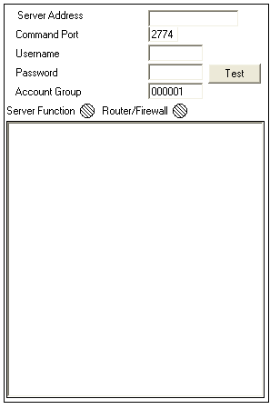

Web Manager Setup
(Administrator login)

These settings normally need to be entered only once on initial setup.

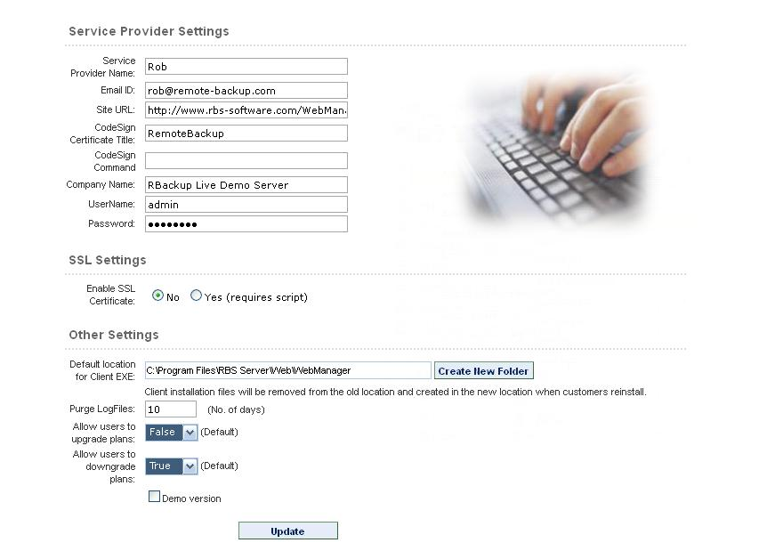

Service Provider Name - Enter the name of the Service Provider

EMail ID - Enter the email address of the Service Provider. This will be used as the default "from" address for Emails sent for welcome, change plan, upgrade storage, and forgot password. This default can be overridden for each Partner in the EMail Notifications section.

Site URL - This is used by the Web Manager to form the URL for the Update Client functions.

Codesign Certificate Title - Optional, used only if you have installed a Code Signing Certificate. This is the company name that is used to sign files.

Codesign Command - Optional, used only if you have installed a Code Signing Certificate. Enter the command used to initiate the code signing process. See the documentation for your Code Signing Certificate. Here is an example for a Verisign Classs 3 Code Signing Certificate using Microsoft Authenticode:

-spc "credentials.spc" -v "privatekey.pvk" -n "softwarename" -i "website.com" -t http://timestamp.verisign.com/scripts/timstamp.dll

Note about Code Signing Certificate files:

Place your credentials.spc and privatekey.pvk files in a location and add that location in the web.config like this:

<add key=”CertLocation” value=”C:\Program Files\RBS Server\Web\WebManager\SignCode” />

Company Name - Used on the Code Signing Certificate and on the End User License Agreement (EULA) to replace the macro - comp -

UserName - The administrator's login username

Password - The administrator's login password

Enable SSL Certificate - If you have installed an SSL Certificate select Yes.

Default location of Client EXE - Enter the default location the Web Manager will use to build the client installers. The default is usually OK.

Purge Logfiles - Enter a number of days to keep the server's log files. Older files will be purged.

Allow users to upgrade plan - Select True or False (Yes or No) to set the default for new users.

Allow users to downgrade plan - Select True or False (Yes or No) to set the default for new users.

Demo Version - Checkmark this if you want to enable your Web Manager with a Demo login to allow prospective Partners to look around the Admin functions of the site. (Multitenantcy Feature) You will be asked to assign a demo username and password.

Live data will be hidden, and demo users will not be able to edit anything.

Orders
(Administrator and Partner logins)

The Orders worksheet contains transactions that need your attention. Use the Orders worksheet to complete all your orders. Visit this page regularly.

Click the green button to the left of each transaction to expand it for more detail. These transactions can include:

    - New online registrations
    - Account cancellations
    - Plan Updates
    - Purchases of more storage space
    - Recurring billing successes
    - Recurring billing failures

You will need to take action to complete some transactions. For example, if you are using the Bill Me or Offline Processing Payment Gateways you may need to handle billing manually when a New Registration comes in.

If you are using one of the automated Payment Gateways for credit cards or PayPal, the transaction may have already been processed when you see it here. (E-Commerce PlugIn only)

If a transaction has been processed automatically the Paid checkbox will be selected, the AuthCode field will contain the authorization code returned by your Payment Processor, and the Update button will not be active. In this case the E-Commerce PlugIn has already processed the payment and deposited money in your Payment Processing account.

To process a payment manually, use your manual or virtual credit card terminal, or make an entry in your billing software, or take whatever action you need to take. Once completed, mark the transaction Paid, enter an authorization code (Any text will work here,) and press the Update button.

The Orders worksheet does not process orders or payments. It is only a worksheet for you to use to make sure all the transactions that need attention are handled. The goal is to have all the Paid checkboxes checkmarked.

See the section on Payment Gateway Setup for more information on how the Orders worksheet works with automated payment processing.

Help

Support Central
This displays the main technical RBS support page.

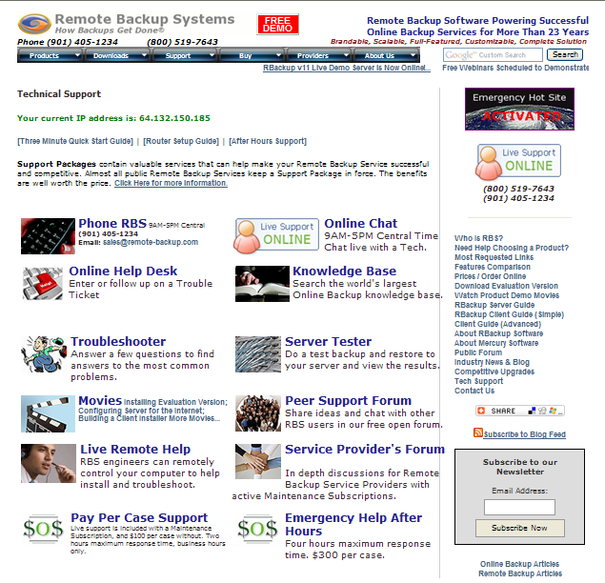

Web Manager Help
Displays this help system.

RBS Server Help
Displays the RBS Server Help.

RBS Client Help
Displays the RBS Client Help.

Download/Re-download Help
(Administrator and Partner logins)

Use this screen to edit or translate the help files included in the Client software installer.

The help files built into the Client software are .CHM files. There are two of them, one for the Advanced interface, and one for the Simple interface. They can be edited with any software capable of editing a .CHM file. There are also MS Word documents for both interfaces.

After you have edited your help documents, upload them to your Client installer using the appropriate Upload button.

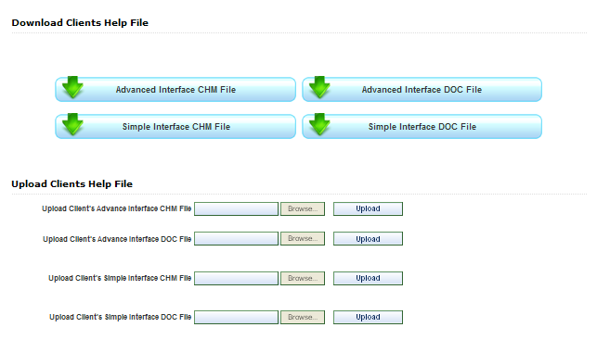

Download Disk Restore
(Server must be authorized for the Disk Restore Utility)

Click this button to download the Disk Restore utility. Make sure your RBS Server is correctly installed and fully functional before downloading.

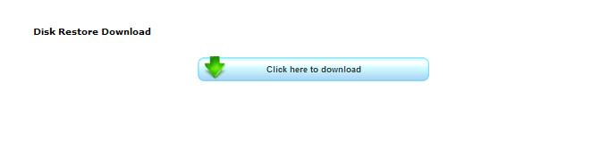

Download WebRestore
Click this button to download the Web Restore utility. Make sure your RBS Server is correctly installed and fully functional before downloading. This button rebuilds the Web Restore utility from other settings that must be correct.



About
This screen displays your serial number, version numbers and other information.

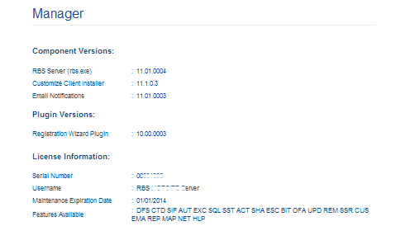

User Remote Management

The Remote Management Console
(Administrator, Group, and Partner logins)

The User Remote Management Console is accessed from the Accounts menu, on the Manage Users screen. This allows you to remotely change some settings for users. Changes are automatically downloaded and applied during the next backup session.

If your software also includes the Remote Helpdesk PlugIn, you can use it to remotely access your end users' computers for real-time remote control of the monitor, keyboard, and mouse.

Click the Remote Management icon.

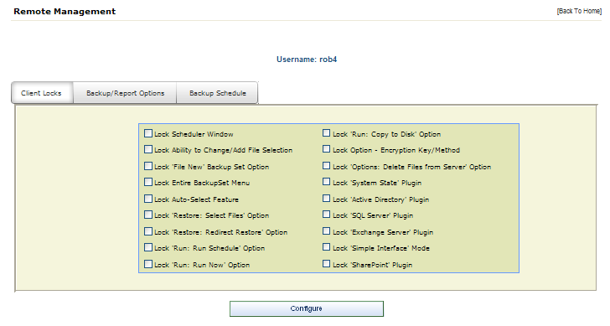

The first screen in the End User Remote Management console allows you to configure Client Locks. You can lock out certain features of the Client software, preventing end users from using them. For example, if you don't want clients to be able to change backup schedules or change file selections, select Lock Scheduler Window and Lock Ability to Change/Add File Selection.

Client Locks are useful when you want to distribute a pre set-up version of the Client software with few options. This allows you to better control your costs and reduce support issues associated with users who might misconfigure the software.

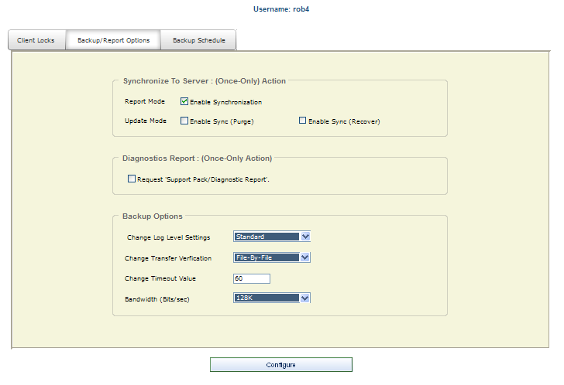

The second tab in the User Remote Management console is for Backup/Report Options.

Report Mode: Enable Synchronization - Creates a report showing the differences between the client's catalog (what the Client thinks is stored on the Server) and the Server's database (what is actually stored on the Server)

Update Mode: Enable Sync (Purge) - Depending on the results of the Report Mode operation, this option can be used to purge files from the RBS Server which do not show up in the Client's catalog, and are no longer needed.

Enable Sync (Recover) - Depending on the results of the Report Mode operation, this option adds files to the Client's catalog which exist in the RBS Server but not in the Client's catalog.

Request Support Pack/Diagnostics Report - This is a "once only" action. It instructs the RBS Client software to create a Service Pack and Diagnostic Report, and send it to the RBS Server. The Service Pack is sent in standard .ZIP format to the Client's Data Root directory on the RBS Server.

Change Log Level Settings - This options changes the log level of the Client software.

Change Transfer Verification - This changes the Transfer Verification method.

Bandwidth (Bits/sec) - This controls the bandwidth allocated for each client. The default is 512Kbps.

The third tab in the User Remote Management console is for changing the Backup Schedule settings.

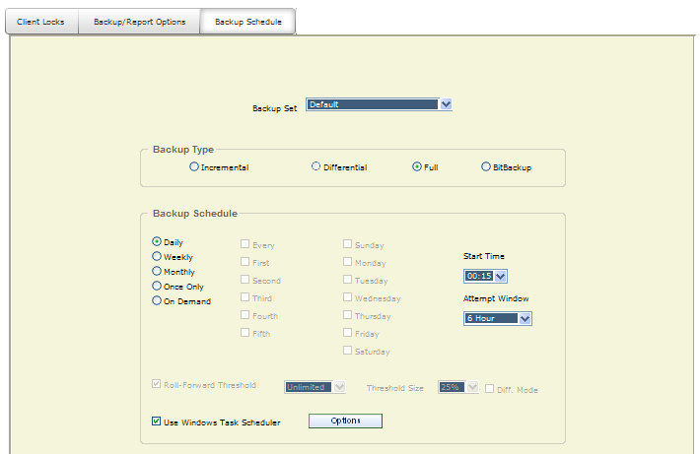
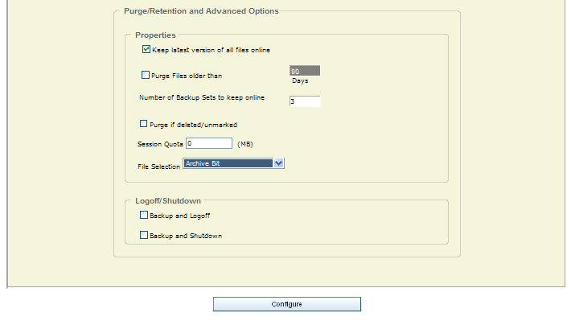

This is where you define the dates and times for the Backup Sets to run. RBackup can run multiple Backup Sets. Select the Backup Set you want to edit.

This screen contains a box called Backup Type, which is where you select the type of backup this Backup Set will run.

Incremental - Entire files will be backed up which have been modified since the last backup. Then, after they are backed up, the files will be marked on the disk as having been backed up. This is the default and most widely-used way to back up data files.

Differential - Entire files will be backed up which have been modified since the last backup, the same as Incremental. However, after the files are backed up, they will not be marked as having been backed up. The reason for this option is in case you also want to do tape backups as well as remote backups. Your tape backup software relies on the marks placed on the files to determine which files need to be backed up. So, you don't want to remove them with your Remote Backup.

Full - Entire files will be backed up regardless of whether they have been changed since their last backup. This is the least-used option because it results in the largest Backup Sets and longest on-line times.

BitBackup - Only the parts of files that have changed will be backed up. This option creates sub-file or "patch" backups. This creates the smallest backups that take the least amount of time, and is the recommended default setting. For more information on how BitBackup works, see How BitBackup Works.

Backup Schedule

Daily - Selecting this option will launch a backup every day, seven days a week.

Weekly - This schedule lets you select which days of the week to do a backup.

Monthly - On this schedule you can select the first, second, third, fourth or fifth of any day of the week. Here are some examples: You can pick the first and third Wednesdays of each month. You can select the second Tuesday and Thursdays. There are a lot of possible schedules you can use here.

Once Only - This schedule will launch a single backup session, one time only, on a specified date you can pick from a pull-down menu containing a calendar.

On Demand - Pick this selection if you want this backup set to be launched on demand only - not through the scheduler. You can then launch this backup set through the Run: Run Now menu choice in the Client software. You can also run it through Windows Scheduled Tasks.

Start Time - For each of these schedules you can select a Start Time and an Attempt Window. It is important to remember that the Start Time is on a 24-hour schedule, and that anything after midnight is the next day. This means that if you want to back up Friday's work, and you want the backup session to take place after midnight, you should select a time early in the morning of Saturday, not Friday.

The Attempt Window is the number of hours Remote Backup will attempt to perform the backup. Selecting a start time of, for example, 1:00am will not necessarily cause the backup session to start at 1:00am, although it might. Remote Backup might not be able to perform a backup for a variety of reasons - the Server is too busy, files are locked, the computer isn't turned on.

In the event that Remote Backup can't perform a backup at the selected Start Time, it will attempt the backup session some time during the next period of time determined by the number of hours you select here.

BitBackup Threshold Settings

BitBackup is a special kind of backup that backs up only the changed parts of files instead of the full files. It is sometimes called "sub-file" backup or "patch" backup. BitBackup is especially useful for very large files when only small parts of the files change between backups. For a complete explanation, see How BitBackup Works.
For example, if only a five-character word changes in a 2 megabyte document, BitBackup will back up only five characters. This can save large amounts of storage space on the Server, and it can significantly speed up the time needed to do a backup.

BitBackup always backs up a full file the first time. Thereafter, it backs up only the changed parts of the file. Each of the BitBackup backups sent after a full backup can restore the file up to the point in time when that backup was done, called cumulative backups. So, as time goes on, BitBackup archives become larger as they contain more changes.

Periodically, BitBackup needs to reset - a process called Roll-Forward. To do this, Remote Backup sends the full file again, and then resets BitBackups, which reduces their file size back to the minimum. This process cycles according to the settings at the bottom of this screen.

Roll-Forward Threshold - This is the number of BitBackups that will be done before Remote Backup resends the full file again.

Threshold Size - The percentage of BitBackup size to full-file size. In the example on this screen, when the size of the most recent BitBackup archive exceeds 50% of the size of the full file, Remote Backup will perform a Roll-Forward, re-sending the full file.

Using the Threshold Size feature instead of the Roll-Forward Threshold setting takes more time during preparation of a backup, because Remote Backup needs make a BitBackup archive to compare its size to the full file.

Differential Mode - Select this checkbox to set a Backup Set defined as BitBackup to operate in Differential Mode. Differential Mode in BitBackup operates the same way as Differential Mode for entire files, except that with BitBackup only the parts of the files that have changed are transmitted to the RBS Server. Archive bits are not reset. This setting is useful if you need to coordinate your Remote Backups with local Tape backups.

Use Task Scheduler - Select this checkbox to use the Windows Task Scheduler to launch this backup set instead of using RBackup's built-in scheduler. Some applications have the potential to interfere with RBackup's built-in scheduler, especially when RBackup is running in Service Mode. It is generally considered more reliable for wide-scale distributions to use the Windows Task Scheduler.

The Options button let you change the Windows account under which this task runs, and control the computer's power management options
.

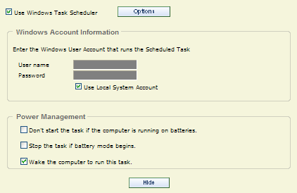

Purge/Retention & Advanced Options

The settings on this tab control file retention policy, session quota, file selection method, and optional actions that can be taken at the end of backup sessions.

Keep latest version of all files online - Check this setting if you want to keep the most recent version of a file regardless the other settings on this screen. For example, assume you have set Purge Files older than to 30 days. If you only have a single copy of a file within that time frame, and you do not checkmark this option, that file will be erased when its age is over 30 days. If you checkmark this option, that file will be retained regardless of its age until a more recent one appears at your RBS Server.

Purge Files older than - Use this setting to set the retention period of the files in this Backup Set to a number of days. In this example, files will be retained for 30 days and then erased from the RBS Server.

Number of Backup Sets to Keep Online - When Purge Files Older Than is not selected, this option becomes available. You can select a number of backup sets to keep online, and have the Client software delete old backup sets (all the files in a backup set) in a First-In-First-Out method. For example, if you have this set to 7, when the 8th Backup Set is stored, the oldest backup set will be deleted.

Purge if deleted/unmarked - Select this checkbox to automatically delete files from the Server at the end of their retention period if they are deleted from the Client or if they are deselected (unmarked) by the Client.

Session Quota - You can set a limit on the amount of data an individual Backup Set can send to the Server in a single session. You might want to do this to limit a first backup from a Client who has a large amount of data, so that it sends the first backup over a series of backup sessions rather than all at once. You can also use this to help define different backup plans for sales and pricing purposes. Select the Session Quota in megabytes (a gigabyte is 1000 megabytes) OR enter zero for unlimited.

File Selection - This sets the way RBackup selects files for backup. If set to Archive Bit, RBackup will select files that have changed since the last backup, according to the archive setting for the file. This is a very fast way to select files. However, if another program resets the archive bit before the backup, the file might not be selected for backup.

Setting the File Selection method to Modified Date/Time has an advantage and a disadvantage: It can select files for backup regardless of the archive bit, so it's generally more reliable. Its disadvantage is that during a backup session the file selection process is slower than using the archive bit - sometimes quite a bit slower. This might not matter, however, if backups are done at night when nobody is using the computer.

FastPick is a fast file selection method that compares the date and time of all files with the date and time of the most recent backup for this backup set. If a file has been modified since the previous backup was performed, it is backed up.

LogOff/Shutdown - You can set the Client computer to either log off the current user or shut down the computer at the end of the backup session.

The Configure button saves all your changes.

The Remote Helpdesk
Type topic text here.

End User Login

User Login Console
End users log into the Web Manager using the Username and Password set up when their accounts were created. The End User Login Console shows information about the account on the left, and a gauge on the right that displays the disk space quota and the amount of quota space used.

The graphics and text at the top and bottom of this page are configurable. They can be found in the HTML files \header.html and \footer.html

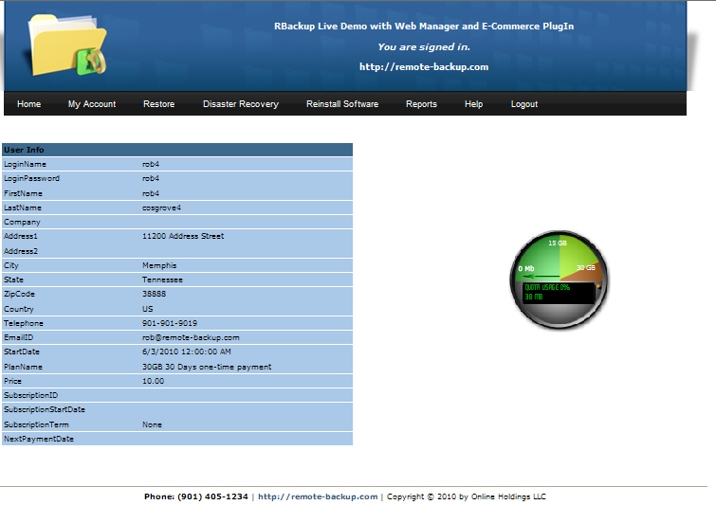

My Account Menu

Change Storage Plan
End users can change their storage plan here. The screen displays the current plan, and a drop down menu to select the new plan.

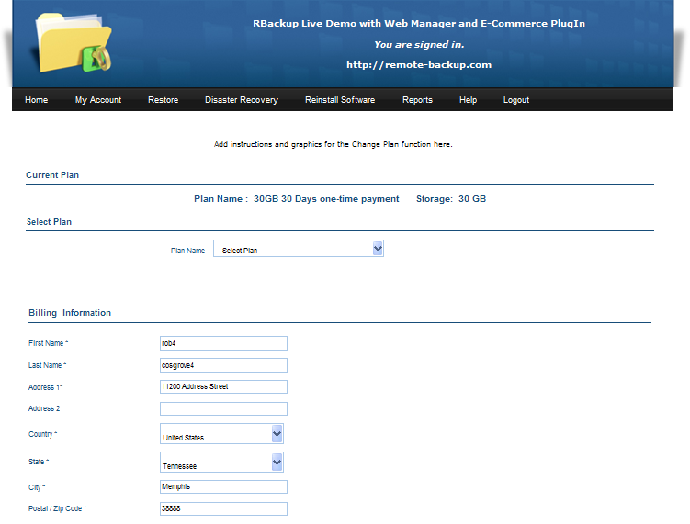

Buy More Space
(E-Commerce PlugIn)

End users can buy more storage space here. The screen displays the price per gigabyte and allows users to enter the number of gigabytes they want to buy. The order form requests payment information.

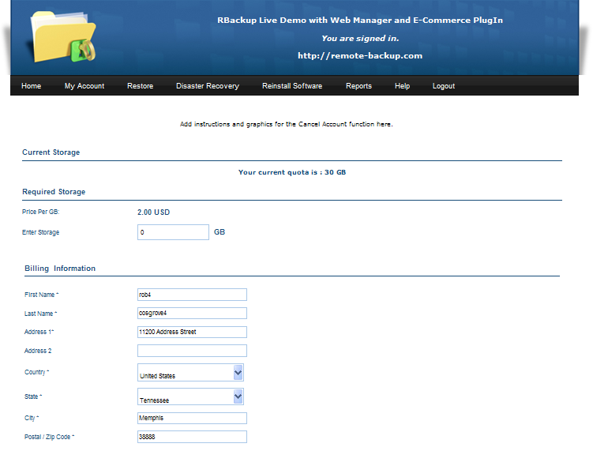

Cancel Account
(E-Commerce PlugIn)

End users can use this screen to cancel their accounts. The text above the Yes / No control is configurable, as is the graphic and text at the top of the screen. See Web Manager Default Website for more information.

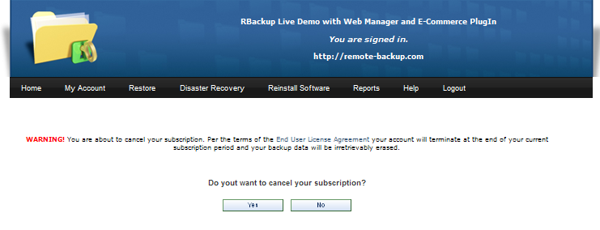

When end users cancel their accounts the Canceled Account Email notification is sent, and the following screen is displayed. The text is taken from the HTML file \cancelled.html.

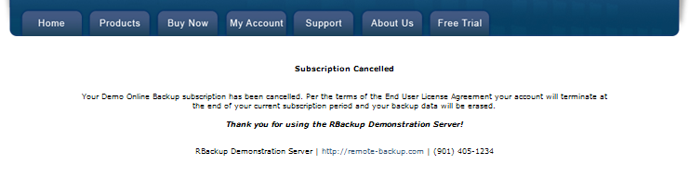

An entry is made in the Orders worksheet, and no other action is taken. The account IS NOT suspended. No changes are made to recurring billing. Backups will continue as normal until the Service Provider manually suspends or deletes the account.

Service Providers have different ways of dealing with cancellations. Some will offer to refund the remaining balance of the subscription immediately, and some will wait until the next subscription renewal date to cancel without a refund. Therefore, cancellation is a manual process for the Service Provider.

Usually a Service Provider will manually suspend or delete an end user's account and cancel recurring billing through the Payment Processor's online console (not a part of the E-Commerce PlugIn) and may wait to do so until the end of the user's current subscription period. This is consistent with the wording in the default End User License Agreement (EULA).

Restore
(Server must be authorized for the Web Restore utility)

This function lets end users download the Web Restore utility to restore their files to any computer. The text is taken from the HTML file \Restore.html

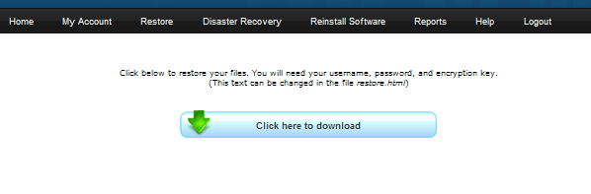
The Web Restore agent is a small .EXE file that executes on end user's computers and requests the Username, Password, and License Key. The restore interface is the same as the RBS Client software. After the restore is completed, the Web Restore agent uninstalls itself.

Disaster Recovery
This function re-installs the Client software in Disaster Recovery mode.

The text is taken from the HTML file \Disaster.html

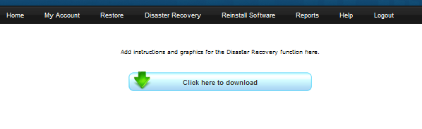

Reports
The following reports are available to end users. They are nearly identical in format to similar reports available to Administrators and Group Managers, filtered to display a single end user's information.

    - User Summary Report
    - User Session Report
    - User Quota Report
    - Disk Resources Report

Help
The Help link displays the HTML page \support.html which you can edit.

Installation
Installation of the Web Manager and E-Commerce PlugIns should be performed by someone familiar with installing Web Servers. This is not a trivial installation. While there is an automated installer, you must manually edit the web.config file, HTML files, and IIS settings. We strongly recommend having RBS remotely install this PlugIn for you.

Even if RBS installs the PlugIns for you, you are responsible for editing the HTML files and database to include your own company name, product name, and other information specific to your business. You will need to understand HTML coding techniques to edit the HTML files, and follow instructions in other parts of this documentation to further brand your Client software and the web pages that make up these two PlugIns. This chapter includes instructions on which HTML files to edit.

This PlugIn requires other software from Microsoft to be installed first. These are called Prerequisites. Please install and verify all the Prerequisites (see below) before installing this PlugIn.

The Free Installation service provided with some RBS software packages includes installing the purchased software in the default location only. It does not include installing or configuring any of the Prerequisites. If you would like RBS to install and configure your Prerequisites, or to move your software to another computer, we can do so for an additional charge.

Order PlugIn Installation (including Prerequisites) Here

This PlugIn must be installed on the RBS Server computer in the \Web\ folder of the Application Directory.

If there is an existing web site on the server on which you will install this PlugIn, additional manual adjustments will need to be done. The installer uses only the default settings for the first web site on a server.

This installation includes two PlugIns - the Web Manager PlugIn and the E-Commerce PlugIn. While the installer installs both PlugIns, only the PlugIn(s) for which you are authorized will function. The menu system will display only features associated with the PlugIn(s) for which you are authorized.

RBS' free installation service is for a standard configuration in the default location, after all prerequisites have been installed and configured by the end user. If you want a different type of installation, different defaults, or a different location please ask your installation engineer to quote a price for this extra work.

Unless you have contracted RBS to do so, you are responsible for developing and uploading your own customized graphics, and for completing all the program defaults and branding. Full instructions are included in this documentation.

Prerequisites

The Web Manager PlugIn requires the following prerequisites. To find out how to check for these prerequisites, see "How to Check for Prerequisites" further down this page. Please note that the free installation service offered with some software packages covers only the purchased software, and not the Prerequisites.

- Console login with Administrator rights
- RBS Server v11 or greater installed and tested
- The RBS Web Manager Installer file (RBSWebManager.exe)
- Internet Information Server v6 or greater, installed and working
- ASP.NET enabled
- MS .NET framework versions 2.0, 3.0 and 3.5
- (If the RBS Server uses the SQL Server PlugIn) SQL Management Studio Express installed
- SSL Certificate installed (E-Commerce PlugIn only)
- Router and Firewall setup complete.
- The PlugIns must be installed in the \Program Files\RBS Server\Web\ directory.

The Web Manager Installer verifies most prerequisites (except for the SSL certificate) and will notify you if you need to install something else.

The Web Manager Installer installs a default self-signed SSL certificate for testing purposes. If you intend to make your Web Manager available on the Internet, you should purchase and install your own SSL certificate.

1. Run the installer file, RBSWebManager.exe on your RBS Server computer.

Enter the fully qualified URL for the website hosting your Web Manager.

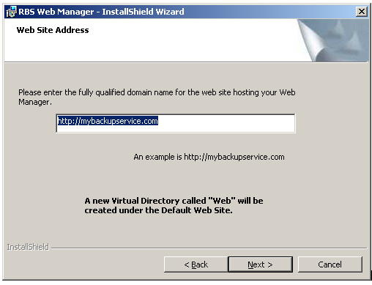

The installer creates a file called web.config in the \Web\WebManager\ folder.

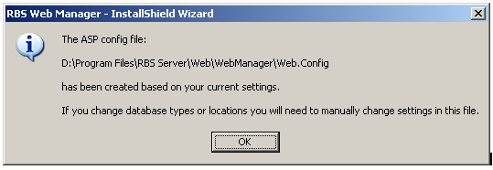

The web.config file contains settings that control how the web site works. It can be edited with any text editor (like Notepad.) Do not edit this file with MS Word or Wordpad.

Open the web.config file with Notepad and search for the following text:

<!--License Serial-->
<add key="SerialNo" value="##SERIAL##"/>

Replace ##SERIAL## with the serial number of your RBS Server, which can be found on the Help : About screen on the RBS Manager application.

Save the web.config file.

2. Verify the Security Account that IIS Uses to Run Web Manager

The account that IIS is running under when you need to make changes to the security settings. If, for example, your Web application writes to files or to a database, you'll need to grant the correct permissions to the folder or database. Before you can change these security settings, it's important the know what account IIS is using.

Accounts Used by IIS:

  - Windows XP: ASPNET
  - Windows 2003 server and above: Application Pool Identity.

How to find out the application pool identity (screenshots are for Windows 2003 Server)

Right click on the virtual directory and select properties. Click on the virtual directory tab and make a note of the value in the Application Pool drop down control.

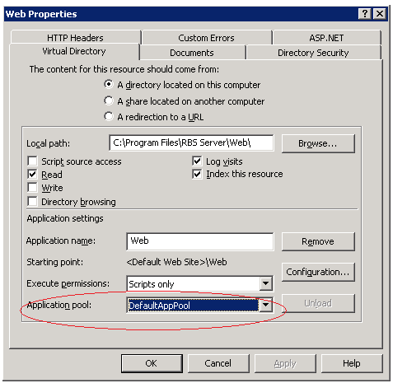

Expand Application Pools.

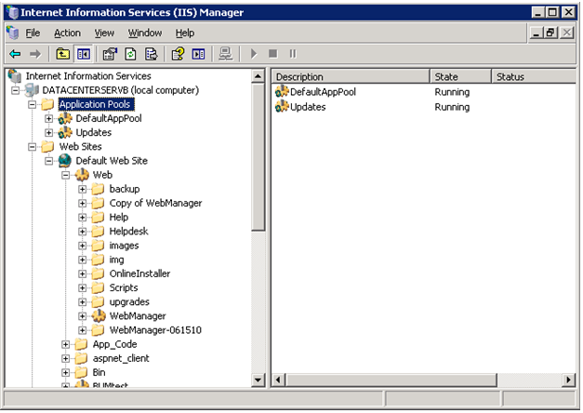

Right click on the specific application pool and select properties.

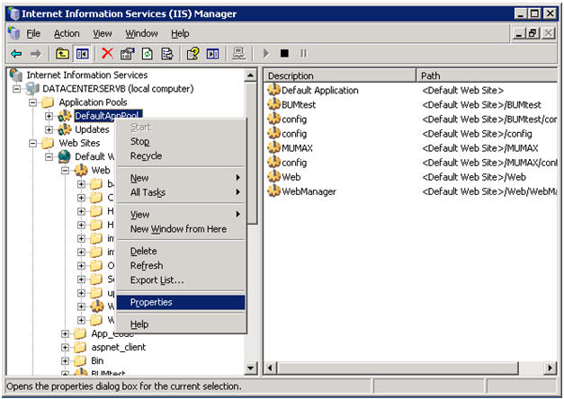

Click on the Identity tab.

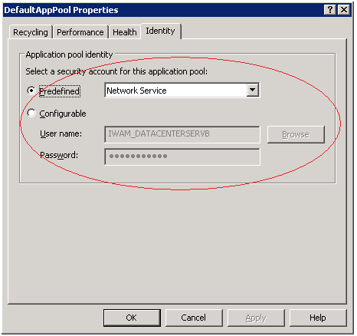

3. Set up Folder Permissions

It is mandatory to give permission to access the RBS Server folder because Web Manager will read and write files inside this folder during runtime.

Open Windows Explorer and go to the target path C:\Program Files\RBS Server. Then right click RBS Server and click Properties. In the properties window, click the Security tab.

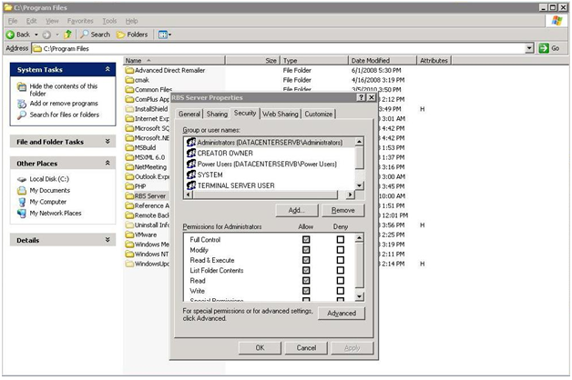

Give read and write permission to the user account from "Verify the Security Account that IIS Uses to Run Web Manager" above. Windows XP uses the ASPNET account, Windows 2003 server and above uses the application pool identity. To find out the application pool identity in your version of IIS, refer to "Verify the Security Account that IIS Uses to Run Web Manager."

If the user not found in the list then click Add button. This will show “Select Users or Groups” dialog box.

Click Advanced… button and then click Find Now button.

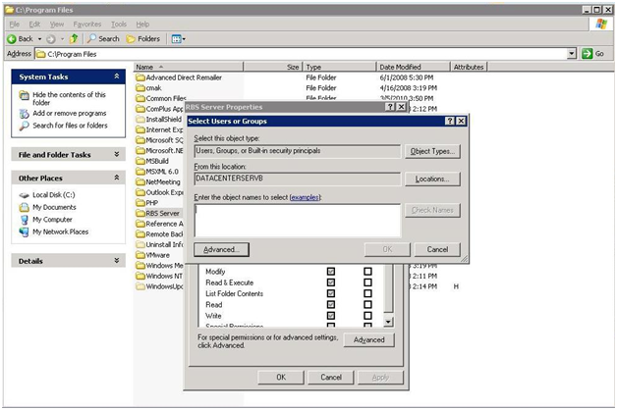

Select the required users from the search result and click Ok.

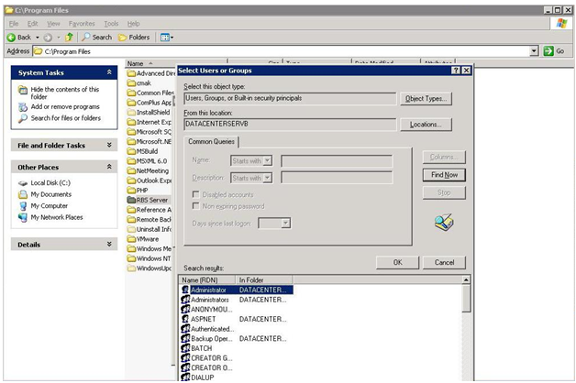

Now give full permission to the selected users.

4. Run the Application

Open Internet Explorer, and then go to the URL http://localhost/web/webmanager

Site URL - Optional, used only if you have installed a Code Signing Certificate.

Certificate Title - Optional, used only if you have installed a Code Signing Certificate.

Company Name - Used on the Code Signing Certificate and on the End User License Agreement (EULA) to replace the macro - comp -

UserName - The administrator's login username

Password - The administrator's login password

5. Configure Email Server and Email Notifications

Click Here for instructions.

6. Verify Server Properties are correct.

Click Here for instructions

7. Set up Account Groups (optional)

Click Here for instructions.

8. Set up Payment Gateways (E-Commerce PlugIn only)

Click Here for instructions.

9. Define Plans

Click Here for instructions.

10. Add Coupons (optional)

Click Here for instructions.

11. Set Storage Price

Click Here for instructions.

12. Customize (and optionally translate) Client Installers

Click Here for instructions

13. Customize (and optionally translate) the Client's Help File

Click Here for instructions.

14. Customize (and optionally translate) the Web Manager's Web Site

Click Here for instructions.

Setup Complete!

Configuring the Web Manager to work with Microsoft SQL Server
(versions 2000, 2005 and 2008)

This step is necessary if the RBS Server is using SQL Server as its database. This requires the SQL Server PlugIn.

There are two steps to configure the web manager for SQL Server.

- Create a new user account in SQL Server (RBS) and use it in the web manager connection string (web.config).
- Setup SQL Server for SQL and Windows authentication.

Run the SQL Server Management Studio. Select Run and type ssmsee

Right click on the SQL Instance and select Properties.

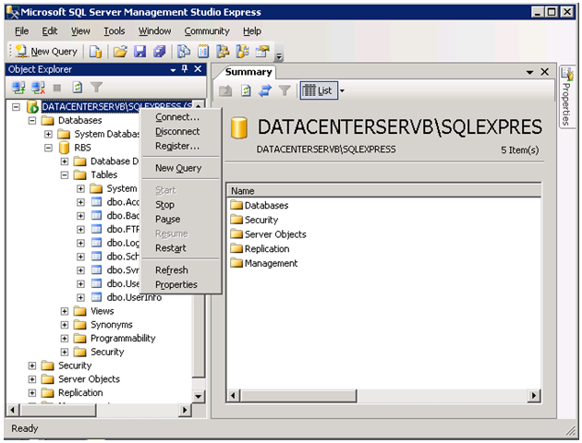

Select Security in the left-hand side and select “SQL and Windows Authentication mode”

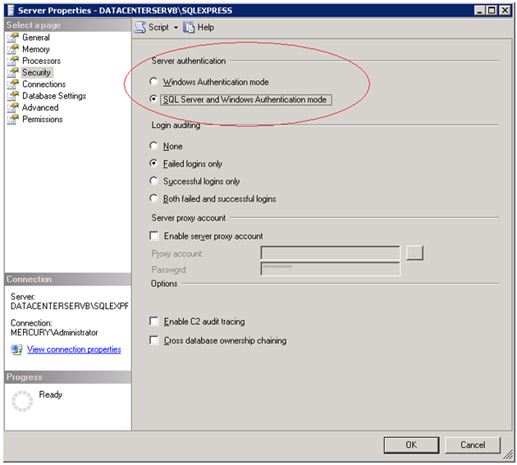

Expand the “RBS” database, expand the Security node.

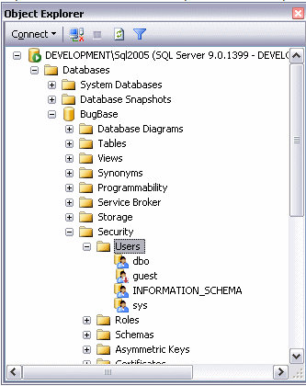

Right-click the Users/Logins node and choose New User/New Login.

In the Username text box, type MyWebsiteUser.

In the Login Name text box, type MyWebsiteUser. Alternatively, you can click the little button with the three ellipses and browse for the user name.

At the bottom half of the screen, you see a box labeled Database role membership. In this box, you can choose a number of roles that you want to grant to your new user. Give users as few permissions as possible. A good choice is db_datareader and db_datawriter that allows the account to both read from and write to tables in the database.

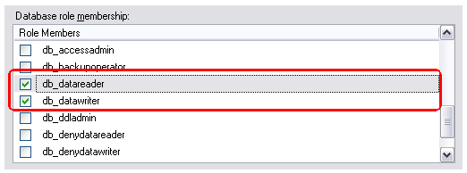

Now change the web manager web.config file to connect to this SQL instance with the created username and password. Open the \webmanager\web.config file with Notepad and search for the following text:

<!--RBS Server Database Type 0-Access, 1-SQL Server-->
<add key="DBType" value="##RBSSERVERDBTYPE##" />

<!--Web Manager Database Type 0-Access, 1-SQL Server-->
<add key="ClientDBType" value="##CLIENTDBVALUE##" />

<add key="managerdb" value="##MANAGERDB##"/>

Change ##RBSSERVERDBTYPE## to 1

Change ##CLIENTDBVALUE## to 1

Change ##MANAGERDB## to Server=DATACENTERSERVB\SQLEXPRESS;Initial Catalog=RBS;User ID=MyWebsiteUser;password=Pa$w0rD

(For the above value, use the actual username and password.)

Save the web.config file.

Installation Workarounds

Error: Could not load type ‘System.ServiceModel.Activation.HttpModule’ from assembly ‘System.ServiceModel, Version=3.0.0.0, Culture=neutral, PublicKeyToken=b77a5c561934e089'.

This is an unhandled exception during the execution of the current web request. Please review the stack trace for more information about the error and where it originated in the code.

Exception Details: System.TypeLoadException: Could not load type

‘System.ServiceModel.Activation.HttpModule’ from assembly ‘System.ServiceModel, Version=3.0.0.0, Culture=neutral, PublicKeyToken=b77a5c561934e089'.

Resolution

To resolve this issue, run the following from command line:

For 32 bit systems:

C:\WINDOWS\Microsoft.NET\Framework\v2.0.50727\aspnet_regiis.exe /iru

For 64 bit systems:

C:\WINDOWS\Microsoft.NET\Framework64\v2.0.50727\ aspnet_regiis.exe /iru

Not showing the Chart image in dashboard.

Resolution

In IIS7, click on the Web Manager node and then click ‘Add the managed handler’ link on the right side.
Then input the below information in the following order:

ChartImage.axd
Telerik.Web.UI.ChartHttpHandler, Telerik.Web.UI
ChartHandler

How to Check for Prerequisites

Administrator Privileges

    - Make sure you have an Administrator's login. If RBS technicians are installing they will need this login.

RBS Server v11 or greater installed and tested

    - Run the RBS Manager console application.
    - Select Help : About
    - Read the version number.

If the RBS Server is not installed, or if its version number is less than 11, install or upgrade it at the Products Download page.

Is IIS (Internet Information Services or Application Server) installed?

- Open Run
- Type inetmgr
- If IIS installed, this will open the IIS Manager application

If IIS is not installed, install and configure it. Search Microsoft Technet for more information.

Note: If IIS is installed prior to .NET framework installation, then please follow the steps:

- Open command prompt (Open Run and then type CMD)
- Change to the following directory
  - (for 32 bit systems) C:\WINDOWS\Microsoft.NET\Framework\v2.0.50727
  - (for 64 bit systems)C:\WINDOWS\Microsoft.NET\Framework64\v2.0.50727
- Type aspnet_regiis.exe –i

Is .Net framework 2.0, 3.0 and 3.5 installed?

  - Open control panel -> Add or Remove programs
  - Look for Microsoft .NET Framework (all three versions)

If .NET (all three versions) is not installed, install it. Search Microsoft Technet for more information.

Note: please reboot the system after the .NET framework install is done.

Is ASP Installed?

    - Open Service Manager (enter services.msc from Run).
    - Look for “ASP.Net State Service” and see if it is Started.

If it is not started, then start the service and change the startup type to “Automatic”.

Is Asp.Net enabled in IIS? (These instructions vary for different operating systems)

    - Open Control Panel
    - Select Administrative Tools
    - Select Internet Information Services
    - Expand your computer name
    - Click on "Web Service Extensions."
    - Make sure "ASP.NET" status is “Allowed”, if not, then right click and click enable

Search Microsoft Technet for more information.

Is SQL Server Management Studio installed? (Only necessary if the RBS Server uses the SQL Server PlugIn)

    - Open Run
    - Type ssmsee
    - If the software starts, it is installed.

If the software does not start, it is not installed. Download it and install it from the Microsoft download site.

SSL Certificate installed (E-Commerce PlugIn only)

While an SSL certificate is not required by the software, it is strongly recommended if you are going to provide web access to the public. Any certificate authority can provide an SSL certificate. Prices start at about $29 per year.

For instructions on installing your SSL certificate, see the Microsoft Support site. Search for "How to implement SSL in IIS"

A self-signed certificate is installed by default for testing. You can replace it later.

Router and Firewall Setup

Since the RBS Server should already be installed and tested, the firewall and router should have also been properly set up. If you still need to set up your router and firewall, you can find instructions at the following link.

Router and Firewall Setup

For the Web Manager and E-Commerce PlugIns you will need to handle ports 80 and 443 the same way the documentation at the above link suggests handling port 2774.

Translating for Different Languages

Note: If RBS does not currently support your language, we can give you the raw language files so you can translate them yourself. Return them to us and we will compile them into your software.

Client Simple Interface

The Client software's Simple Interface is available in different languages. End users can change the language preference after the Client software is installed. As the Service Provider, you can set the default language in the Customize Client Installer screens.

Client Advanced Interface

The Advanced Interface of the Client software cannot be translated. It is available only in English.

Client Installer

The text in the Client Installer defaults to English and does not automatically change when you change the default language. The Installer text can be edited in the Advanced Settings of the Customize Client Installer screens and must be translated manually.

Client Documentation

You can translate the Client documentation when you customize it. It is available from RBS only in English. See this section for more information.

